Line Segments ⸱ Practice

Examples 1 and 2
Find the measure of each segment.
1. $\overline{PR}$ 2. $\overline{EF}$ 3. $\overline{ JL}$
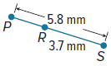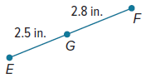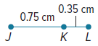

4. $\overline{HJ}$ 5. $\overline{AC}$ 6. $\overline{SV}$
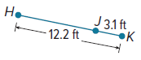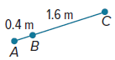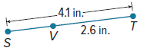

7. $\overline{NQ}$ 8. $\overline{AC}$ 9. $\overline{GH}$
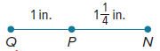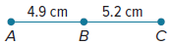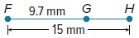

Example 3
Find the value of the variable and YZ if Y is between X and Z.
10. XY = 11, YZ = 4c, XZ = 83 11. XY = 6b, YZ = 8b, XZ = 175

12. XY = 7a, YZ = 5a, XZ = 6a + 24 13. XY = 5.5, YZ = 2c, XZ = 8.9

14. XY = 5n, YZ = 2n, XZ = 91 15. XY = 4w, YZ = 6w, XZ = 12w – 8

16. XY = 11d, YZ = 9d – 2, XZ = 5d + 28 17. XY = 4n + 3, YZ = 2n – 7, XZ = 20

18. XY = 3a – 4, YZ = 6a + 2, XZ = 5a + 22 19. XY = 3k – 2, YZ = 7k + 4, XZ = 4k + 38

20. XY = 4x, YZ = x, and XZ = 25 21. XY = 4x, YZ = 3x, and XZ = 42

22. XY = 12, YZ = 2x, and XZ = 28 23. XY = 2x + 1, YZ = 6x, and XZ = 81

Example 4
24. RAILROADS A straight railroad track is being built to connect two cities. The measured distance of the track between the two cities is 160.5 miles. A mail stop is 28.5 miles from the first city. How far is the mail stop from the second city?

25. CARPENTRY A carpenter has a piece of wood that is 78 inches long. He wants to cut it so that one piece is five times as long as the other piece. What are the lengths of the two pieces?

26. WALKING Marshall lives 2300 yards from school and 1500 yards from the pharmacy. The school, pharmacy, and his home are all collinear, as shown in the figure.

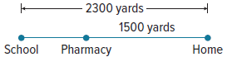

What is the distance from the pharmacy to the school?

27. COFFEE SHOP Chenoa wants to stop for coffee on her way to school. The distance from Chenoa’s house to the coffee shop is 3 miles more than twice the distance from the coffee shop to Chenoa’s school. The total distance from Chenoa’s house to her school is 5 times the distance from the coffee shop to her school.

a. What is the distance from Chenoa’s house to the coffee shop? Write your answer as a decimal, if necessary.

b. What assumptions did you make when solving this problem?

Example 5
Find the measure of each segment.
28. $\overline{MO}$ 29. $\overline{WY}$ 30. $\overline{FG}$
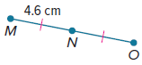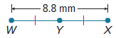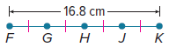

31. $\overline{QT}$ 32. $\overline{DE}$
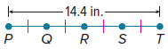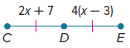

33. $\overline{UX}$
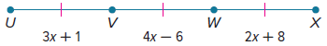

Mixed Exercises

34. Find the length of $\overline{UW}$ if W is between U and V, UV = 16.8 centimeters, and
VW = 7.9 centimeters.
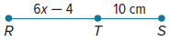
35. Find the value of x if RS = 24 centimeters.

36. Find the length of $\overline{LO}$ if M is between L and O, LM = 7x – 9, MO = 14 inches, and
LO = 10x – 7.

37. Find the value of x if $\overline{PQ}$ ≅ $\overline{RS,}$ PQ = 9x – 7, and RS = 29.

38. Find the measure of $\overline{NL}$.

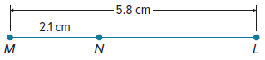

39. PRECISION If point P is between A and M, write a true statement.

40. HIKING A hiking trail is 20 kilometers long. Park organizers want to build 5 rest stops for hikers with one on each end of the trail and the other 3 spaced evenly between. How much distance will separate successive rest stops?

41. RACE The map shows the route of a race. You are at Y, 6000 feet from the first checkpoint A. The second checkpoint B is located at the midpoint between A and the end of the race Z. The total race is 3.1 miles. How far apart are the two checkpoints?

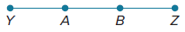

42. FIELD TRIP The marching band at Jefferson High School is taking a field trip from Lansing, Michigan to Detroit, Michigan. The bus driver was told to stop 53 miles into the trip. If the rest of the trip is 41 miles and the entire journey can be represented by the expression 3x + 16, find the value of x.

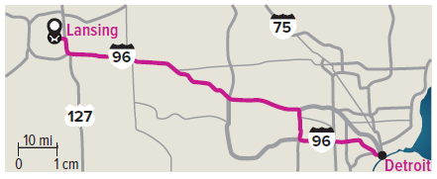

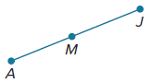
43. DISTANCE Madison lives between Anoa and Jamie as depicted on the line segment. The distance between Anoa’s house and Madison’s house is represented by 3x + 2 miles, the distance between Madison’s house and Jamie’s house is represented by 3x + 4 miles, and the distance between Anoa’s house and Jamie’s house is represented by 9x – 3 miles. Find the value of x. Then find the distance between Madison’s house and Jamie’s house.
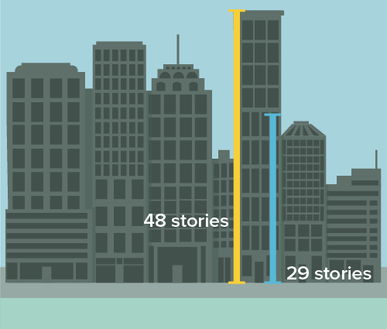

44. FIREFIGHTING A firefighter training course is taking place in a high-rise building. The high-rise building where they practice is 48 stories high. If the emergency happens on the top floor and the firefighters have already gone 29 stories, how many stories do they still need to go?

45. CAFE You are waiting at the end of a long straight line at Coffee Express. Your friend Denzel is
r + 12 feet in front of you. Denzel is 2r + 4 feet away from the front of the line. If Denzel is in the exact middle of the line, how many feet away are you from the front of the line?

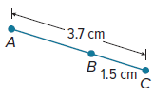
46. REASONING For $\overline{AC}$, write and solve an equation to find AB.

47. PERSEVERE Point K is between points J and L. If JK = x² – 4x, KL = 3x – 2, and
JL = 28, find the lengths of JK and KL.

48. ANALYZE Determine whether the statement If point M is between points C and D, then CD is greater than either CM and MD is sometimes, always, or never true. Justify your argument.

49. PERSEVERE Point C is located between points B and D. Also, $BC$ = 5x + 7,
$CD$ = 3y + 4, $BD$= 38, and $BD$ = 2x + 8y. Find the values of x and y.

50. WRITE If point B is between points A and C, explain how you can find AC if you know AB and BC. Explain how you can find BC if you know AB and AC.

51. CREATE Sketch line segment AC. Plot point B between A and C. Use a ruler to find AC and AB. Then write and solve an equation to find BC.

