Distance ⸱ Practice

Example 1
Use the number line to find each measure.
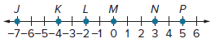

1. JL 2. JK 3. KP

4. NP 5. JP 6. LN

Use the number line to find each measure.
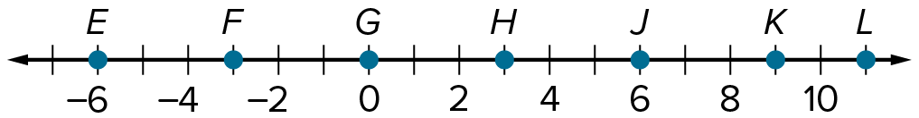

7. JK 8. LK 9. FG

10. JG 11. EH 12. LF

Use the number line to find each measure.
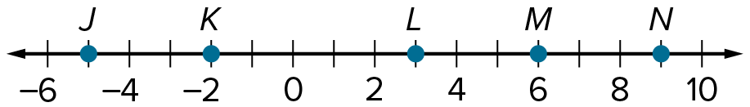

13. LN 14. JL

Example 2
Determine whether the given segments are congruent. Write yes or no.
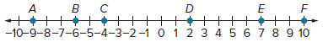

15. $\overline{AB}$ and $\overline{EF}$ 16. $\overline{BD}$ and $\overline{DF}$ 17. $\overline{AC}$ and $\overline{CD}$

18. $\overline{AC}$ and $\overline{DE}$ 19. $\overline{BE}$ and $\overline{CF}$ 20. $\overline{CD}$ and $\overline{DF}$

Example 3
Find the distance between each pair of points.
21. 22. 23.
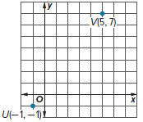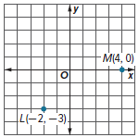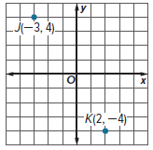

24. A(2, 6), N(5, 10) 25. R(3, 4), T(7, 2) 26. X(–3, 8), Z(–5, 1)

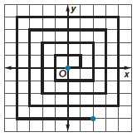
Example 4
27. SPIRALS Denise traces the spiral shown in the figure. The spiral begins at the origin. What is the shortest distance between Denise’s starting point and her
ending point?

28. ZOOLOGY A tiny songbird called the blackpoll warbler migrates each fall from North America. A tracking study showed one bird flew from Vermont at map coordinates (63, 45) to Venezuela at map coordinates (67, 10) in three days. If each map coordinate represents 75 kilometers, how far did the bird travel?

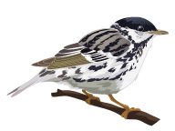
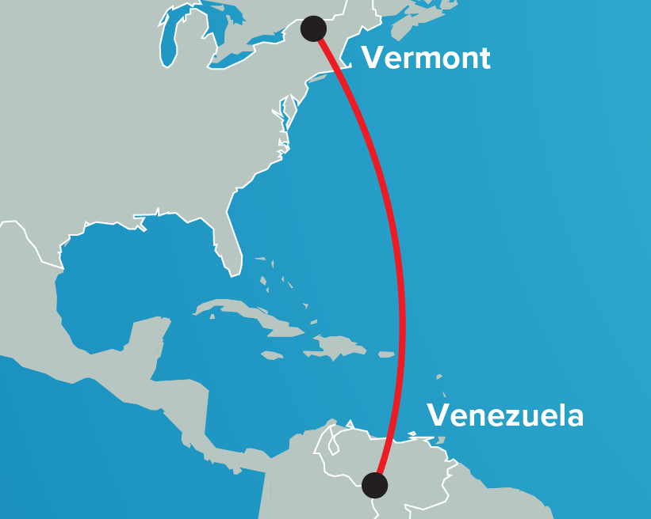

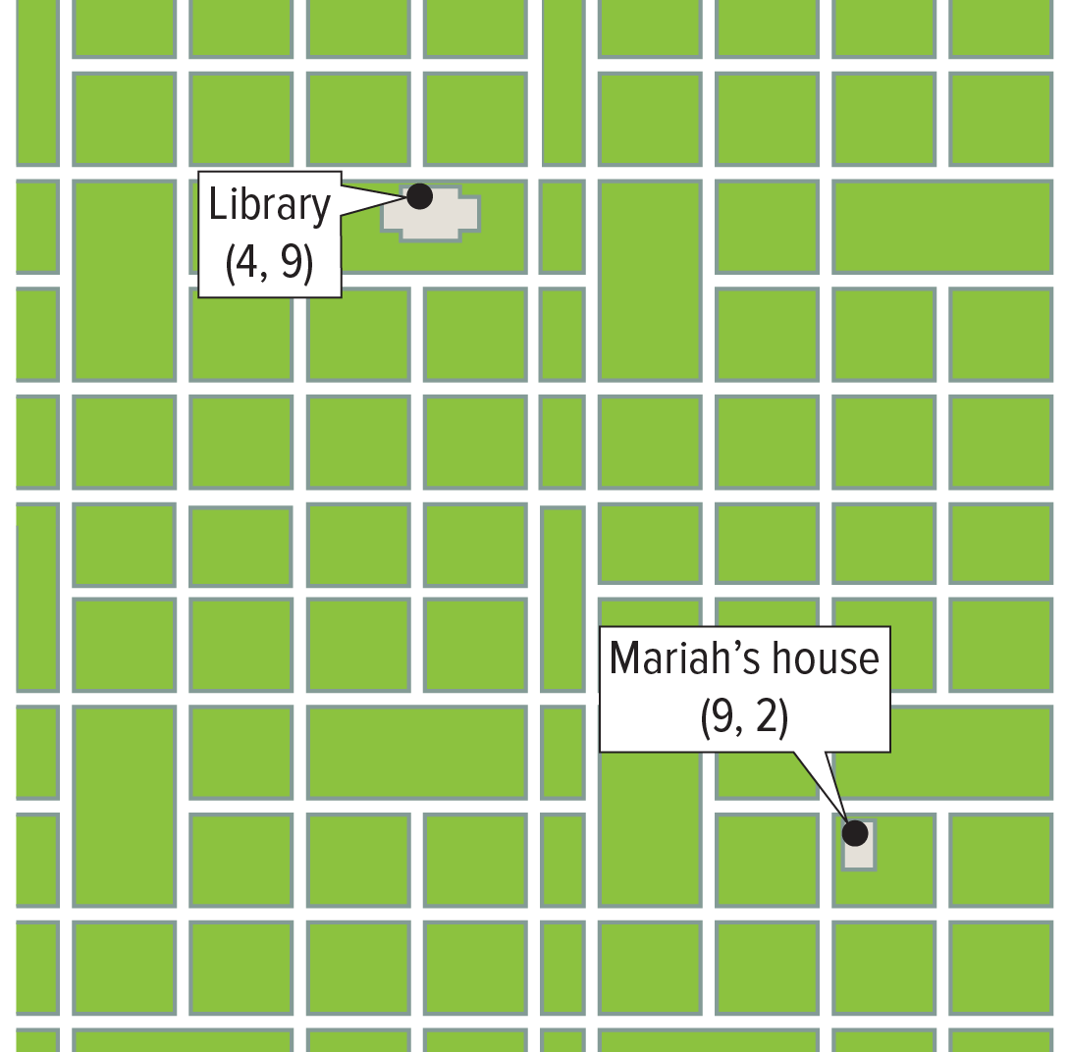
29. CONSTRUCT ARGUMENTS Mariah is training for a sprint-distance triathlon. She plans on cycling from her house to the library, shown on the grid with a scale in miles. If the cycling portion of the triathlon is 12 miles, will Mariah have cycled at least $\frac{2}{3}$ of that distance during her bike ride? Justify your argument.

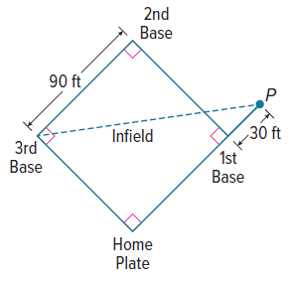
30. SPORTS The distance between each base on a baseball infield is 90 feet. The third baseman throws a ball from third base to point P. To the nearest foot, how far did the player throw the ball?

Mixed Exercises
Find the distance between each pair of points. Round to the nearest tenth, if necessary.

31. M(–4, 9), N(–5, 3) 32. C(2, 4), D(5, 7)

33. A(5, 1), B(3, 6) 34. V(4, 4), X(5, 8)

35. S(6, 4), T(3, 2) 36. M(–1, 8), N(–3, 3)

37. W(–8, 1), Y(0, 6) 38. B(3, –4), C(5, –5)

39. R(6, 11), T(3, –7) 40. A(–3, 8) and B(–1, 4)

41. M(4, –3) and N(–2, 1) 42. X(–3, 5) and Y(4, 2)

43. Use the number line to determine whether $\overline{SV}$ and $\overline{UX}$ are congruent.
Write yes or no.
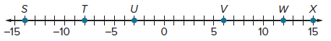

Name the point(s) that satisfy the given condition.
44. two points on the x-axis that are 10 units from (1, 8)

45. two points on the y-axis that are 25 units from (–24, 3)

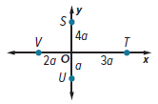
46. Refer to the figure. Are $\overline{VT}$ and $\overline{SU}$ congruent?

47. KNITTING Mel is knitting a scarf with diagonal stripes. Before she began, she laid out the pattern on a coordinate grid where each unit represented 2 inches. On the grid, the first stripe began at (2, 0) and ended at (5, 4). All of the stripes are the same length. How many inches long is each stripe in the scarf?


48. ART A terracotta bowl artifact has a triangular pattern around the top, as shown. All the triangles are about the same size and can be represented on a coordinate plane with vertices at points (0, 6.8), (4.5, 6.8), and (2.25, 0). If each unit represents 1 centimeter, what is the approximate perimeter of each triangle, to the nearest tenth of a centimeter?

49. ANALYZE Consider rectangle QRST with QR = ST = 4 centimeters and RS = QT = 2 centimeters. If point U is on $\overline{QR}$ such that QU = UR and point V is on $\overline{RS}$ such that RV = VS, then is $\overline{QU}$ congruent to $\overline{RV}$? Justify your argument.

50. WRITE Explain how the Pythagorean Theorem and the Distance Formula are related.

51. PERSEVERE Point P is located on the segment between point A(1, 4) and point D(7, 13). The distance from A to P is twice the distance from P to D. What are the coordinates of point P?

52. CREATE Plot points Y and Z on a coordinate plane. Then use the Distance Formula to find YZ.

53. PERSEVERE Suppose point A is located at (1, 3) on a coordinate plane. If AB is 10 and the
x-coordinate of point B is 9, explain how to use the Distance Formula to find the y-coordinate of point B.

54. WRITE Explain how to use the Distance Formula to find the distance between points (a, b) and (c, d).

