Locating Points on a Number Line ⸱ Practice

Examples 1 and 3

Refer to the number line

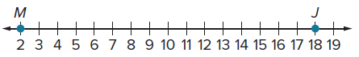

- Find the coordinate of point B that is $\frac{1}{4}$ of the distance from M to J.

2. Find the coordinate of point C that is $\frac{7}{8}$ of the distance from M to J.

3. Find the coordinate of point D that is $\frac{7}{16}$ of the distance from M to J.

4. Find the coordinate of point X such that the ratio of MX to XJ is 3:1.

5. Find the coordinate of point X such that the ratio of MX to XJ is 2:3.

6. Find the coordinate of point X such that the ratio of MX to XJ is 1:1.

Refer to the number line.

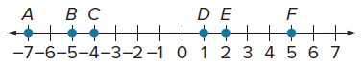

7. Find the coordinate of point G that is $\frac{2}{3}$ of the distance from B to D.

8. Find the coordinate of point H that is $\frac{1}{5}$ of the distance from C to F.

9. Find the coordinate of point J that is $\frac{1}{6}$ of the distance from A to E.

10. Find the coordinate of point K that is $\frac{4}{5}$ of the distance from A to F.

11. Find the coordinate of point X such that the ratio of AX to XF is 1:3.

12. Find the coordinate of point X such that the ratio of BX to XF is 3:2.

13. Find the coordinate of point X such that the ratio of CX to XE is 1:1.

14. Find the coordinate of point X such that the ratio of FX to XD is 5:3.

Refer to the number line.
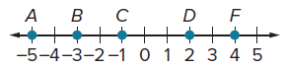

15. Find the coordinate of point X on $\overline{AF}$ that is $\frac{1}{3}$ of the distance from A to F.

16. Find the coordinate of point Y on $\overline{AC}$ that is $\frac{1}{4}$ of the distance from A to C.

Refer to the number line.

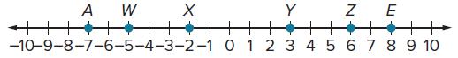

17. Which point on is $\frac{2}{3}$ of the distance from A to E?

18. Point X is what fractional distance from E to A?

19. Find the coordinate of point M on that is $\frac{1}{5}$ of the distance from A to E.

Refer to the number line.

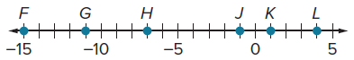

20. The ratio of FX to XK is 1:1. Which point is located at X?

21. Find the coordinate of Q on $\overline{FL}$ such that the ratio of FQ to QL is 12:7.

Examples 2 and 4
22. TRAVEL Caroline is taking a road trip on I-70 in Kansas. She stops for gas at mile marker 36. Her destination is at mile marker 353 in Topeka, but she decides to stop at an attraction $\frac{3}{4}$ of the way after stopping for gas. At about which mile marker did Caroline stop to visit the attraction?

23. HIKING A hiking trail is 24 miles from start to finish. There are two rest areas located along
the trail.
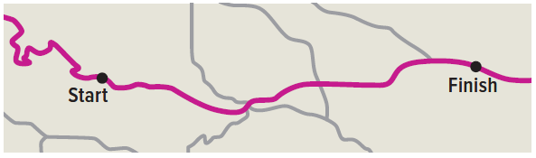

a. The first rest area is located such that the ratio of the distance from the start of the trail to the rest area and the distance from the rest area to the end of the trail is 2:9. To the nearest hundredth of a mile, how far is the first rest area from the starting point of the trail?
b. Kadisha claims that the distance she has walked and the distance she has left to walk has a ratio of 5:7. How many miles has Kadisha walked?

24. Melany wants to hang a canvas, which is 8 feet wide, on his wall. Where on the canvas should Melany mark the location of the hangers if the canvas requires a hanger every $\frac{1}{5}$ of its length, excluding the edges? Justify your answer.

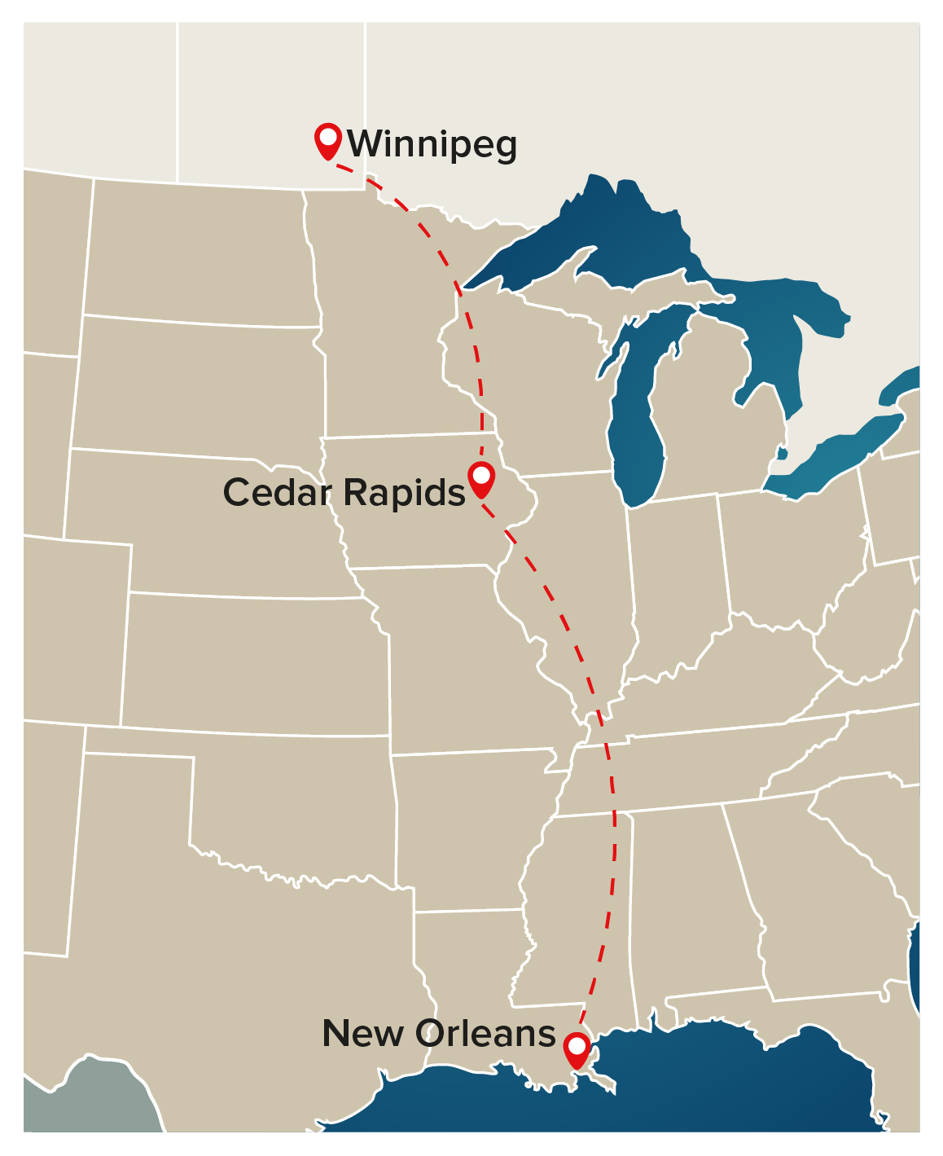
25. MIGRATION Many American White Pelicans migrate each year, with hundreds of them stopping to rest in various locations along the way. The ratio of the distance some flocks travel from their summer home to one stopover to the distance from the stopover to the winter home is 3:4. If the total distance the pelicans migrate is 1680 miles, how long is the distance from the summer home to the stopover?

Mixed Exercises
26. Write an equation that can be used to find the coordinate of point K that is $\frac{2}{5}$ of the distance from Q to R.
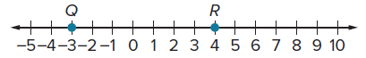

27. SOCIAL MEDIA Tito is posting a photo and needs to resize it to fit. The photo’s width should fill $\frac{4}{5}$ of the width of the page. On Tito’s screen, the total width of the page is 3 inches. How wide should the photo be?

28. NEONATAL At birth, the ratio of a baby’s head length to the length of the rest of its body is 1:3. If a baby’s total body length is 22 inches, how long is the baby’s head?

29. CREATE Draw a segment and label it $\overline{AB}$. Using only a compass and a straightedge, construct a segment $\overline{CD}$ such that $CD=5\frac{1}{4}AB$. Explain and then justify your conclusion.

30. WRITE Naoki wants to center a canvas, which is 8 feet wide, on his bedroom wall, which is 17 feet wide. Where on the wall should Naoki mark the location of the nails, if the canvas requires nails every $\frac{1}{5}$ of its length, excluding the edges? Explain your solution process.

31. ANALYZE Determine whether the following statement is sometimes, always, or never true. Justify your argument.

If $\overline{XY}$ is on a number line and point W is $\frac{2}{5}$ of the distance from X to Y, then the coordinate of point W is greater than the coordinate of point X.

32. PERSEVERE On a number line, point A is at 5, and point B is at 10. Point C is on $\overline{AB}$ such that the ratio of AC to CB is 1:3. Find D on $\overline{BC}$ that is $\frac{3}{8}$ of the distance from B to C.

