Locating Points on a Coordinate Plane ⸱ Practice

Example 1
Find the coordinates of point X on the coordinate plane for each situation.
1. Point X on is $\frac{1}{5}$ the 2. Point X on is $\frac{1}{6}$ the 3. Point X on is $\frac{1}{3}$ the
distance from A to B. distance from R to S. distance from J to K.
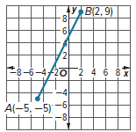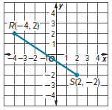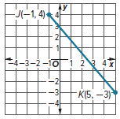

Example 2
Refer to the coordinate grid.
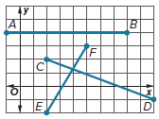
4. Find point X on such that the ratio of AX to XB is 1:3.

5. Find point Y on such that the ratio of DY to YC is 2:1.

6. Find point Z on such that the ratio of EZ to ZF is 2:3.

Examples 1 and 2
Refer to the coordinate grid.
7. Find point C on that is $\frac{1}{5}$ of the distance from A to B.
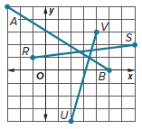
8. Find point Q on that is $\frac{5}{8}$ of the distance from R to S.
9. Find point W on that is $\frac{1}{7}$ of the distance from U to V.
10. Find point D on that is $\frac{3}{4}$ of the distance from A to B.

11. Find point Z on such that the ratio of RZ to ZS is 1:3.

12. Find point G on such that the ratio of AG to GB is 3:2.

13. Find point E on such that the ratio of UE to EV is 3:4.

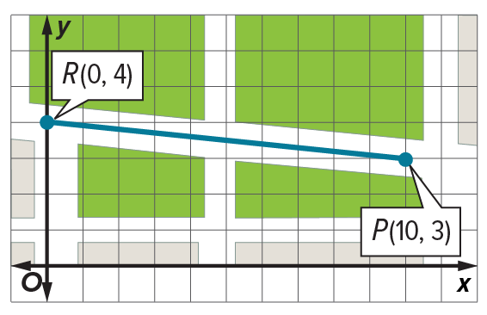
Example 3
14. MAPS Leila is walking from the park at point P to a restaurant at point R. She wants to stop for a break once the distance she has traveled and the distance she has left to travel has a ratio of 3:5. At which point should Leila stop for her break?

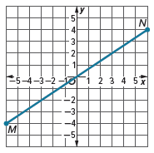
15. CITY PLANNING The United States Capitol is located at (2, –4) on a coordinate grid. The White House is located at (–10, 16) on the same coordinate grid. Find two points on the straight line between the United States Capitol and the White House such that the ratio is 1:3.
Mixed Exercises
Refer to the coordinate grid.
16. Find X on $\overline{MN}$ that is $\frac{3}{4}$ of the distance from M to N.

17. Find Y on $\overline{MN}$ such that the ratio of MY to YN is 1:3.

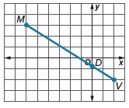
Point D is located on $\overline{MV}$. The coordinates of D are $\left(0,-\frac{3}{4}\right)$.
18. What ratio relates MD to DV?

19. What fraction of the distance from M to V is MD?

20. What ratio relates DV to MD?

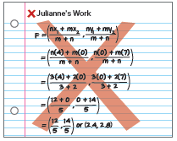
21. FIND THE ERROR Point W is located at (0, 7) and point X is located at (4, 0).
Julianne wants to find point F on such that WF to FX is 2:3.
a. What error did Julianne make when solving this problem?
b. What are the correct coordinates of point F?

22. ANALYZE Is the point one-third of the distance from (x₁, y₁) to (x₂, y₂) sometimes, always, or never the point ? Justify your argument.

23. WRITE Point P is located on the segment between point A(1, 4) and point D(7, 13). The distance from A to P is twice the distance from P to D. Explain how to find fractional distance that P is from A to D. What are the coordinates of point P?

24. PERSEVERE Point C(6, 9) is located on the segment between point A(4, 8) and point B. Point C is $\frac{1}{4}$ the distance from A to B. What are the coordinates of point B?

25. CREATE Draw a line on a coordinate plane. Label two points on the line F and G. Locate a third point on the line between points F and G and label this point H. The point H on $\overline{FG}$ is what fractional distance from F to G?

