Midpoints and Bisectors ⸱ Practice

Example 1
Use the number line to find the coordinate of the midpoint of each segment.
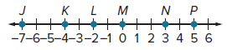
1. 2. 3.

4. 5. 6.

Use the number line to find the coordinate of the midpoint of each segment.
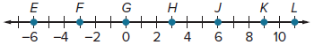
7. $\overline{FK}$ 8. $\overline{HK}$ 9. $\overline{EF}$

10. $\overline{FG}$ 11. $\overline{JL}$ 12. $\overline{EL}$

USE TOOLS Use the number line to find the coordinate of the midpoint of each segment.
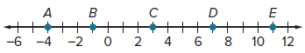

13. $\overline{DE}$ 14. $\overline{BC}$

15. $\overline{BD}$ 16. $\overline{AD}$

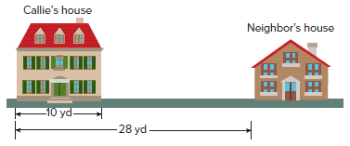
Example 2
17. HOME IMPROVEMENT Callie wants to build a fence halfway between her house and her neighbor’s house. How far away from Callie’s house should the fence
be built?

18. DINING Calvino’s home is located at the midpoint between Fast Pizza and Pizza Now. Fast Pizza is a quarter mile away from Calvino’s home. How far away is Pizza Now from Calvino’s home? How far apart are the two pizzerias?

Example 3
Find the coordinates of the midpoint of a segment with the given endpoints.
19. (5, 11), (3, 1) 20. (7, –5), (3, 3) 21. (–8, –11), (2, 5)

22. (7, 0), (2, 4) 23. (–5, 1), (2, 6) 24. (–4, –7), (12, –6)

25. (2, 8), (8, 0) 26. (9, –3), (5, 1) 27. (22, 4), (15, 7)

28. (12, 2), (7, 9) 29. (–15, 4), (2, –10) 30. (–2, 5), (3, –17)

31. (2.4, 14), (6, 6.8) 32. (–11.2, –3.4), (–5.6, –7.8)

Example 4
Find the coordinates of the missing endpoint if B is the midpoint of .
33. C(–5, 4), B(–2, 5) 34. A(1, 7), B(–3, 1)

35. A(–4, 2), B(6, –1) 36. C(–6, –2), B(–3, –5)

37. A(4, –0.25), B(–4, 6.5) 38.

Examples 5 and 6
Suppose M is the midpoint of . Find each missing measure.
39. FM = 5y + 13, MG = 5 – 3y, FG = ? 40. FM = 3x – 4, MG = 5x – 26, FG = ?

41. FM = 8a + 1, FG = 42, a = ? 42. MG = 7x – 15, FG = 33, x = ?

43. FM = 3n + 1, MG = 6 – 2n, FG = ? 44. FM = 12x – 4, MG = 5x + 10, FG = ?

45. FM = 2k – 5, FG = 18, k = ? 46. FG = 14a + 1, FM = 14.5, a = ?

47. MG = 13x + 1, FG = 15, x = ? 48. FG = 11x – 15.6, MG = 10.9, x = ?

Mixed Exercises
Find the coordinates of the missing endpoint if P is the midpoint of $\overline{NQ}$.
49. N(2, 0), P(5, 2) 50. N(5, 4), P(6, 3) 51. Q(3, 9), P(–1, 5)

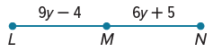
52. Find the value of y if M is the midpoint of $\overline{LN }$.

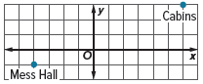
53. CAMPING Troop 175 is designing a new campground by first mapping everything on a coordinate grid. They have found locations for the mess hall and their cabins. They want the bathrooms to be halfway between these two places. What are the coordinates of the location of the bathrooms?

54. GAME DESIGN A computer software designer is creating a new video game. The designer wants to create a secret passage that is halfway between the castle and the bridge. Where should the secret passage be located? 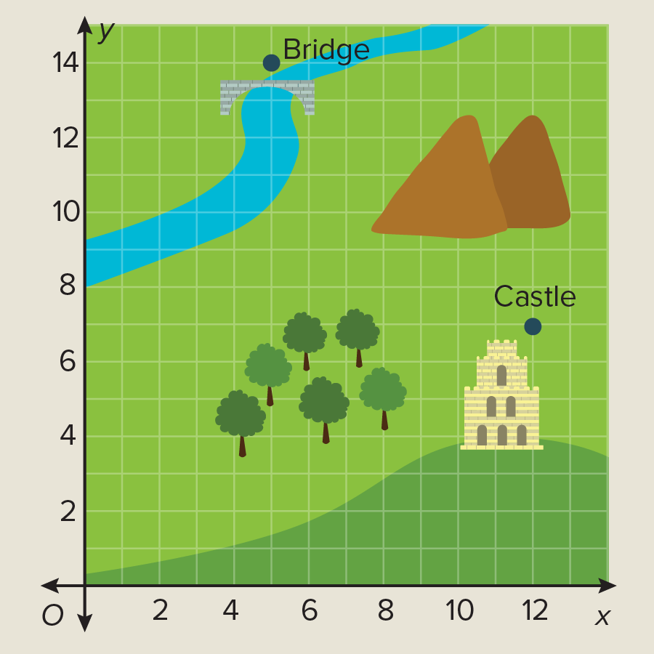
55. SCAVENGER HUNT Pablo is going to ask Bianca to prom by sending her on a scavenger hunt. At the end of the scavenger hunt, Pablo will be standing halfway between the gazebo and the ice cream shop in town. Where should Pablo stand?
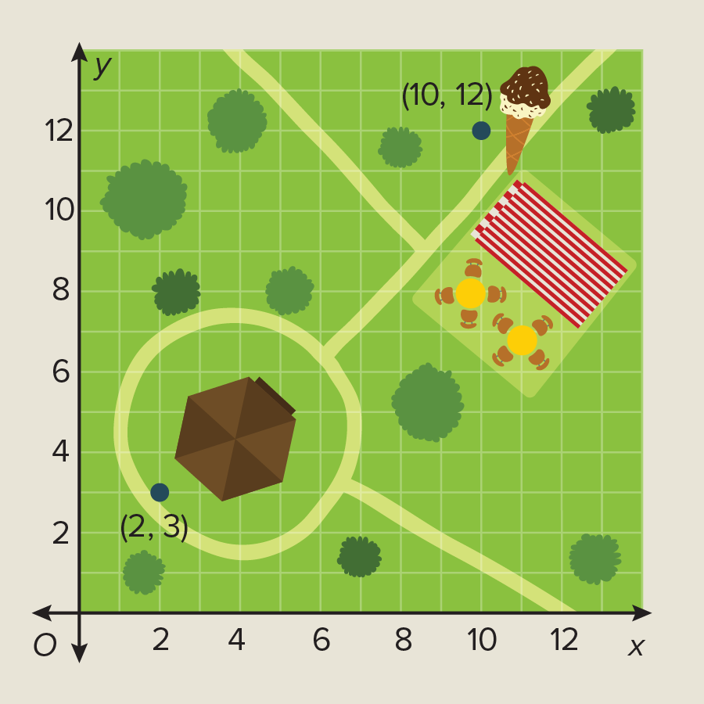

56. WALKING Javier walks from his home at point K to the Internet café at point O. If the
school at point W is exactly halfway between Javier’s house and the Internet café, how far
does Javier walk?

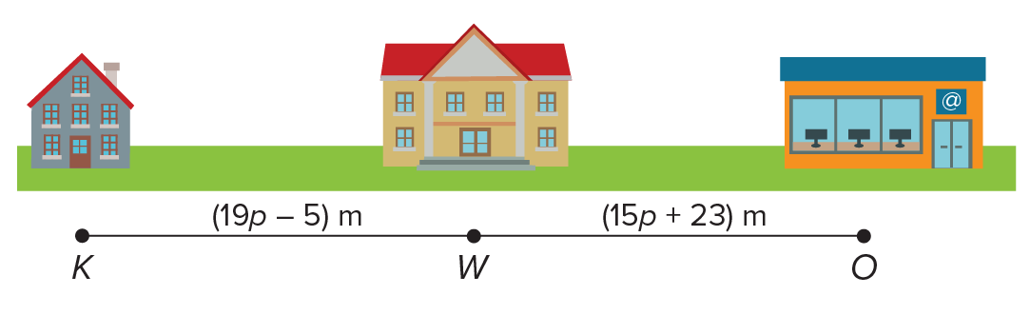

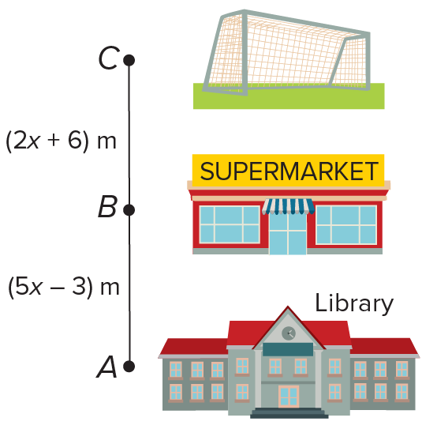
57. SCHOOL LIFE Bryan is at the library doing a research paper. He leaves the library at point A and walks to the soccer field for a game at point C. The supermarket at point B is exactly halfway between the library and the soccer field. After Bryan’s first soccer game, he walks to the supermarket to buy a snack, and then he walks back to the soccer field for his second game. Not including the time spent at the soccer game, how far does Bryan walk?

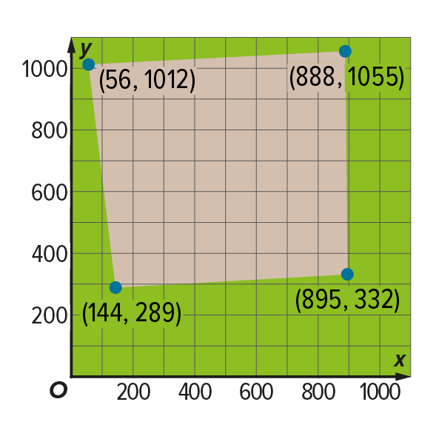
58. REASONING A drone flying over a field of corn identifies a dry area. The coordinates of the vertices of the area are shown. To what coordinates should the portable irrigation system be sent to water the dry area? Explain your reasoning.

59. PERSEVERE Describe a method of finding the midpoint of a segment that has one endpoint at
(0, 0). Derive the midpoint formula, give an example using your method, and explain why your method works.

60. WRITE Explain how the Midpoint Formula is a special case of the Section Formula.

61. CREATE Construct $\overline{AC}$ given $\overline{AB}$ if $B$ is the midpoint of $\overline{AC}$.

