Angles and Congruence ⸱ Practice

Example 1
Use the figure to identify angles and parts of angles that satisfy each given condition.
1. Name the vertex of $∠$1.

2. Name the sides of $∠$4.

3. What is another name for $∠$3?

4. What is another name for $∠$CAD?

Example 2
5. In the figure, $\vec{LF}$ and $\vec{LK}$ are opposite rays. $\vec{LG}$ bisects $∠$FLH. If m$∠$FLG = 14x + 5 and m$∠$HLG = 17x – 1, find m$∠$FLH.

In the figure, $\vec{BA}$ and $\vec{BC}$ are opposite rays. $\vec{BH}$ bisects $∠$EBC.
6. If m$∠$ABE = 2n + 7 and m$∠$EBF = 4n – 13, find m$∠$ABE.

7. If m$∠$EBH = 6x + 12 and m$∠$HBC = 8x – 10, find m$∠$EBH.
8. If m$∠$ABF = 7b – 24 and m$∠$ABE = 2b, find m$∠$EBF.

9. If m$∠$EBC = 31a – 2 and m$∠$EBH = 4a + 45, find m$∠$HBC.

10. If m$∠$ABF = 8w – 6 and m$∠$ABE = 2(w + 11), find m$∠$EBF.

11. If m$∠$EBC = 3r + 10 and m$∠$ABE = 2r – 20, find m$∠$EBF.

Example 3
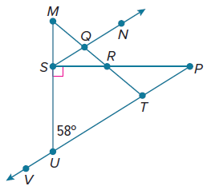
Refer to the figure.
12. Name two adjacent angles

13. Name two vertical angles

14. Find $m∠SUV.$

Find the value of each variable.
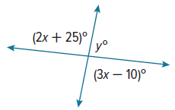
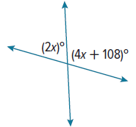
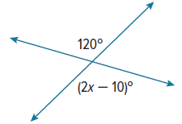
15. 16. 17.

Mixed Exercises
Use the figure to name the vertex of each angle.
18. $∠$1 19. $∠$2

20. $∠$4 21. $∠$7

Use the figure to name the sides of each angle.
22. $∠$QPT 23. $∠$MNV

24. $∠$6 25. $∠$3

Use the figure to write another name for each angle.
26. $∠$9 27. $∠$QPT

28. $∠$MQS 29. $∠$5

Use the figure above to name each angle, point, or pair of angles.

30. a point in the interior of $∠$VRQ 31. a point in the exterior of $∠$MRT

32. a pair of angles that share exactly one point 33. a pair of angles that share more than one point

Find the value of each variable.
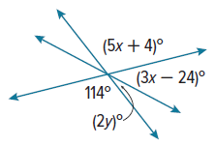
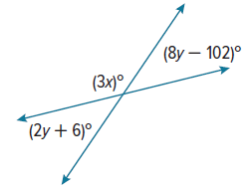
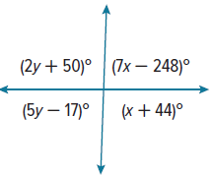
34. 35. 36.

Name an angle or angle pair that satisfies each condition.
37. two adjacent angles

38. two vertical angles

39. a linear pair that has vertex F

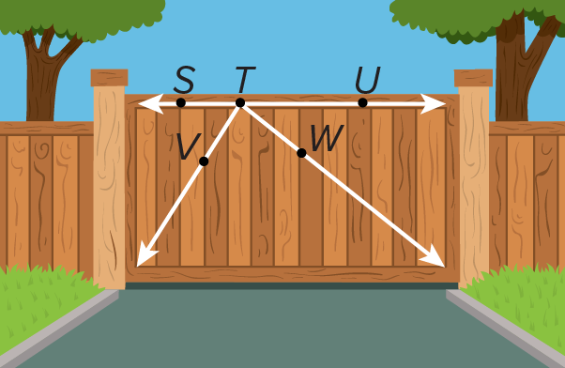
Use the picture at the right.
40. Name four rays.

41. Name three angles.

TRAFFIC In the traffic circle around the Arc de Triomphe in Paris, France, there are eight lanes of traffic. Tell whether each angle pair satisfies the given condition.

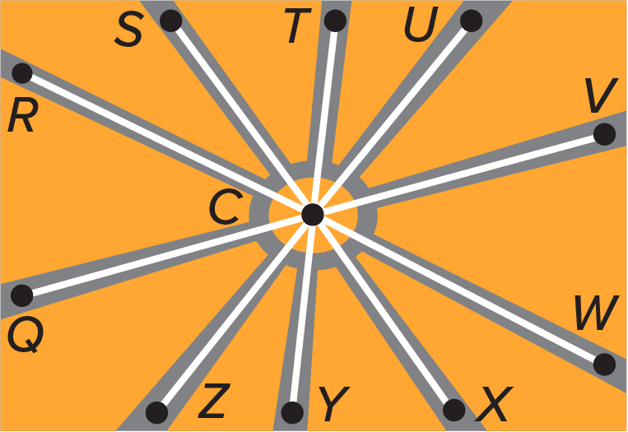
42. vertical angles
a. $∠$ZCY and $∠$TCU b. $∠$XCW and $∠$SCT
c. $∠$QCR and $∠$WCV d. $∠$TCU and $∠$UCT

43. linear pair
a. $∠$RCU and $∠$WCU b. $∠$QCR and $∠$SCR
c. $∠$VCX and $∠$WCY d. $∠$ZCR and $∠$UCW

44. adjacent angles
a. $∠$WCU and$∠$RCU b.$∠$QCS and $∠$SCR
c. $∠$VCW and $∠$QCR d. $∠$VCX and $∠$VCU

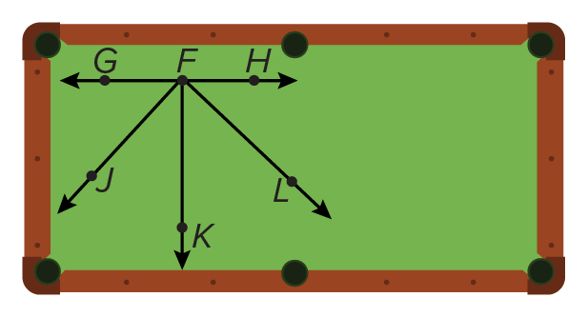
45. POOL Felipe uses a computer program to model the paths of pool balls. $∠$GFH is a straight angle that represents the rail of the pool table. If $\vec{FK}$ bisects $∠$JFL, and m$∠$JFL = 90°, what is m$∠$LFK?

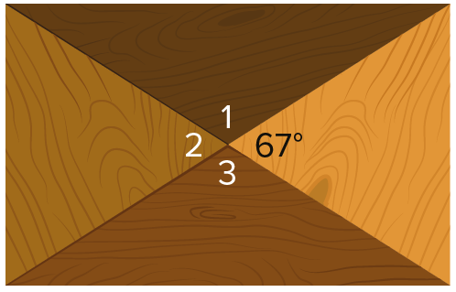
46. WOODWORKING Oliver makes rectangular blocks like the one shown and then glues them together to make a plaque. Find m$∠$1, m$∠$2, and m$∠$3, so that he can cut the pieces of the plaque.

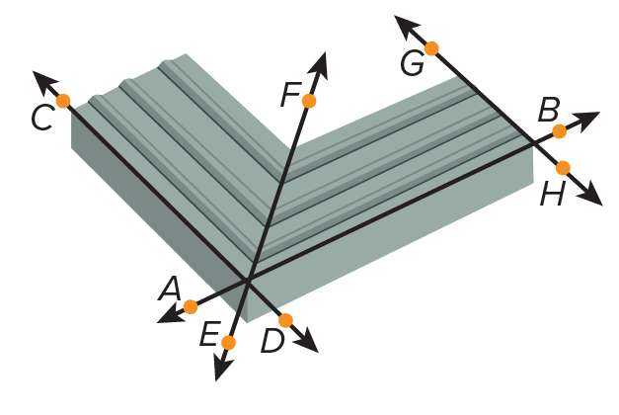
47. WOODWORKING Naomi cuts two pieces of baseboard molding to meet in a corner at a 90° angle.

a. To what degree should she set her table saw for the cut?

b. Which ray represents the angle bisector of the molding angle?

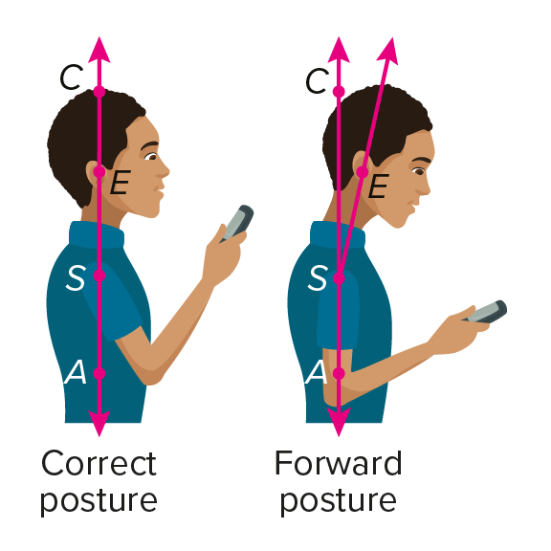
48. TEXTING Moving your head forward to look at a screen can stress your spine. Experts recommend aligning your ears with your shoulders and arms.

a. In the forward posture, what is the relationship between $∠$CSE and $∠$ESA?

b. In a correct posture, what is the relationship between $\vec{SE}$ and $\vec{SA}$?

c. If you are standing so that m$∠$CSE = 26°, what is m$∠$ESA?

d. Standing so that m$∠$CSE ≥ 15° puts more than 27 pounds of pressure on your spine. If there is 34 pounds of pressure on your spine, what inequality describes m$∠$ESA?

49. PERSEVERE $\vec{MP}$ bisects $∠$LMN, $\vec{MQ}$ bisects $∠$LMP, and $\vec{MR}$ bisects $∠$QMP. If m$∠$RMP = 21, find m$∠$LMN. Explain your reasoning.

50. ANALYZE Maria constructed a copy of $∠$PVQ and labeled it $∠$FGH
a. Are $∠$FGH and $∠$QVS a linear pair? Explain.
b. Maria must also copy $∠$QVS. Sal says she can create a copy of $∠$QVS if she extends $\vec{GH}$ past G. Mona says Maria can create a copy of $∠$QVS by extending $\vec{GF}$ past G. Who is correct? Justify your argument.

