Two-Dimensional Figures ⸱ Practice

Example 1
Find the perimeter or circumference and area of each figure if each unit on the graph measures 1 centimeter. Round answers to the nearest tenth, if necessary.
1. 2. 3.
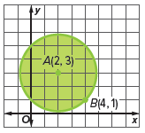
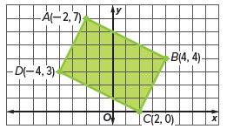
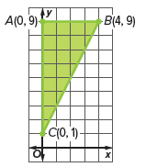

4. 5. 6.
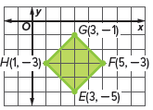
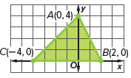
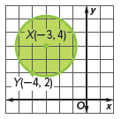

Example 2
Use a two-dimensional model and the dimensions provided to calculate the perimeter or circumference and area of each object. Round to the nearest tenth, if necessary.
7. 8. 9.
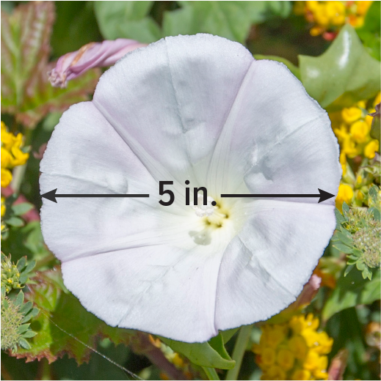
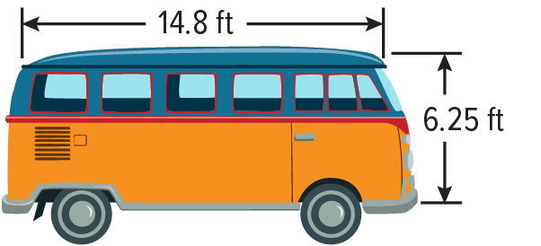
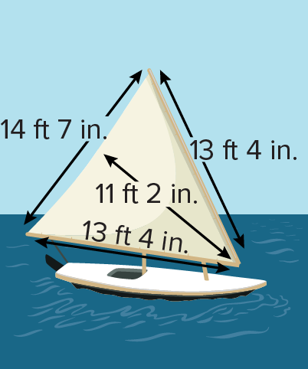

Example 3
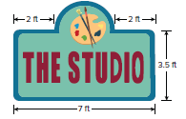
10. DESIGN Dev is designing a new sign for his art studio. However, he needs to make several improvements to the sign before it is ready to be hung.
a. Dev wants to add a metal trim around the perimeter of the sign. How much trim should Dev purchase? Round answer to the nearest foot.
b. The front of the sign also needs to be waterproofed with a protective sealer. How much area needs to be covered by the sealer? Round answer to the nearest square foot.
c. If a pint of sealer covers an area of 20 square feet, then how many pints of sealer should Dev purchase?

11. WORLD RECORD The world’s largest ice cream cake was created on May 10, 2011, in Toronto, Canada. The cake was 4.45 meters long, 4.06 meters wide, and 1 meter tall. All surfaces of the cake except the bottom were covered with a cookie crumble topping. Use an appropriate two-dimensional model to approximate the area covered by the cookie crumble topping. Round the answer to the nearest tenth of a square meter.

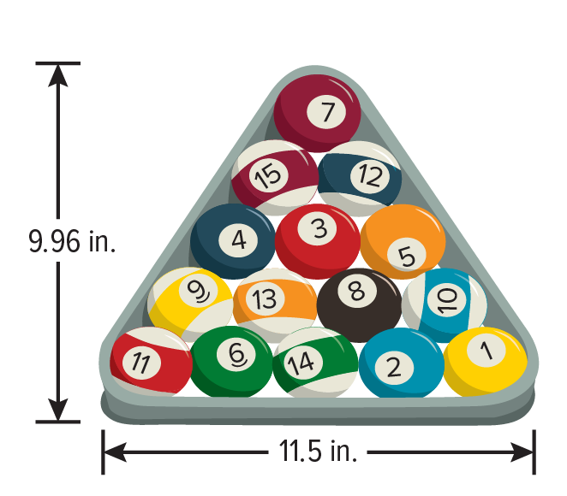
12. POOL Eight-ball pool is a popular game played on a pool table that has six pockets. In eight-ball pool, there are 7 striped balls, 7 solid-colored balls, and a black eight ball. At the beginning of each game, players position the 15 balls in a rack in preparation for the first shot.
a. Find the area contained by the rack using an appropriate two-dimensional model. Round the answer to the nearest tenth of a square inch.
b. Approximate the area covered by a single ball to the nearest tenth of a square inch.

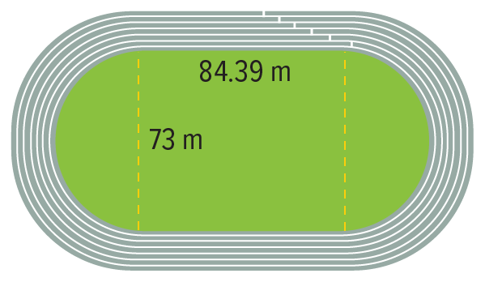
13. TRACK A 400-meter Olympic-size track can be modeled with a rectangle and two semicircles.
a. If an athlete runs around the track once, then how far has the athlete traveled to the nearest meter?
b. What assumption can be used to explain the difference between your answer in part a and the actual length around the track?
c. Each lane is 1.22 meters wide. If the athlete runs in the center of the inside lane, then how far has she traveled after a single lap to the nearest meter?
d. How far inside the track should the athlete be positioned to run exactly 400 meters? Round the answer to the nearest centimeter.

Mixed Exercises
Identify the figure with the given vertices. Find the perimeter and area of the figure.
14. A(3, 5), B(3, 1), C(0, 1) 15. Q(–3, 2), R(1, 2), S(1, –4), T(–3, –4)

16. G(−4, 1), H(4, 1), I(0, −2) 17. K(–1, 1), L(3, 4), M(6, 0), N(2, –3)

18. Rectangle WXYZ has a length that is 5 more than three times its width.
a. Draw and label a figure for rectangle WXYZ.

b. Write an algebraic expression for the perimeter of the rectangle.

c. Find the width if the perimeter is 58 millimeters. Explain how you can check that your answer is correct.

d. Use a ruler to draw and label $\overline{PQ}$, which is congruent to the segment representing the length of rectangle WXYZ. What is the measure of $\overline{PQ}$?

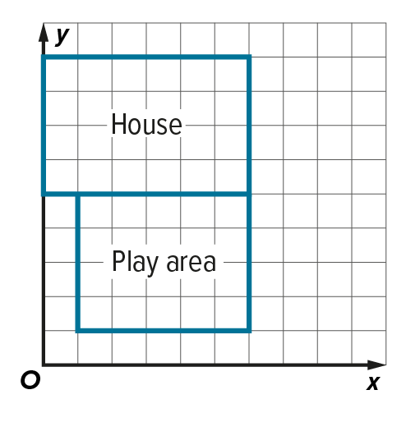
19. FENCING The figure shows Derek’s house and his backyard on coordinate grid. Derek is planning to fence in the play area in his backyard. Part of the play area is enclosed by the house and does not need to be fenced. Each unit on the coordinate grid represents 5 feet. The cost for the fencing materials and installation is $10 per foot. How much will it cost Derek to install the fence? Explain.

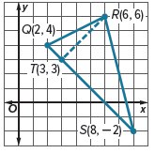
20. Explain a method to find the area of $△$QRS given that $\overline{RT}⊥\overline{QS}$. Then find the area. Show your work.

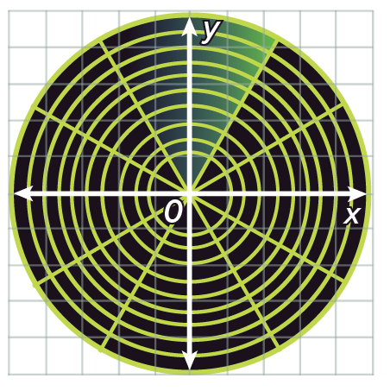
21. SONAR Sonar is used by oceanographers to locate marine animals and to map the contours of the ocean floor. Sonar sends out sound pulses, called pings, and receives the returning sound echo. Sonar uses the returning sound echo to detect the location of animals or the distance from a rock formation. If each unit on the coordinate grid measures 1 mile, then what area does the sonar system cover? Round to the nearest tenth.

22. Two vertices of square ABCD are C(5, 8) and D(2, 4).

a. Do you need to find the coordinates for the other two vertices to find the perimeter and area of the square? Justify your argument.

b. Find the perimeter and area of square ABCD. Show your work.

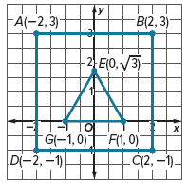
23. The coordinate grid shows an equilateral triangle that fits inside a square.

a. Find the area of the square. Show your work.

b. Find the area of the triangle. Show your work.

c. Find the area of the square that is not covered by the triangle. Write an exact value and then round to the nearest tenth. Justify your reasoning.

24. PERSEVERE The floor plan of a rectangular room has the coordinates (0, 12.5), (20, 12.5), (20, 0), and (0, 0) when it is placed on the coordinate plane. Each unit on the coordinate plane measures
1 foot. How many square tiles will it take to cover the floor of the room if the tiles have a side length of 5 inches? Explain.

25. PERSEVERE The vertices of a rectangle with side lengths of 10 and 24 units are on a circle of
radius 13 units. Find the area between the figures.

26. WRITE Give an example of a polygon that is equiangular but not a regular polygon. Explain your
reasoning.

27. ANALYZE Find the perimeter of equilateral triangle KLM given the vertices K(–2, 1) and M(10, 6). Explain your reasoning.

