Transformations in the Plane ⸱ Practice

Examples 1 and 2
Identify the type of rigid motion shown as a reflection, translation, or rotation.
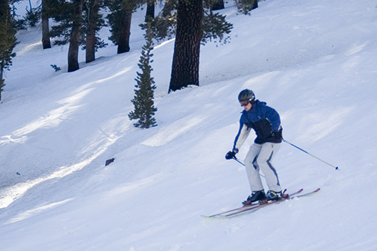
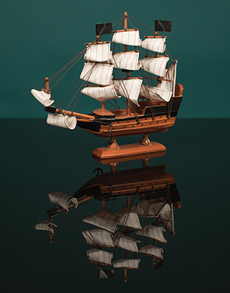
1. 2.

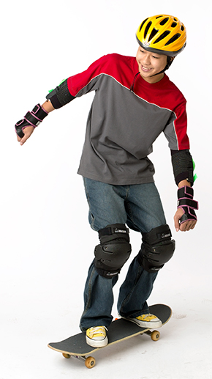
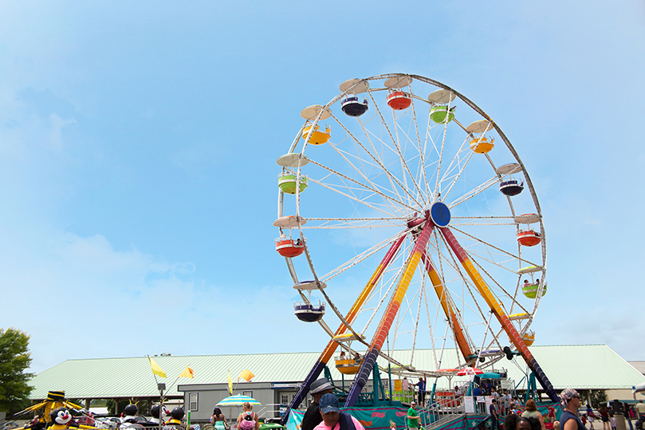
3. 4.

5. 6.
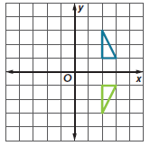
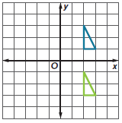

7. 8.
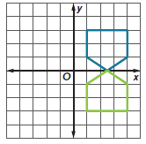
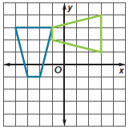

Examples 3–5
Triangle ABC has coordinates A(2, 0), B(–1, 5), and C(4, 3). Determine the coordinates of the vertices of the image after each transformation.
9. reflection in x-axis 10. reflection in y-axis

11. translation along the vector ⟨0, 2⟩ 12. translation along the vector ⟨3, –4⟩

13. rotation 180° about the origin 14. rotation 90° counterclockwise about the origin

Triangle DEF has coordinates D(4, –1), E(5, 2), and F(1, 2). Determine the coordinates of the vertices of the image after each transformation.
15. reflection in x-axis

16. reflection in y-axis

17. translation along the vector ⟨1, 0⟩

18. translation along the vector ⟨–3, 1⟩

19. rotation 180° about the origin

20. rotation 270° counterclockwise about the origin

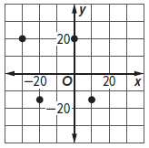
21. AIR SHOW At a flight demonstration, two planes are flying in a synchronized pattern. The planes start their demonstration at (20, –15) and (5, –15). Describe the transformation that represents the planes’ flight pattern to their final destinations at (–30, 20) and (0, 20).

Mixed Exercises
22. OFFICE Francesca draws a plan of her office before she rearranges the furniture. She decides to reflect the entire room over a vertical line through the center of the drawing of the room.
Which is the reflected plan?

A. B. C.
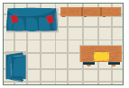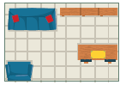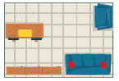
23. BASKETBALL James spins a basketball on his finger and then passes the ball to his friend.
a. What type of transformation is used when James spins the basketball on his finger?

b. What type of transformation is used to pass the basketball?

24. COMBINATION LOCKS Benicio locks his safe by setting each of the three dials to 8. To unlock the safe, he turns the left lock 90° counterclockwise, the middle lock 270° clockwise, and the right lock 180° counterclockwise. What three numbers, in order, unlock the safe?
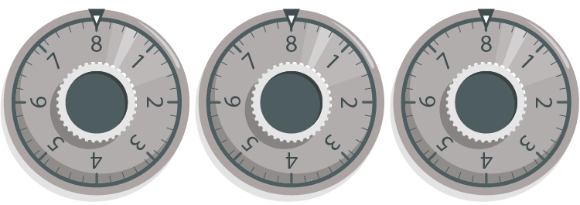

25. BEEKEEPING A beekeeper uses a frame of partial honeycomb cells that bees fill with honey and complete with wax. When the honey is ready for harvest, the beekeeper turns the tap allowing the honey to flow out of the hive without disturbing the bees. By what transformation are the sides of the partial honeycomb cells related when the tap is closed? when the tap is open?

Find the coordinates of the figure with the given coordinates after the transformation on the plane. Then graph the preimage and image.

26. preimage: J(−3, 0), K(−2, 4), L(−1, 0), image: triangle QRS, translation of JKL along vector ⟨5, –4⟩

27. preimage: A(1, 3), B(1, 1), C(4, 1), image: triangle DEF, rotation of ABC 270$°$ counterclockwise about the origin

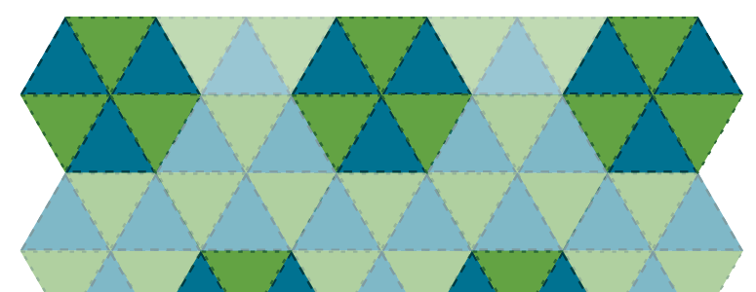
28. FIND THE ERROR Saurabh and Elena visit a craft fair and notice a quilt with a pattern. Saurabh claims the pattern is made using translations. Elena believes that the pattern is made using rotations. Who is correct? Justify your argument.

29. The vertices of △ABC are A(–1, 1), B(4, 2), and C(1, 5). The vertices of △DEF are
D(–1, –1), E(4, –2), and F(1, –5) such that △ABC ≅ △DEF. Identify the congruence transformation.

30. STRUCTURE $\overline{XY}$ has endpoints X(–5, 6) and Y(0, 4), the image of $\overline{XY}$ has the endpoints X'(6, 5), Y'(4, 0), and $\overline{XY}$ ≅ $\overline{X'Y'}$. Identify the transformation.

31. STRUCTURE The vertices of quadrilateral FGHJ are F(2, –3), G(–2, –5), H(–3, 6), and J(3, 5). The vertices of quadrilateral KLMN are K(5, –5), L(1, –7), M(0, 4), and N(6, 3) such that FGHJ ≅ KLMN. If quadrilateral FGHJ is the preimage and quadrilateral KLMN is the image, identify the transformation.

32. ANALYZE The image of ABC reflected in the y-axis is A′B′C′.

a. Describe the result of reflecting A′B′C′ in the y-axis. Explain.

b. Describe the result of reflecting A′B′C′ in the x-axis. Explain.

33. FIND THE ERROR Antwan and Diamond are finding the coordinates of the image of P(2, 3) after a reflection in the x-axis. Is either of them correct? Explain your reasoning.


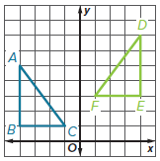
34. WRITE In the diagram, DEF is called a glide reflection of ABC. Based on the diagram, define a glide reflection. Explain your reasoning.

35. CREATE Draw a polygon on the coordinate plane that when reflected in the y-axis looks exactly like the original figure.

36. ANALYZE Is the reflection of a figure in the x-axis equivalent to the rotation of that same figure 180$°$ about the origin? Explain.

