Two-Dimensional Representations of Three-Dimensional Figures ⸱ Practice

Example 1
Make a model of a figure for each orthographic drawing.
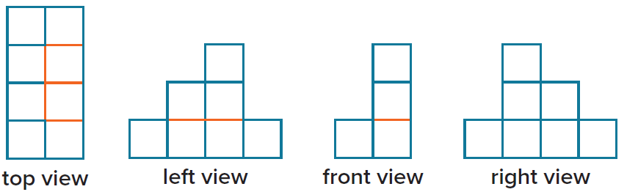
1.

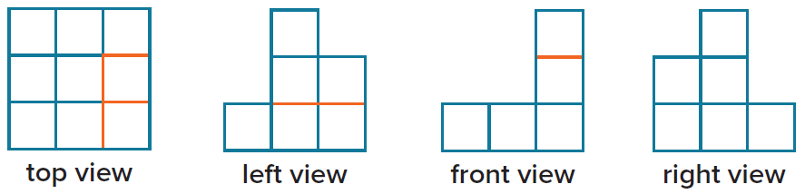
2.

Example 2
Make an orthographic drawing of each figure.
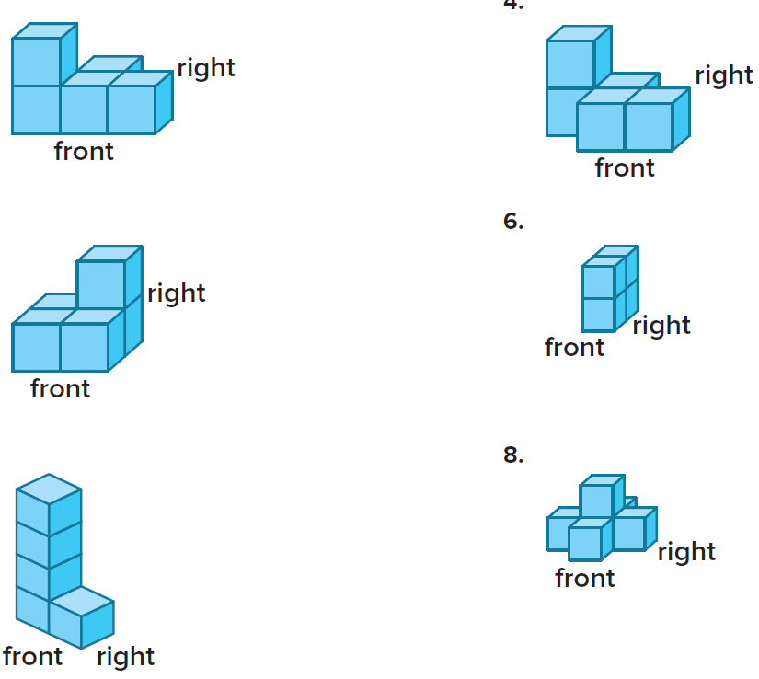

3. 4.



5. 6.



7. 8.

Example 3
Make a model of the solid that is represented by each net. Then identify the solid and find its surface area.
9. 10.
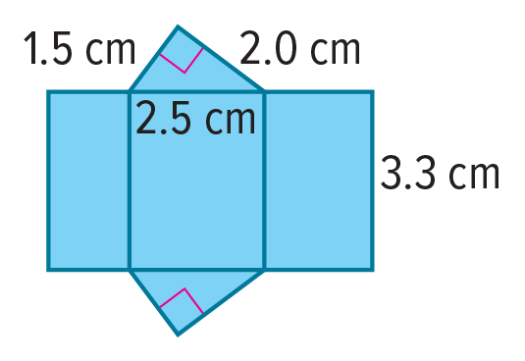
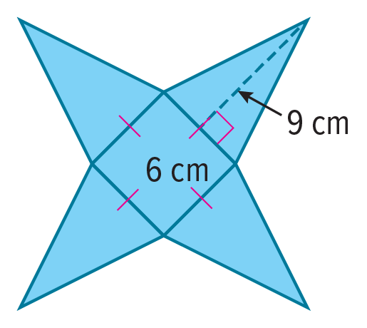

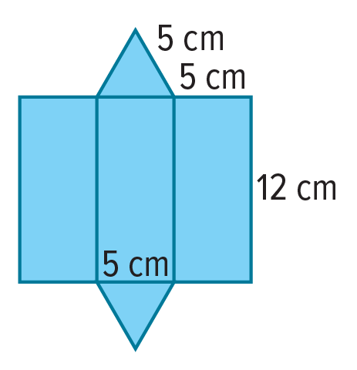
11. 12.

Example 4
Identify the Platonic solid that is represented by the net.
13. 14.

15. 16.

Examples 5 and 6
Draw a net for each solid or object.
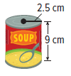
17. 18.

Draw a net for each solid or object.
19. 20.
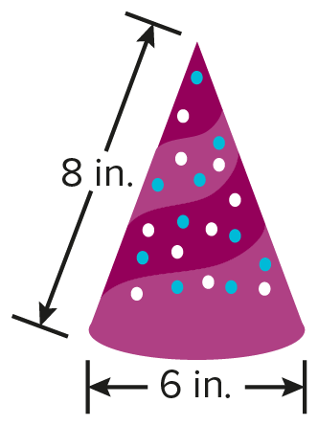
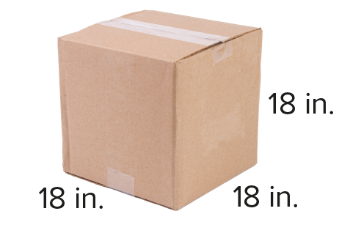

21. 22.
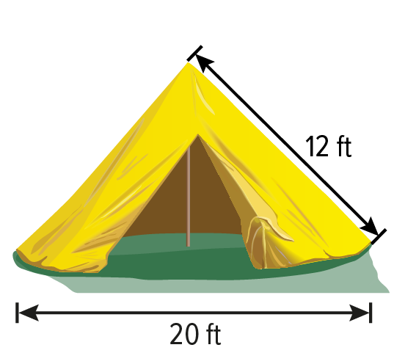
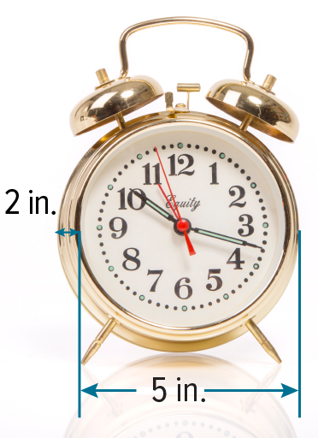

Mixed Exercises
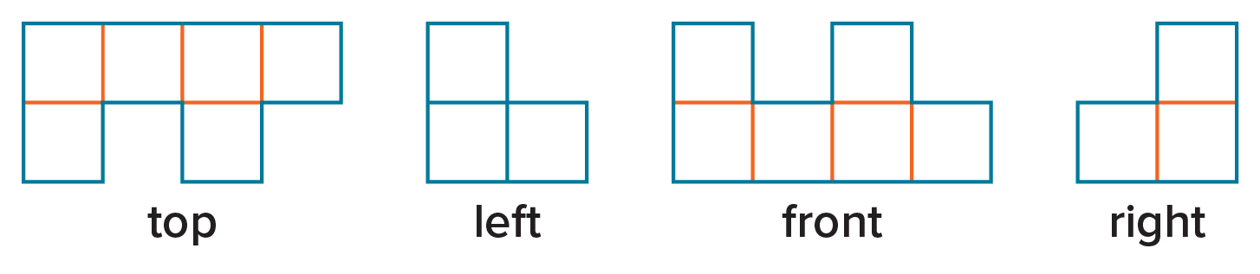
23. GAMING Candela is playing a game that has game pieces. Use the orthographic drawing to make a model of the game piece.

24. FURNITURE Make an orthographic drawing to show the top, front, left, and right views of the storage cabinet.


25. MODELING Identify a real-world object that can be represented by the net shown.

26. GIFT WRAP Olive is wrapping a gift for her sister in a box that has the net shown here. How many square inches of wrapping paper will it take to cover the box?

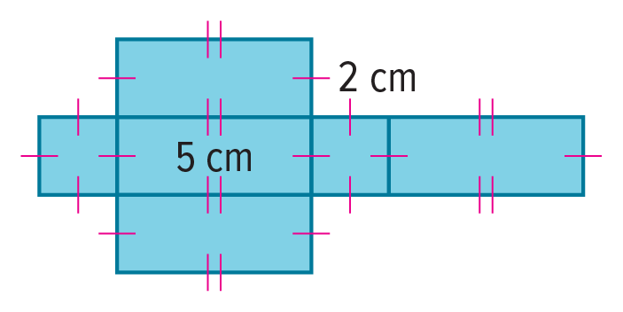
27. ANALYZE Julia knows that a figure has a surface area of 40 square centimeters. The net shown has 5-centimeters and 2-cenitmeters edges. Could the net represent the figure? Justify your argument.

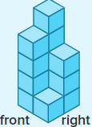
28. WHICH ONE DOESN’T BELONG The model represents a building. Which orthographic drawing does not belong? Justify your conclusion.

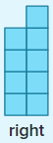
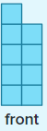
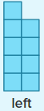

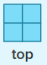

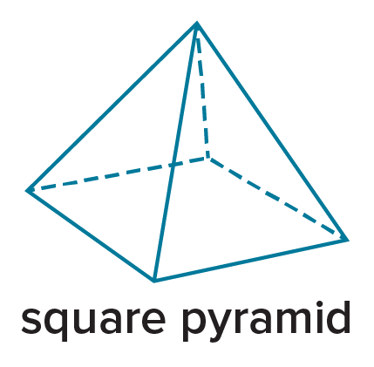
29. FIND THE ERROR Julian and Caleb were planning to make a square pyramid like the one shown. They both decided to make a net of the square pyramid as a plan for how to build it. Who has the correct plan? Explain your reasoning.
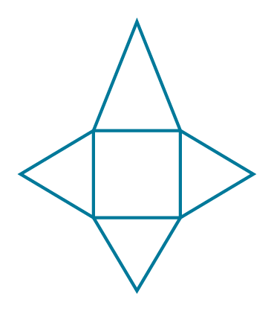


30. CREATE Adriana works for a company called Boxes R Us making different sizes and shapes of boxes for packages. Adriana’s boss wants her to sketch nets of one of the boxes. Sketch a possible net that Adriana could have drawn.

31. WRITE Describe the similarities and differences in orthographic drawings and nets.

32. PERSEVERE How many Platonic solids are there? Give a description of each solid that includes the number of two-dimensional shapes that meet at each vertex, number of faces, number of vertices, and number of edges.

