Precision and Accuracy ⸱ Practice

Example 1

1. PRECISION A manufacturer claims that its rice cakes are packaged with 20 in each package. A sample of 12 packages is counted for accuracy. The sample yields a count of {18, 17, 17, 17, 18, 18, 18, 17, 18, 17, 18, 17} rice cakes. How accurate and precise is the manufacturer’s claim? Explain your reasoning.

Example 2
2. SCALES A 10-pound weight is weighed on two different scales. Find the approximate error of each weight.
a. digital bathroom scale: 9.59 pounds

b. food scale: 10.09 pounds

3. PHYSICS A circuit has amperage of 0.01 milliamp. A multimeter measures the amperage of the circuit at 0.06 milliamp. What is the approximate error?

4. CARPENTRY A door frame is 2.13 meters high. Chandra measures the height of the door frame with a carpenter’s rule. She measures 2.22 meters. What is the approximate error of the height?

5. COOKING Water boils at 212.0°F. Jeremiah uses a kitchen thermometer to measure the temperature of a pot of boiling water. The thermometer measures 213.1°F. What is the approximate error of the temperature?

Example 3
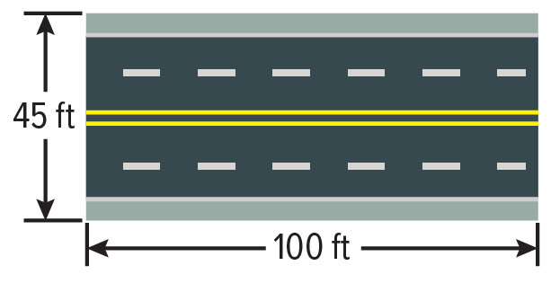
6. CONSTRUCTION The public works department is repaving some of the roads in the city. The materials needed to repave this section of the road cost $2.50 per square foot.

a. What is the possible range for the area of the road?

b. What is the possible range for the cost, c, of the materials needed to repave this section of the road?

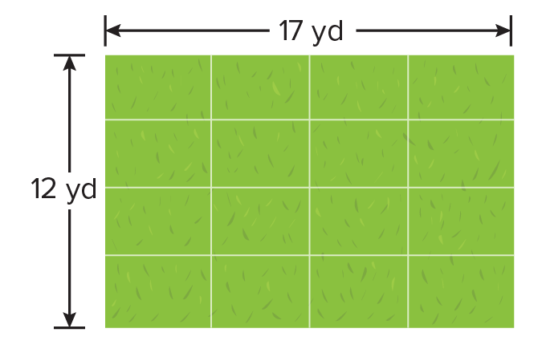
7. GRASS SEED George is buying grass seed for his lawn. Grass seed is sold at $0.40 per square yard.

a. What is the least value for the length of the lawn?

b. What is the greatest value for the width of the lawn?

c. What is the possible range for the area of the lawn?

d. What is the possible range for the cost of the grass seed?

Mixed Exercises
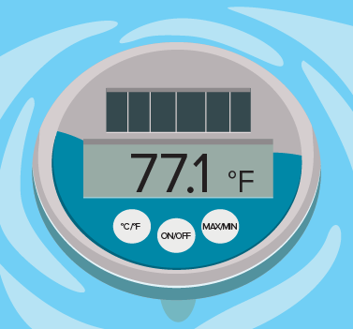
8. THERMOMETER The thermostat on a heated pool is set at 76.5°F.
A thermometer in the pool is shown. What is the approximate error
of the temperature?

9. SANDWICHES A sandwich shop claims to sell foot-long sandwiches. Xiao uses a ruler to measure her sandwich. The ruler measures 11 inches. What is the approximate error of the length?

10. SPEED A police officer uses a radar detector to measure the speed of Roya’s car. Roya’s speedometer reads 55 miles per hour. The radar detector measures her speed at 56.71 miles per hour. What is the approximate error of the speed?

11. BICYCLES An assembly line supervisor weighs three 25-pound bicycle frames on a scale. Find the approximate error of each weight.

a. Bicycle A: 25.11 pounds

b. Bicycle B: 24.99 pounds

c. Bicycle C: 24.36 pounds

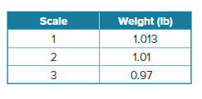
12. DELI Josephina works at a deli. She is testing the scales at the deli to make sure they are accurate. She uses a weight that is exactly 1 pound and gets the following results shown in the table. Which scale is the most accurate?

13. GARDEN Mr. Granger wants to spread fertilizer on his vegetable garden that has dimensions 41.5 feet by 30.8 feet. The fertilizer he chose costs $0.75 per square foot for adequate coverage. What is the possible range for the cost of the fertilizer that is needed to cover the vegetable garden?
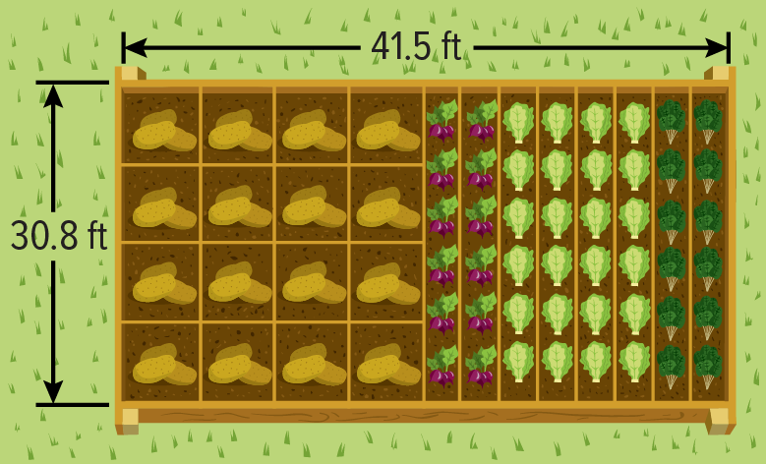

14. HEIGHT Lucas was proud of how much he had grown over the last six months since his grandma had seen him last. He told her he was 6 feet 3 inches. His grandma didn’t believe him, so she measured him again, and he was actually 6 feet 1 inch. What is the approximate error of Lucas’ height?

15. PAINT You measure a wall of your room as 8 feet high and 12 feet wide. You want to apply wallpaper to only this wall. The wallpaper is expensive and will cost $1.25 per square foot. What is the possible range for the cost of the wallpaper?

16. Four measurements were taken three different times. The correct measurement is 52.4 cm. Determine whether the set of measurements is accurate, precise, both, or neither. Explain your reasoning.

a. 56.1 cm, 48.9 cm, 24.2 cm, 5 cm

b. 73.1 cm, 74.0 cm, 73.5 cm, 73.7 cm

c. 52.6 cm, 52.5 cm, 52.2 cm, 52.3 cm

17. WRITE Many people confuse the definitions of accuracy and precision. What is the difference between accuracy and precision? Give an example of a set of four numbers that represents accurate and precise measurements for a cut of meat at a steakhouse that advertises a 16-ounce ribeye steak special on Tuesday nights.

18. WRITE Isabel says that if a set of measurements is accurate, they are also precise. If you agree, explain your reasoning. If you disagree, provide a counterexample.

19. PERSEVERE Jayden measures and labels the dimensions of a box.

a. Calculate the areas of the faces of the box.

b. Determine the surface area of the box.

c. Determine the range of values that should contain the actual (true) measure of the surface area of the box. Explain your reasoning.

d. Suppose the Jayden had incorrectly measured the first dimension as 15.1 inches. Find the surface area of the box using this measure.

20. CREATE A manufacturer claims that its bags of sweetener contain 9.7 ounces in each bag. Create a sample of weights of 10 bags of sweetener so that the sample is precise and accurate. Explain your reasoning.

