Representing Measurements ⸱ Practice

Example 1
Determine the number of significant digits in each measurement.
1. 54.023 2. 0.923 3. 0.30

4. 100.58 5. 0.0002 6. 101.01

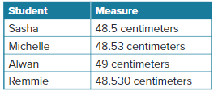
7. ACADEMICS The students in Miss Li’s class are measuring the height of a chalkboard. Miss Li asked the students to write the measurement with 4 significant digits. Which student correctly followed her instructions?

Example 2
Find the possible range for each length of the segment using the correct number of significant figures.
8. 9.
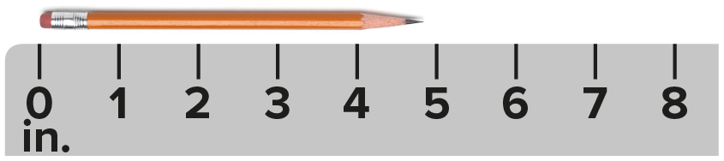
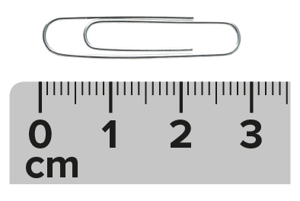
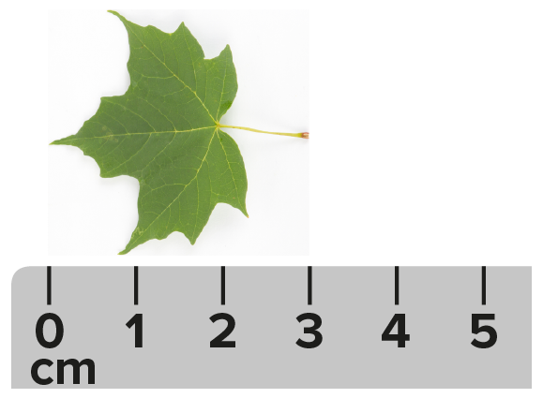

10. 11.
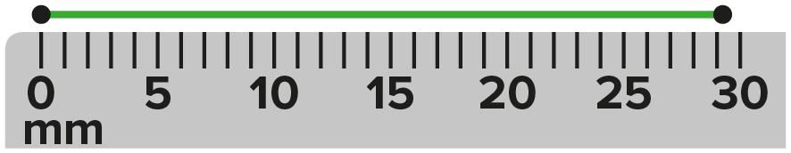

12. 13.

Example 3
The base of a triangle is fixed at 2.218 millimeters. Determine the number of significant figures of the area of the triangle with each given height.
14. 1.86 mm 15. 0.099 mm

16. 0.1279 mm 17. 2.109 mm

18. 11.0 mm 19. 1.7 mm

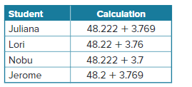
20. Using significant figures, which of the following students wrote a calculation that could have a sum or difference of 51.9?

Example 4
21. CHEMISTRY Angel has 8.341 mL of saline. She pours 1.1 mL of saline into another solution. How much saline does Angel have left? Round your measurement to the correct number of significant figures.

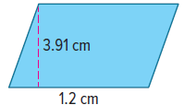
22. A parallelogram with base b and height h has area, A, given by the formula A = bh. Find the area of the given parallelogram. Round your measurement to the correct number of significant figures.

23. AREA Find the area of a triangle with a height of 4.90 centimeters and a base length of 6.174 centimeters. Round your measurement to the correct number of significant figures.
24. DIMENSIONS Rafael is building a horseshoe pit in his backyard. The width of the pit is
29.71 inches, and the length is 30.1 inches.
a. Estimate the area of Rafael’s horseshoe pit.
b. Rafael finds the exact area of the horseshoe pit and rounds his answer to the correct number of significant figures. What area did Rafael find?

Example 5
25. AREA The radius of a circle has the measurement shown. What is the possible range for the area of the circle? Round to the correct number of significant figures.
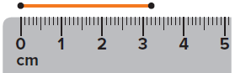

26. CIRCUMFERENCE The radius of a circle has the measurement shown. What is the possible range for the circumference of the circle? Round to the correct number of significant figures.

Mixed Exercises
Determine the number of significant digits in each measurement.
27. 53.74 28. 0.03298 29. 10.500

30. 6,102.0 31. 7,109,100 32. 0.110

33. CHEMISTRY A beaker contains a sample of NaCl weighing 49.8767 grams. If the empty beaker weighs 49.214 grams, what is the weight of the NaCl? Round to the correct number of significant figures.

34. COOKING Jordan makes a sandwich on a paper plate weighing 32.47 grams. The bread weighs 60.13 grams. Jordan adds 12.3 grams of turkey, 2.4 grams of mayonnaise, and 3.0 grams of lettuce. What is the final weight of the plate and sandwich?

35. CHEMISTRY Three chemists weigh an item using different scales. The values they report are shown on the scales. How many significant figures should be used for each measurement?

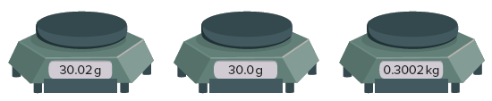

36. SWIMMING POOL A rectangular swimming pool measures 24.2 feet by 76 feet.
- Find the perimeter of the pool. Round to the correct number of significant figures.

- Find the area of the pool. Round to the correct number of significant figures.

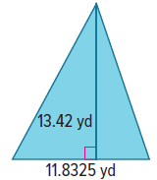
37. AREA Find the area of the given triangle. Round your measure to the correct number of significant figures.

38. MURAL Krista is painting a rectangular wall that has an area of 247 square feet. If she can paint 5.25 square feet in an hour, about how long will it take for Krista to finish the mural on her own? Round to the correct number of significant figures.

39. MASS Suppose that you measured the volume of a rock to be 2.3 cm³ and you know the density to be 3.6 g/cm³. What is the mass of the rock? Round your measure to the correct number of significant figures.

40. DRIVING Keandra is taking a trip to visit her extended family and make a stop somewhere during her trip. The distance between Cincinnati, where Keandra started, and Dayton, where Keandra made the stop is 54 miles. The distance between Dayton and Toledo, where Keandra’s family lives is 150.2 miles. How far did Keandra travel on her trip? Round to the correct number of significant figures.

41. VOLUME A rectangular box has a length of 10.876 inches, a width of 4.34 inches, and a height of 13.22 inches. What is the volume of the rectangular prism? Round to the correct number of significant figures.

42. TRAVEL You estimate that your car gets 28 miles per gallon. The cost of gas per gallon is shown. How much does it cost you to travel 455 miles? Round to the correct number of significant figures.

43. FIND THE ERROR A student found that the dimensions of a rectangle were 1.40 centimeters and 1.60 centimeters. She was asked to report the area using the correct number of significant figures. She reported the area as 2.2 square centimeters. What error did the student make? Explain your reasoning.

44. PERSEVERE The Sun is an excellent source of electrical energy. A field of solar panels yields 19.23 Watts per square foot. Determine the amount of electricity produced by a field of solar panels that is 410 feet by 201$\frac{1}{3}$ yards.

45. WRITE When explaining the process of finding the perimeter of a triangle using significant digits, Trinidad claimed that 0.045 inch and 0.0045 inch have the same number of significant figures. Is she correct? Explain your answer.

46. WRITE How do you use significant figures to determine how to report a sum or product of
two measures?

47. ANALYZE Determine whether the following statement is sometimes, always, or never true. Justify your argument.
Zeros are significant figures.

48. CREATE The swim team measures time to the hundredth of a second. Amanda’s time was slower than Jocelyn’s time in the 100-meter freestyle. What are possible times for Amanda and Jocelyn if each has times with 4 significant digits?

