Writing Proofs ⸱ Practice

Example 1
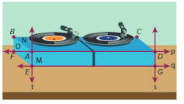
MUSIC Explain how the figure illustrates that each statement is true. Then state the postulate that can be used to show that each statement is true.
- Planes O and M intersect in line t.

- Line p lies in plane N.

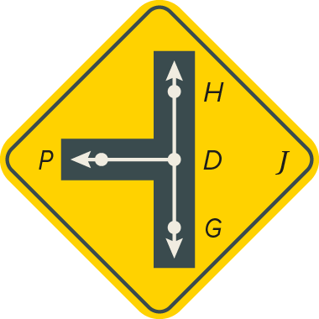
SIGNS In the figure, $\overset{⃡}{DG}$ and $\vec{DP}$ is in plane J and H lies on $\overset{⃡}{DG}$. State the postulate that can be used to show that each statement is true.
3. Points G and P are collinear.

4. Points D, H, and P are coplanar.

Example 2
CONSTRUCT ARGUMENTS Determine whether each statement is always, sometimes, or never true. Justify your argument.
5. There is exactly one plane that contains noncollinear points A, B, and C.

6. There are at least three lines through points J and K.

7. If points M, N, and P lie in plane X then they are collinear.

8. Points X and Y are in plane Z. Any point collinear with points X and Y are in plane Z.

9. The intersection of two planes can be a point.

10. Points A, B, and C determine a plane.

Example 3
11. PROOF Point Y is the midpoint of $\overline{XZ}$. Point W is collinear with X, Y, and Z. Z is the midpoint of $\overline{YW}$. Write a two-column proof to prove that $\overline{XY}≅\overline{ZW}$.

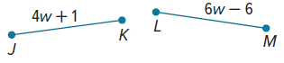
12. PROOF Write a two-column proof to prove that w = 3.5.

Given: $\overline{JK}≅\overline{LM}$
Prove: w = 3.5

13. PROOF Complete the two-column proof.
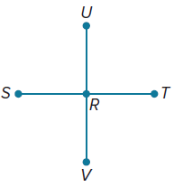
Given: SR = RT, SR = UR, and RT = RV
Prove: R is the midpoint of $\overline{ST}$. R is the midpoint of $\overline{UV}$.
Proof:
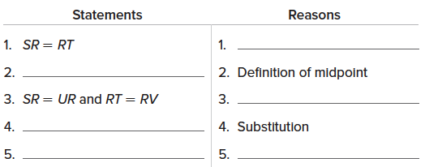

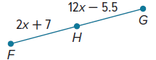
14. PROOF Complete the two-column proof to prove that x = 1.25.

Given: H is the midpoint of $\overline{FG}$.
Prove: x = 1.25
Proof:
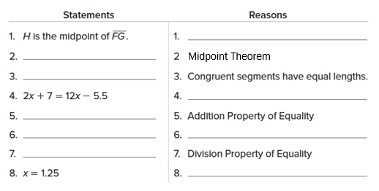
Example 4
15. PROOF Point L is the midpoint of $\overline{JK}$. $\overline{JK}$ intersects $\overline{MK}$ at K. If $\overline{MK}≅\overline{JL}$, write a flow proof to prove that $\overline{LK}≅\overline{MK}$.

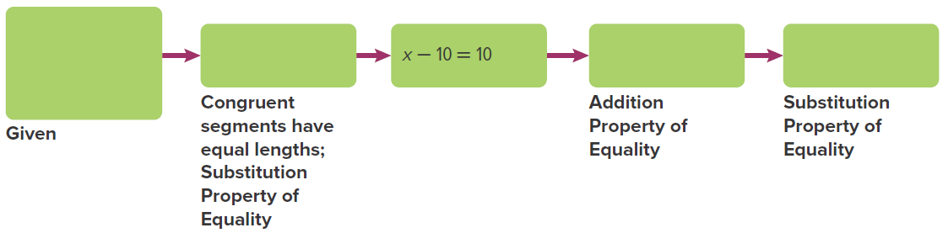
16. PROOF Complete the flow proof to prove that if $\overline{MN}≅\overline{PQ}$, MN = 5x – 10, and PQ = 4x + 10, then MN = 90.

Example 5

17. PROOF In the figure at the right, point B is the midpoint of $\overline{AC}$ and point C is the midpoint of $\overline{BD}$. Write a paragraph proof to prove that AB = CD.

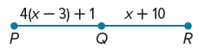
18. PROOF Write a paragraph proof to prove that if PQ = 4(x – 3) + 1, QR = x + 10, and x = 7, then $\overline{PQ}≅\overline{QR}$.

Mixed Exercises
19. What postulate can be used to show the following statement is true?
Line m contains points A and F.

20. ROOFING Fai and Max are building a new roof. They wanted a roof with two sloping planes that intersect in a curved arch. Is this possible?

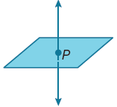
21. Carson claims that a line can intersect a plane at only one point, and he draws this picture to show his reasoning. Iza thinks it is possible for a line to intersect a plane at more than one point. Who is correct? Explain.

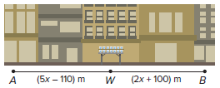
22. REASONING The figure shows a straight portion of the course for a city marathon. The water station W is located at the midpoint of $\overline{AB}$.

a. What is the length of the course from point A to point W?

b. Write a paragraph proof for your answer to part a.

c. Explain how you used a definition in your paragraph proof.

23. AIRLINES An airline company wants to provide service to San Francisco, Los Angeles, Chicago, Dallas, Washington D.C., and New York City. The company’s president draws lines between each pair of cities in the list on a map. No three of the cities are collinear. How many lines
did the president draw?

24. SMALL BUSINESSES A small company has 16 employees. The owner placed 16 points on a sheet of paper in such a way that no 3 were collinear. Each point represented a different employee. He then connected two points with a line segment if they represented coworkers in the same department.
a. What is the maximum number of line segments that can be drawn between pairs among the 16 points?
b. When the owner finished the diagram, he found that his company was split into two groups, one with 10 people and the other with 6. All the people within a group were in the same department, but nobody from one group was from the other group. How many line segments were there?

25. FIND THE ERROR Omair and Ana were working on a paragraph proof to prove that if $\overline{AB}$ is congruent to $\overline{BD}$ and A, B, and D are collinear, then B is the midpoint of $\overline{AD}$. Each student started his or her proof in a different way. Is either of them correct? Explain your reasoning.
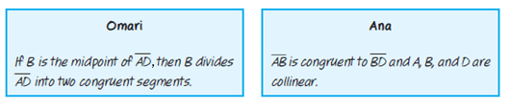

26. CREATE Draw a figure that satisfies five of the seven postulates you have learned. Explain which postulates you chose and how your figure satisfies each postulate.

27. PERSEVERE Use the following true statements and the definitions and postulates you have learned to answer
each question.
Two planes are perpendicular if and only if one plane contains a line perpendicular to the second plane.
a. Through a given point, there passes one and only one plane perpendicular to a given line. If plane Q is perpendicular to line $l$ at point X and line $l$ lies in plane P, what must also
be true?
b. Through a given point, there passes one and only one line perpendicular to a given plane.
If plane Q is perpendicular to plane P at point X and line a lies in plane Q, what must also
be true?

28. WRITE How does writing a proof require logical thinking?

ANALYZE Determine if each statement is sometimes, always, or never true. Justify your argument.

29. Through any three points, there is exactly one plane.

30. A plane contains at least two distinct lines.

