Proving Segment Relationships ⸱ Practice
Example 1
1. PROOF Write the correct statements and reasons to complete the two-column proof.
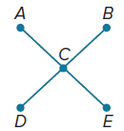
Given: C is the midpoint of $\overline{AE}$.
C is the midpoint of $\overline{BD}$.
$\overline{AE}$ ≅ $\overline{BD}$
Prove: $\overline{AC}$ ≅ $\overline{CD}$
Proof:

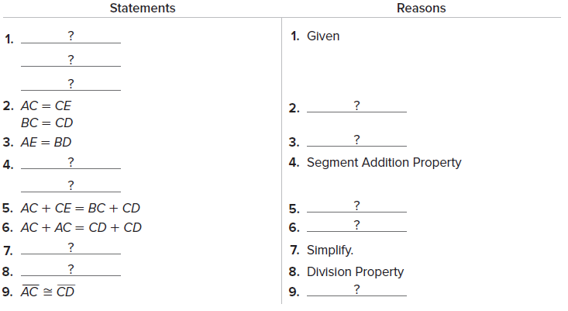

2. PROOF Write the correct statements and reasons to complete the two-column proof.
Given: $\overline{SU}$ ≅ $\overline{LR}$
$\overline{TU}$ ≅ $\overline{LN}$
Prove: $\overline{ST}$ ≅ $\overline{NR}$
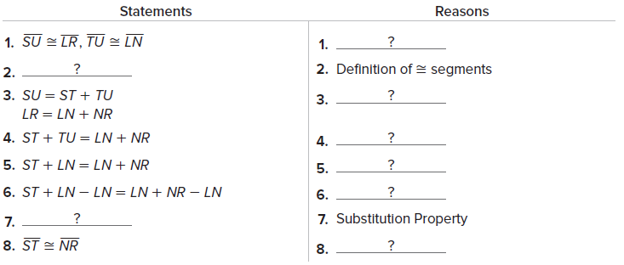
Proof:

Example 2
PROOF Write a two-column proof to prove each geometric relationship.
3. If $\overline{VZ}≅\overline{VY}$ and $\overline{WY}≅\overline{XZ}$, 4. If E is the midpoint of $\overline{DF}$ and
then $\overline{VW}≅\overline{VX}$. $\overline{CD}≅\overline{FG}$, then $\overline{CE}≅\overline{EG}$.

Example 3
5. FAMILY Maria is 11 inches shorter than her sister Clara. Luna is 11 inches shorter than her brother Chad. If Maria is shorter than Luna, how do the heights of Clara and Chad compare? What else can be concluded if Maria and Luna are the same height?

6. LUMBER Byron works in a lumberyard. His boss just cut a dozen planks and asked Byron to double check that they are all the same length. The planks were numbered 1 through 12. Byron took out plank number 1 and checked that the other planks are all the same length as plank 1. He concluded that they must all be the same length. Explain how you know that plank 7 and plank 10 are the same length even though they were never directly compared to each other.

7. NEIGHBORHOODS Karla, Lola, and Mandy live in three houses that are on the same line. Lola lives between Karla and Mandy. Karla and Mandy live a mile apart. Is it possible for Lola’s house to be a mile from both Karla’s and Mandy’s houses?

Mixed Exercises
8. PROOF Five lights, A, B, C, D, and E, are aligned in a row. The middle light is the midpoint of the segment between the second and fourth lights and also the midpoint of the segment between the first and last lights.
a. Draw a figure to illustrate the situation.
b. Complete this proof.
Given: C is the midpoint of $\overline{BD}$ and $\overline{AE}$.
Prove: AB = DE
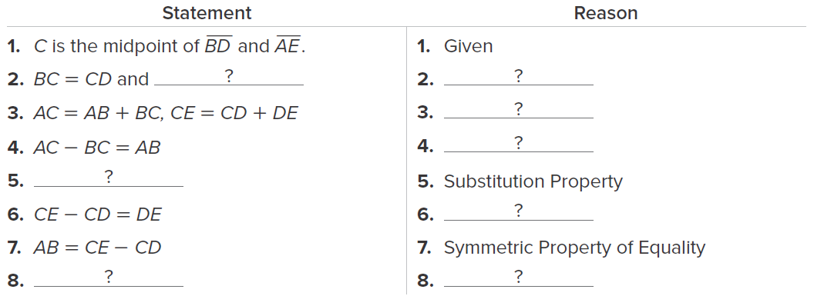

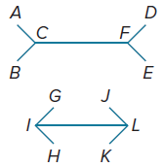
9. PROOF $\overline{AC}≅\overline{GI}$, $\overline{FE}≅\overline{LK}$, and AC + CF + FE = GI + IL + LK. Prove that $\overline{CF}≅\overline{IL}$.

10. PROOF Consider $\overset{⃡}{PS}$.
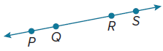
a. Complete the two-column proof.
Given: $\overline{PQ}≅\overline{RS}$
Prove: $\overline{PR}≅\overline{QS}$
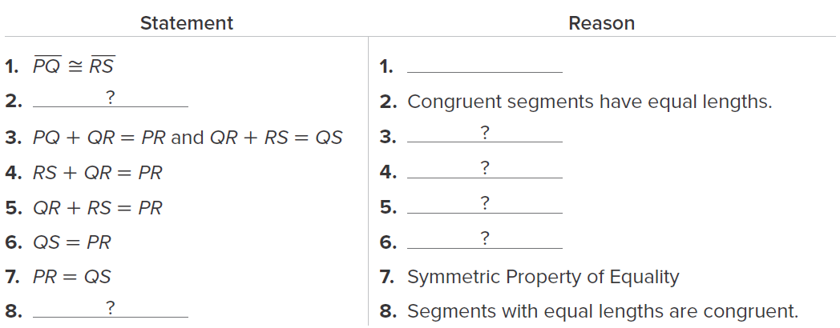

b. Can it also be proved that $\overline{PQ}≅\overline{RS}$ if $\overline{PR}≅\overline{QS}$? Explain.

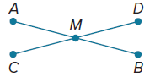
11. PROOF A city planner is designing a new park. The park has two straight paths, $\overline{AB}$ and $\overline{CD}$, which are the same length. A monument, M, is located at the midpoint of both paths.
a. The city planner thinks that the length of $\overline{AM}$ will be the same as the length of $\overline{CM}$. Explain why this makes sense.
b. Complete the two-column proof.
Given: $\overline{AB}≅\overline{CD}$; M is the midpoint of $\overline{AB}≅\overline{CD}$.
Prove: $\overline{AM}≅\overline{CM}$

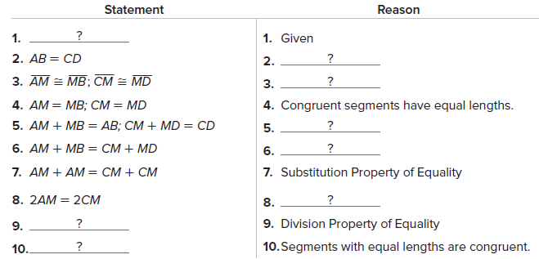

12. PROOF Write a paragraph proof for each property of segment congruence.
a. Reflexive Property of Segment Congruence
Given: $\overline{XY}$
Prove: $\overline{XY}≅\overline{XY}$

b. Symmetric Property of Segment Congruence
Given: $\overline{AB}≅\overline{CD}$
Prove: $\overline{CD}≅\overline{AB}$

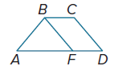
13. FIND THE ERROR In the diagram, $\overline{AB}≅\overline{CD}$ and $\overline{CD}≅\overline{BF}$. Examine the conclusions made by Leslie and Shantice. Is either of them correct? Explain your reasoning.

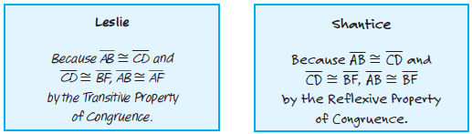

14. PROOF ABCD is a square. Proof that $\overline{AC}≅\overline{BD}$.

15. CREATE Draw a representation of the Segment Addition Postulate in which the segment is two inches long, contains four collinear points, and contains no congruent segments.

16. CREATE Write an example of the Transitive Property and the Substitution Property that illustrates the difference between them.
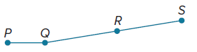
17. FIND THE ERROR Justin knows that point R is the midpoint of $\overline{QS}$, and he knows that this means QR = RS. He says that PR = PQ + QR by the Segment Addition Postulate. So, PR = PQ + RS by substitution. Do you agree with Justin’s reasoning? Explain your reasoning.

18. WRITE Compare and contrast paragraph proofs and two-column proofs.

19. PROOF Write a paragraph proof to prove that if P, Q, R, and S are collinear, $\overline{PQ}$ ≅ $\overline{RS}$, and Q is the midpoint of $\overline{PR}$, then R is the midpoint of $\overline{QS}$.

