Proving Angle Relationships ⸱ Practice

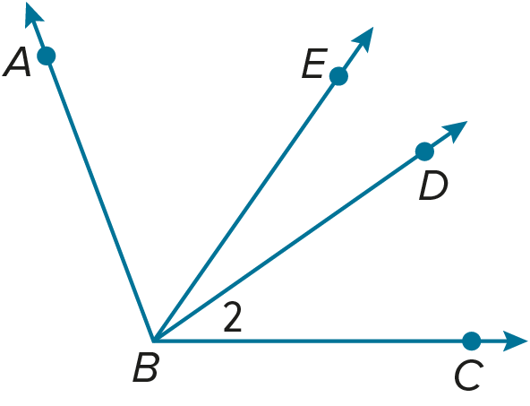
Example 1
Find the measure of each angle.
1. Find m∠ABC if m∠ABD = 70° and m∠DBC = 43°.

2. If m∠EBC = 55° and m∠EBD = 20°, find m∠2.

3. Find m∠ABD if m∠ABC = 110° and m∠2 = 36°.


Example 2
4. FLAGS The Alabama state flag is white and has two diagonal red stripes. If the $m∠1=112°$, what is $m∠2$?

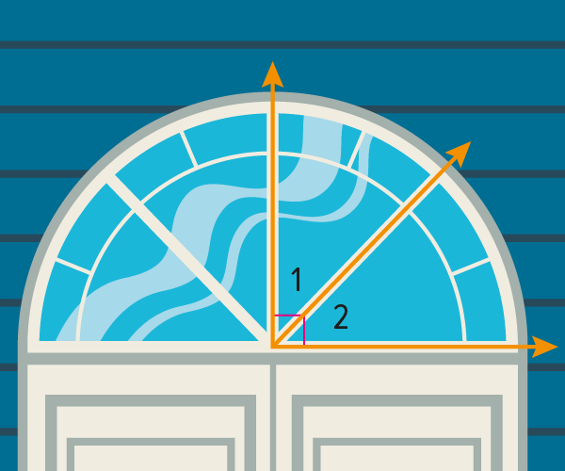
5. CONSTRUCTION Alan has installed a new window above the entrance of an office building. If $m∠2=44°$, what is $m∠1$?

Example 3
PROOF Write a two-column proof.

6. Given: $∠2≅∠4$
Prove: $∠1≅∠3$
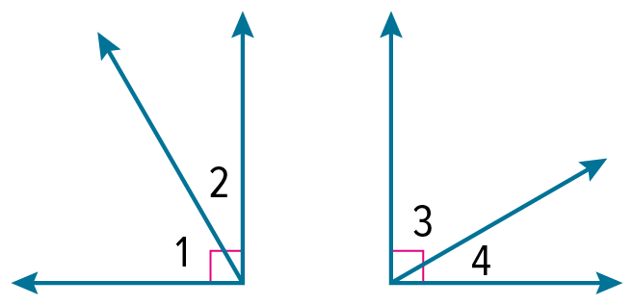
7. Given: $∠1≅∠3$
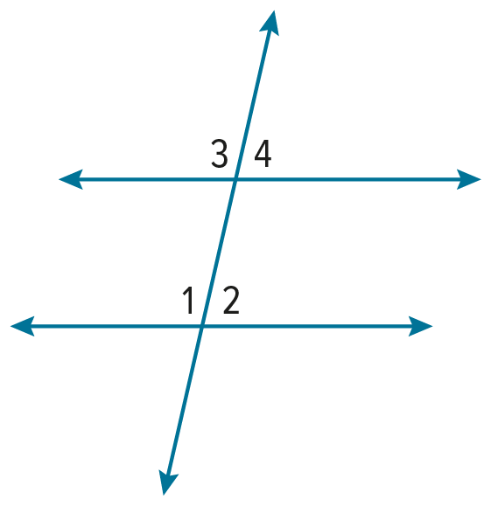
Prove: $∠2≅∠4$

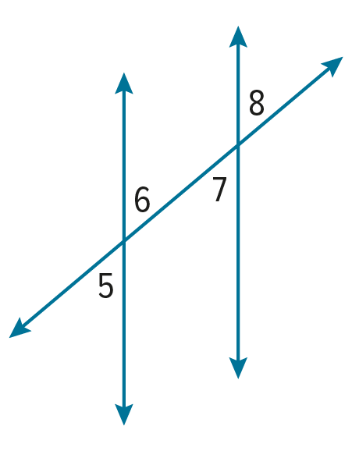
Example 4
PROOF Write a two-column proof.
8. Given: $∠5≅∠7$
Prove: $∠5≅∠8$

Example 5
PROOF Write a two-column proof.

9. Given: $m∠ABC=m∠DEF$
$∠ABC$ and $∠DEF$ are supplementary.
Prove: $∠ABC$ and $∠DEF$ are right angles.

10. Given: $∠1≅∠2;m⊥p$
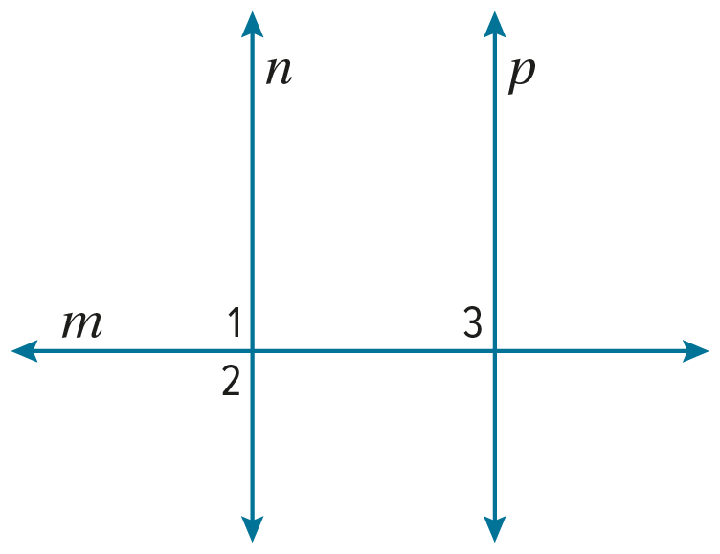
Prove: $∠2≅∠3$

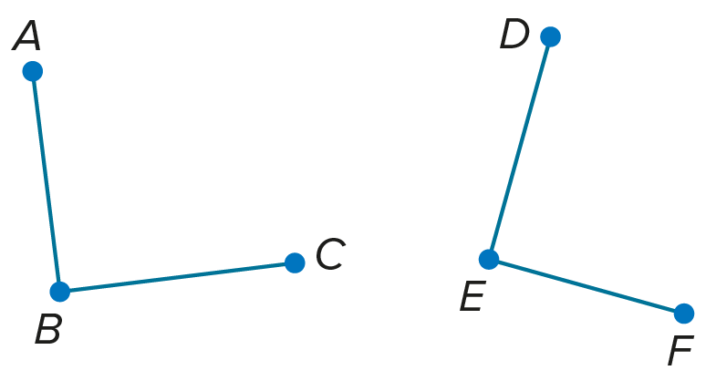
Mixed Exercises
11. Find m∠ABC and m∠CBD if m∠ABD = 120°. | 12. Find m∠JKL and m∠LKM if m∠JKM = 140°.
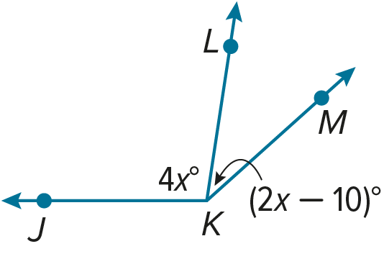
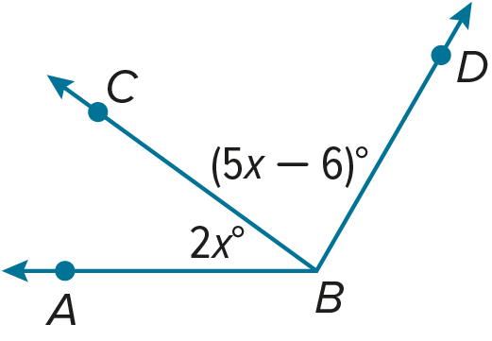

Find the measure of each numbered angle and name the theorems used to justify your work.
13. m∠6 = (2x – 21)° 14. m∠5 = m∠6 15. $∠2$ and $∠3$ are complementary.
m∠7 = (3x – 34)° $∠1≅∠4$ and $m∠2=28°$.

16. $∠2$ and $∠4$ and $∠4$ and $∠5$ 17. $m∠9=\left(3x+12\right)°$ 18. $m∠3=\left(2x+23\right)°$
are supplementary. $m∠10=\left(x-24\right)°$ $m∠4=\left(5x-112\right)°$
$m∠4=105°$.

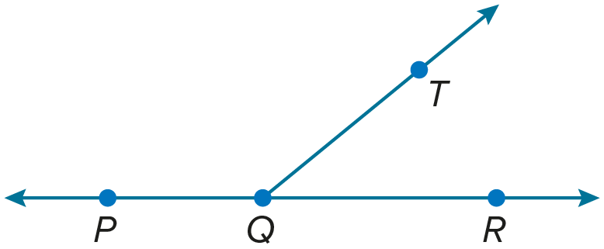
PROOF Write a two-column proof for each theorem.
19. Supplement Theorem
Given: $∠PQT$ and $∠TQR$ form a linear pair.
Prove: $∠PQT$ and $∠TQR$ are supplementary.

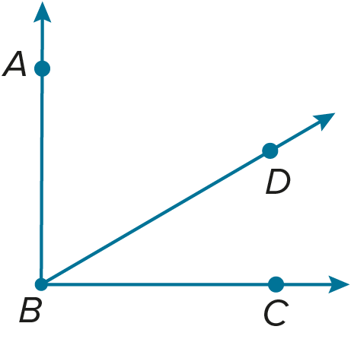
20. Complement Theorem
Given: $∠ABC$ is a right angle.
Prove: $∠ABD$ and $∠CBD$ are complementary.

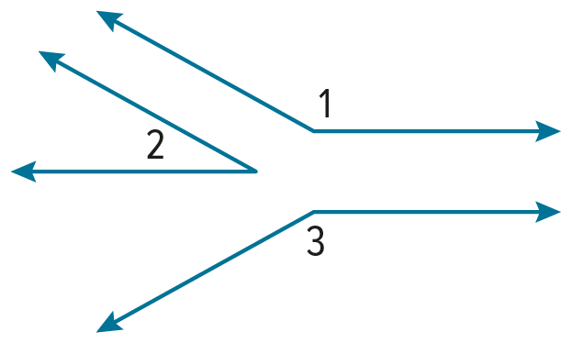
21. Congruent Supplements Theorem (Case 1)
Given: $∠1$ and $∠2$ are supplementary.
$∠2$ and $∠3$ are supplementary.
Prove: $∠1≅∠3$

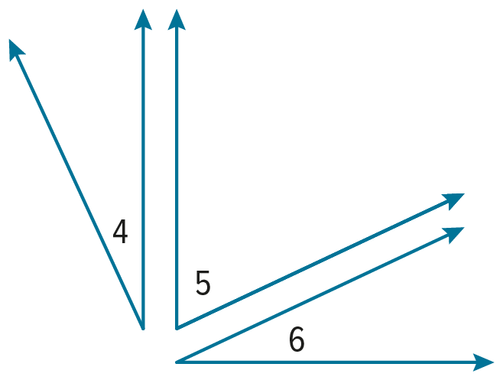
22. Congruent Complements Theorem (Case 1)
Given: $∠4$ and $∠5$ are complementary.
$∠5$ and $∠6$ are complementary.
Prove: $∠4≅∠6$

PROOF Use the figure to write a proof of each theorem.

23. Perpendicular lines intersect to form four right angles. (Theorem 3.9)

24. Perpendicular lines form congruent adjacent angles. (Theorem 3.11)

25. If two angles are congruent and supplementary, then each angle is a right angle. (Theorem 3.12)

26. If two congruent angles form a linear pair, then they are right angles. (Theorem 3.13)

27. CONSTRUCT ARGUMENTS For a school project, students are making a giant icosahedron, which is a large solid with twenty identical triangular faces. John is in charge of quality control. He must make sure that the measures of all the angles in all the triangles are the same. He does this by using a precut template and comparing the corner angles of every triangle to the template. How does this assure that the angles in all the triangles will be congruent to each other?

28. ANALYZE Find m∠C if ∠C ≅ ∠A, m∠A = 3x°, m∠B = (x + 20)°, and ∠A and ∠B are supplementary. Justify your argument.

29. CREATE Draw ∠WXZ such that m∠WXZ = 45°. Construct ∠YXZ ≅ ∠WXZ. Make a conjecture about the measure of ∠WXY, and then prove your conjecture.

30. WRITE Write the steps that you would use to complete the proof.
Given: $\overline{BC}≅\overline{CD}$, AB = $\frac{1}{2}$BD
Prove: $\overline{AB}≅\overline{CD}$

31. PERSEVERE In Exercises 21 and 22, you proved one case of the Congruent Supplements Theorem and one case of the Congruent Complements Theorem. Explain why there is another case for each of these theorems. Then write a proof of this second case for each theorem.

