Parallel Lines and Transversals ⸱ Practice
Example 1
Identify each of the following using the figure shown. Assume lines and planes that appear to be parallel or perpendicular are parallel or perpendicular, respectively.
1. three segments parallel to $\overline{AE}$ 2. a segment skew to $\overline{AB}$

3. a pair of parallel lines 4. a segment parallel to $\overline{AD}$

5. three segments parallel to $\overline{HG}$ 6. five segments skew to $\overline{BC}$

7. How could you characterize the relationship between faces ABCD and DCGH? Explain.

Examples 2 and 3
Identify the transversal connecting each pair of angles. Then classify the relationship between each pair of angles as alternate interior, alternate exterior, corresponding, or consecutive interior angles.
8. $∠$4 and $∠$5 9. $∠$5 and $∠$15
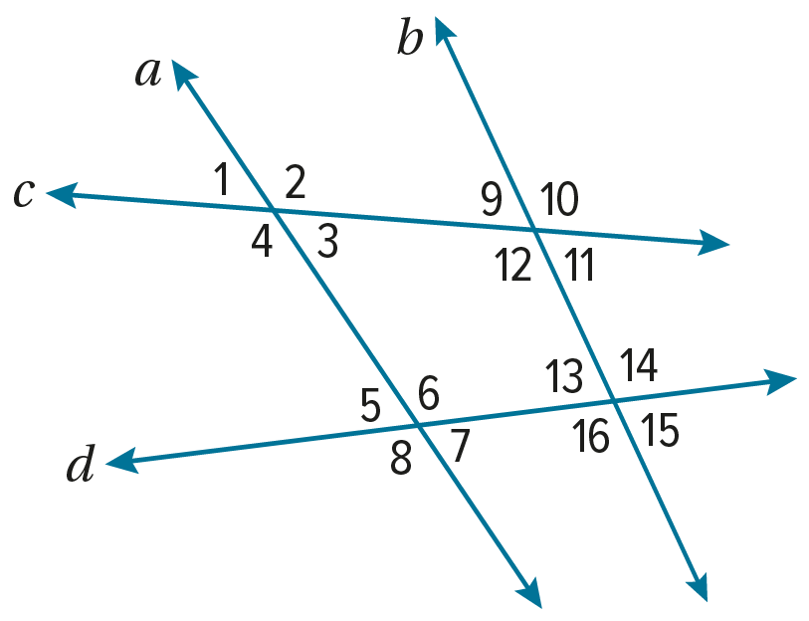

10. $∠$12 and $∠$14 11. $∠$7 and $∠$15

12. $∠$2 and $∠$12 13. $∠$3 and $∠$6

14. $∠$1 and $∠$9 15. $∠$3 and $∠$9

16. $∠$10 and $∠$16 17. $∠$5 and $∠$13
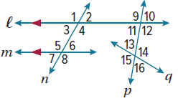

For Exercises 18 and 19, use the figure.
18. What type of angles are $∠$3 and $∠$10?

19. State the transversal that connects $∠$11 and $∠$13.

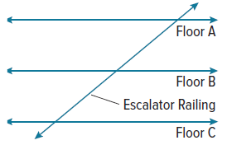
20. ESCALATORS An escalator at a shopping mall runs up several levels. The escalator railing can be modeled by a straight line running past horizontal lines that represent the floors. Describe the relationships of these lines.

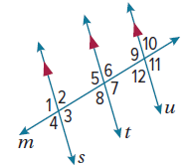
Example 4
In the figure, m$∠$7 = 100$°$. Find the measure of each angle.
21. $∠$9 22. $∠$6

23. $∠$8 24. $∠$2

25. $∠$5 26. $∠$11

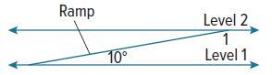
27. RAMPS A parking garage ramp rises to connect two horizontal levels of a parking lot. The ramp makes a 10$°$ angle with the horizontal. What is the measure of angle 1 in the figure?

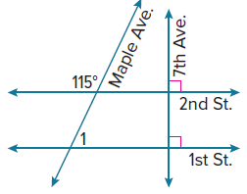
28. CITY ENGINEERING Seventh Avenue runs perpendicular to 1st and 2nd Streets, which are parallel. However, Maple Avenue makes a 115$°$ angle with 2nd Street. What is the measure of angle 1?

Example 5
Find the value of the variables in each figure. Explain your reasoning.
29. 30.
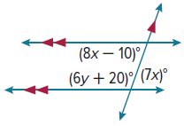
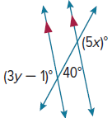
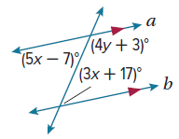

31. Find the value of the variables in the figure.

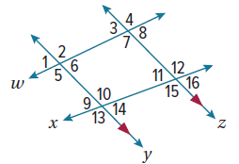
Mixed Exercises
In the figure, m$∠$3 = 75$°$ and m$∠$10 = 105$°$. Find the measure of each angle.
32. $∠$2 33. $∠$5

34. $∠$7 35. $∠$15

36. $∠$14 37. $∠$9

USE A MODEL Lines $a$ and $b$ are parallel and are cut by transversal t to form interior angles $∠$7, $∠$8, $∠$9, and $∠$10. $∠$7 and $∠$8 are consecutive interior angles, and m$∠$7 = 94$°$. $∠$8 and $∠$10 are alternate interior angles. Find the measure of each angle.
38. $∠$10 39. $∠$9 40. $∠$8

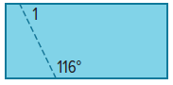
41. CARPENTRY A carpenter is building a podium. The side panel of the podium is cut from a rectangular piece of wood. The rectangle must be sawed along the dashed line in the figure. What is the measure of $∠$1? Explain your reasoning.

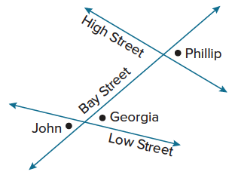
42. MAPPING Use the figure.
a. Connor lives at the angle that forms an alternate interior angle with Georgia’s residence. Label the location of Connor’s home on the map.
b. Quincy lives at the angle that forms a consecutive interior angle with Connor’s residence. Label the locations of Quincy’s home on the map.

43. USE A SOURCE Research the flag for the Soloman Islands. Sketch the flag. Label angles formed by the yellow stripe, or transversal. Describe the relationship between the angles you labeled on the flag.

44. PRECISION Find the values of x and y 45. PROOF In the figure, the
in the trapezoid. Justify your answer. lines m and n are parallel and the lines p and q
are parallel. Write a paragraph proof to prove
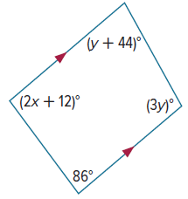
that if m$∠$1 – m$∠$4 = 25°, then
m$∠$9 – m$∠$12 = 25$°$.
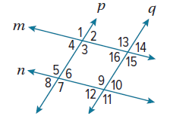

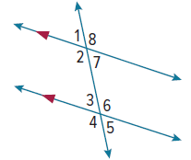
46. In the figure, m$∠$4 = 118°. Find each angle measure. Justify each step.
a. m$∠$8

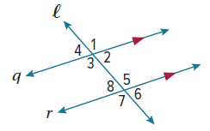
b. m$∠$7

47. PROOF Write a paragraph proof of the Alternate Exterior Angles Theorem. Given: q ǁ r; Prove: $∠$1 ≅ $∠$7.

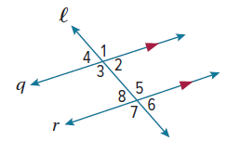
48. PROOF Write a two-column proof to prove each theorem.
a. Consecutive Interior Angles Theorem
Given: q ǁ r
Prove: $∠$2 and $∠$5 are supplementary

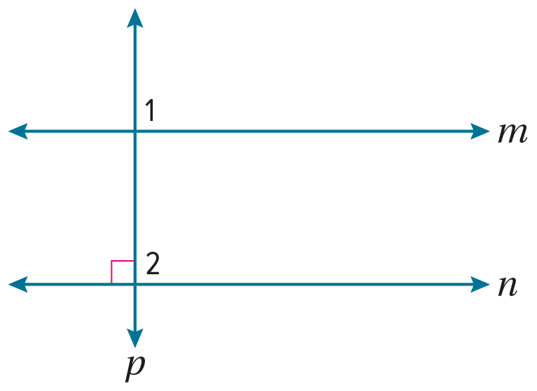
b. Perpendicular Transversal Theorem.
Given: m ǁ n; $p⊥n$
Prove: $p⊥m$

49. CREATE Plane P contains lines a and b. Line c intersects plane P at point J. Lines a and b are parallel lines, lines a and c are skew, and lines b and c are not skew. Draw a figure based upon this description.

ANALYZE Plane X and plane Y are parallel and plane Z intersects plane X. Line $\overset{⃡}{AB}$ is in plane X, line $\overset{⃡}{CD}$ is in plane Y, and line $\overset{⃡}{EF}$ is in plane Z. Determine whether each statement is always, sometimes, or never true. Justify your argument.
50. $\overset{⃡}{AB}$ is skew to $\overset{⃡}{CD}$. 51. $\overset{⃡}{AB}$ intersects $\overset{⃡}{EF}$.

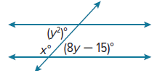
52. WRITE Compare and contrast the Alternate Interior Angles Theorem and the Consecutive Interior Angles Theorem.

53. PERSEVERE Find the values of x and y.

54. ANALYZE Determine the minimum number of angle measures you would have to know to find the measures of all the angles formed by two parallel lines cut by a transversal. Justify your argument.

55. WRITE Can a pair of planes be described as skew? Explain.

