Slope and Equations of Lines ⸱ Practice

Example 1
Determine whether $\overset{⃡}{AB}$ and $\overset{⃡}{CD}$ are parallel, perpendicular, or neither. Graph each line to verify your answer.
1. A(1, 5), B(4, 4), C(9, –10), D(–6, –5) 2. A(–6, –9), B(8, 19), C(0, –4), D(2, 0)

3. A(4, 2), B(–3, 1), C(6, 0), D(–10, 8) 4. A(8, –2), B(4, –1), C(3, 11), D(–2, –9)

5. A(8, 4), B(4, 3), C(4, –9), D(2, –1) 6. A(4, –2), B(–2, –8), C(4, 6), D(8, 5)

Example 2
Determine whether each pair of lines is parallel, perpendicular, or neither.
7. 8. 9.
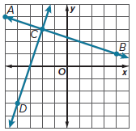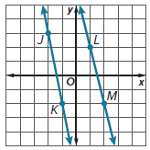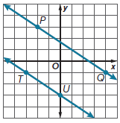
Example 3
Determine whether each pair of lines is parallel, perpendicular, or neither.
10. y = 2x + 4, y = 2x – 10 11. y = – $\frac{1}{2}$x – 12, y – 3= 2(x + 2)

12. y – 4 = 3(x + 5), y + 3 = – $\frac{1}{3}$(x + 1) 13. y – 3 = 6(x + 2), y + 3 = – $\frac{1}{3}$(x – 4)

14. $x=-2, y=10$ 15. $y=5, y=-3$

Example 4
Graph the line that satisfies each condition.
16. passes through A(2, –5), parallel to $\overset{⃡}{BC}$ with B(1, 3) and C(4, 5)
17. passes through X(1, –4), parallel to $\overset{⃡}{YZ}$ with Y(5, 2) and Z(–3, –5)
18. passes through K(3, 7), perpendicular to $\overset{⃡}{LM}$ with L(–1, –2) and M(–4, 8)
19. passes through D(–5, –6), perpendicular to $\overset{⃡}{FG}$ with F(–2, –9) and G(1, –5)
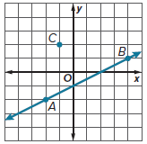
20. SKIING Gavin is working on an animated film about skiing. The figure shows a ski slope, represented by $\overset{⃡}{AB}$, and one of the chairs on the chair lift, represented by point C.
a. The chair needs to move along a straight line that is parallel to $\overset{⃡}{AB}$. What is the equation of this line?
b. The top of the chair lift occurs at y = 20. Explain how Gavin can find the coordinates of the chair when it reaches the top of the chair lift.

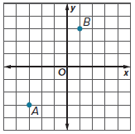
21. REASONING The director of a marching band uses a coordinate plane to design the band’s formations. During one formation, a drummer marches from point A to point B and then turns 90° to her right and marches until she reaches the x-axis.

a. When the drummer marches from point B to the x-axis, what is the equation of the line that she marches along?

b. The director wants to know whether the drummer will cross the x-axis at a point where the x-coordinate is greater than or less than 5. Explain how the director can answer this question.

Example 5
Write an equation in slope-intercept form for each line described.
22. passes through (–7, –4), perpendicular to y = $\frac{1}{2}$x + 9

23. passes through (–1, –10), parallel to y = 7

24. passes through (6, 2), parallel to y = – $\frac{2}{3}$x + 1

25. passes through (–2, 2), perpendicular to y = –5x – 8

Mixed Exercises
Find the value of x or y that satisfies the given conditions. Then graph the line.
26. The line containing (4, –2) and (x, –6) is perpendicular to the line containing (–2, –9) and (3, –4).

27. The line containing (–4, 9) and (4, 3) is parallel to the line containing (–8, 1) and (4, y).

28. The line containing (8, 7) and (7, –6) is perpendicular to the line containing (2, 4) and (x, 3).

29. The line containing (1, –3) and (3, y) is parallel to the line containing (5, –6) and (9, y).

Write an equation in slope-intercept form for a line that is parallel and a line that is perpendicular to the given line and passes through the given point.
30. passes through B(6, 3) 31. passes through S(–2, –4)

PRECISION Determine whether any of the lines in each figure are parallel or perpendicular.
Justify your answers.
32. 33. 34.

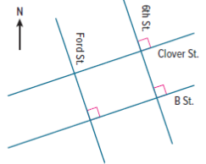
35. CITY BLOCKS The figure shows a map of part of a city consisting of two pairs of parallel roads. If a coordinate grid is applied to this map, Ford Street would have a slope of –3.
a. The intersection of B Street and Ford Street is 150 yards east of the intersection of Ford Street and Clover Street. How many yards south is it?
b. What is the slope of 6th Street? Explain.
c. What are the slopes of Clover and B Streets? Explain.
d. The intersection of B Street and 6th Street is 600 yards east of the intersection of B Street and Ford Street. How many yards north is it?

36. REASONING $\overset{⃡}{AB}$ is parallel to $\overset{⃡}{CD}$. The coordinates of A, B, and C are A(–3, 1), B(6, 4), and
C(1, –1). What is a possible set of coordinates for point D? Describe the reasoning you used to find the coordinates.

37. USE A MODEL A video game designer is using a coordinate plane to plan the path of a helicopter. She has already determined that the helicopter will move along straight segments from P to Q to R. The designer wants the next part of the path, $\overline{RS}$, to be perpendicular to $\overline{QR}$, and she wants point S to lie on the y-axis. What should the coordinates of point S be? Justify your answer.

38. Line p passes through (1, 3) and (4, 7) and line q passes through (0, –2) and (a, b).
a. Find the slopes of lines p and q.
b. Find possible values of a and b if p $∥$ q.

39. STRUCTURE Let a and b be nonzero real numbers. Line p has the equation y = ax + b.
a. Find the equation of the line through (5, 1) that is parallel to line p. Write the equation in point-slope form. Explain your reasoning.
b. Find the equation of the line through (2, 3) that is perpendicular to line p. Write the equation in slope-intercept form. Explain your reasoning.

40. CONSTRUCT ARGUMENTS The equation of line ℓ is 3y – 2x = 6.
a. Line m is perpendicular to line ℓ and passes through the point P(6, –2). Find the equation of line m.
b. Line n is parallel to line m. Is it possible to write the equation of line n in the form 2x + 3y = k for some constant k? Justify your argument.

41. ANALYZE Draw a square ABCD with opposite vertices at A(2, –4) and C(10, 4).
a. Find the other two vertices of the square and label them B and D.
b. Show that $\overline{AD}∥\overline{BC}$ and $\overline{AB}∥\overline{DC}$.
c. Show that the measure of each angle inside the square is equal to 90$°$.

42. PERSEVERE Find the value of n so that the line perpendicular to the line with the equation
–2y + 4 = 6x + 8 passes through the points (n, –4) and (2, –8).

43. ANALYZE Determine whether the points at (–2, 2), (2, 5), and (6, 8) are collinear. Justify
your argument.

44. CREATE Write equations for a pair of perpendicular lines that intersect at the point at (–3, –7).

45. WRITE Write biconditionals to determine whether lines are parallel or perpendicular
using slopes.

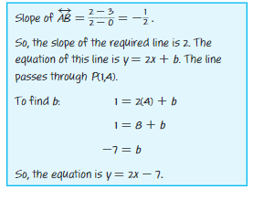
46. FIND THE ERROR A student was asked to find the equation of the line perpendicular to $\overset{⃡}{AB}$ that passes through point P, given that A, B, and P have coordinates A(0, 3), B(2, 2), and P(1, 4). The student’s work is shown at the right. Do you agree with the student’s solution? Explain your reasoning.

