Proving Lines Parallel ⸱ Practice

Example 1
Use the given information to determine which lines, if any, are parallel. State the postulate or theorem that justifies your answer.
1. $∠$3 ≅ $∠$7 2. $∠$9 ≅ $∠$11

3. $∠$2 ≅ $∠$16 4. m$∠$5 + m$∠$12 = 180$°$

Given the following information, determine which lines, if any, are parallel. State the theorem that justifies your answer.
5. $∠$1 ≅ $∠$6 6. m$∠$7 + m$∠$6 = 180$°$

Example 2
Find the value of x so that $l∥m$.
7. 8. 9.
10. 11. 12.

13. Find the value of x so that ℓ ║ m.

Example 3

14. BOOKS Each orange book on the bookshelf makes a 70° angle with the base of the shelf. What more can you say about these two orange books? Explain.

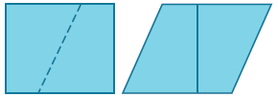
15. PATTERNS A rectangle is cut along the slanted, dashed line shown in the figure. The two pieces are rearranged to form another figure. Describe as precisely as you can the shape of the new figure. Explain.

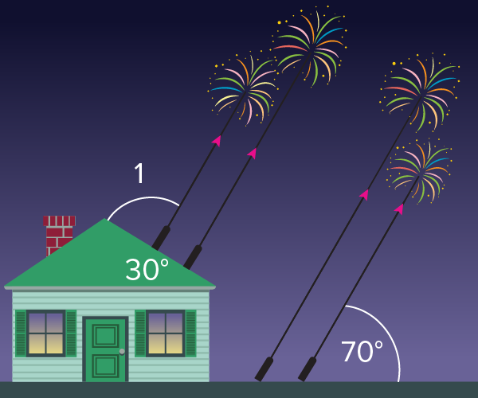
16. FIREWORKS The designers of a fireworks display want to have four fireworks shoot out along parallel trajectories. They decide to place two launchers on a dock and two launchers on the roof of a building. To make this display work, what should the measure of angle 1 be? Explain.

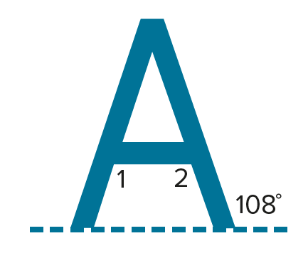
17. REASONING Chaska is making a giant letter A to put on the rooftop of the A is for Apple Orchard Store. The figure shows a sketch of the design.
a. What should the measures of angles 1 and 2 be so the horizontal part of the A is truly horizontal? Explain.
b. When building the A, Chaska makes sure that angle 1 is correct, but when he measures angle 2, it is not correct. What does this imply about the A?

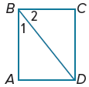
Mixed Exercises
18. PROOF Provide a reason for each statement in the proof of the Perpendicular Transversal Converse.
Given: $∠$1 and $∠$2 are complementary; $\overline{BC}⊥\overline{CD}$
Prove: $\overline{BA}∥\overline{CD}$
Proof:
Statements | Reasons
1. $\overline{BC}⊥\overline{CD}$  2. m$∠$ABC = m$∠$1 + m$∠$2  3. $∠$1 and $∠$2 are complementary.  4. m$∠$1 + m$∠$2 = 90  5. m$∠$ABC = 90  6. $\overline{BA}⊥\overline{BC}$  7. $\overline{BA}∥\overline{CD}$ | 1. _____?_____  2. _____?_____  3. _____?_____  4. _____?_____  5. _____?_____  6. _____?_____  7. _____?_____

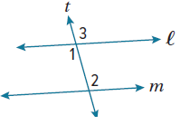
19. PROOF Write a paragraph proof to prove the Alternate Interior Angles Converse.
Given: $∠$1 $≅$ $∠$2
Prove: $l∥m$

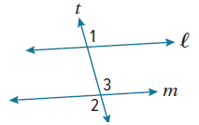
20. PROOF Write a paragraph proof to prove the Alternate Exterior Angles Converse.
Given: $∠1≅∠2$
Prove: $l∥m$

USE TOOLS Use a compass and straightedge to construct the line through point P that is parallel to line q.
21. 22.
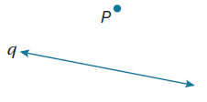
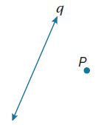

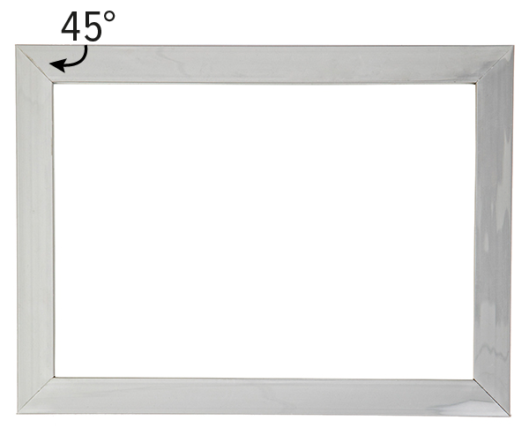

23. PICTURE FRAMES Lindy is making a wooden picture frame. She cuts the top and bottom pieces at a 45$°$ angle. If the corners are right angles, explain how Lindy knows that each pair of opposite sides is parallel.

24. REASONING Jim made a frame for a painting. He wants to check to make sure that opposite sides are parallel by measuring the angles at the corners and seeing if they are right angles. How many corners must he check to be sure that the opposite sides are parallel?

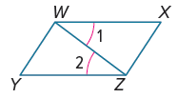
25. FIND THE ERROR Sean and Daniela are determining which lines are parallel in the figure at the right. Sean says that because $∠1≅∠2$, $\overline{WY}∥\overline{XZ}$. Daniela disagrees and says that because $∠1≅∠2$, $\overline{WX}∥\overline{YZ}$. Is either of them correct? Explain your reasoning.

26. ANALYZE Is Theorem 3.23 still true if the two lines are not coplanar? Draw a figure to justify your argument.

27. CREATE Draw a triangle ABC.
a. Construct the line parallel to $\overline{BC}$ through point A.
b. Use the measurements to justify that the line you constructed is parallel to $\overline{BC}$.
c. Justify the construction.

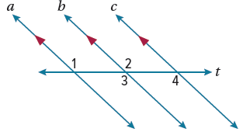
28. PROOF Use the figure at the right to complete the two-column proof to prove that two lines parallel to a third line are parallel to each other.
Given: a $∥$ b and b $∥$ c
Prove: a $∥$ c
Proof:

Statements | Reasons
1. a $∥$ b and b $∥$ c  2. $∠$1 $≅$ $∠$3  3.  4.  5.  6. a $∥$ c | 1. _____?_____  2. _____?_____  3. _____?_____  4. _____?_____  5. _____?_____  6. _____?_____

29. WRITE Can a pair of angles be supplementary and congruent?
Explain your reasoning.

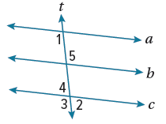
30. PROOF Refer to the figure at the right.
a. If m$∠$1 + m$∠$2 = 180$°$, prove that a $∥$ c.
b. Give that a $∥$ c, if m$∠$1 + m$∠$3 = 180$°$, prove that t $⊥$ c.

