Perpendiculars and Distance ⸱ Practice

Examples 1 and 2
Find the distance between point P and line $l$.
- Line$l$ contains points (0, –3) and (7, 4). Point P has coordinates (4, 3).

- Line$l$ contains points (11, –1) and (–3, –11). Point P has coordinates (–1, 1).

3. Line$l$ contains points (–2, 1) and (4, 1). Point P has coordinates (5, 7).

4. Line$l$ contains points (4, –1) and (4, 9). Point P has coordinates (1, 6).

5. Line$l$ contains points (1, 5) and (4, –4). Point P has coordinates (–1, 1).

6. Line$l$ contains points (–8, 1) and (3, 1). Point P has coordinates (–2, 4).

7. DESIGN Dante is designing a poster for prom using a design program with a
coordinate grid. He starts by creating a geometric border. Dante wants the text
on the poster to be at least 3 inches away from the top left-hand corner of the
border. The border contains the points (0, 7) and (7, 14). If Dante places the text at
(7, 8), is the text at least 3 inches away from the border? If yes, how far away is the
text from the border? Let every unit represent an inch. Round your answer to the
nearest hundredth, if needed.

8. PHYSICS Mrs. Holmes’s physics class is using 3D-printing software to create miniature bridges that can hold at least 5 pounds. Teams will print multiple parts of the bridges and then assemble the parts. One team wants there to be at least 6 inches between the upper rail and the lower rail of the bridge. The lower rail of the bridge contains the points (2, 10) and (16, 3). If the upper rail contains the point (5, 1), will the bridge meet the team’s specifications? If yes, how far apart are the rails? Let every unit represent an inch. Round your answer to the nearest hundredth, if needed.

Example 3
Find the distance between each pair of parallel lines with the given equations.
9. y = 7 10. x = –6 11. y = 3x
y = –1 x = 5 y = 3x + 10

12. y = –5x 13. y = x + 9 14. y = –2x + 5
y = –5x + 26 y = x + 3 y = –2x – 5

15. y = $\frac{1}{4}$x + 2 16. 3x + y = 3 17. y = – $\frac{5}{4}$x + 3.5
4y – x = –60 y + 17 = –3x 4y + 10.6 = –5x

Mixed Exercises
Find the distance from the line to the given point.
18. y = –3; (5, 2) 19. y = $\frac{1}{6}$x + 6; (–6, 5) 20. x = 4; (–2, 5)

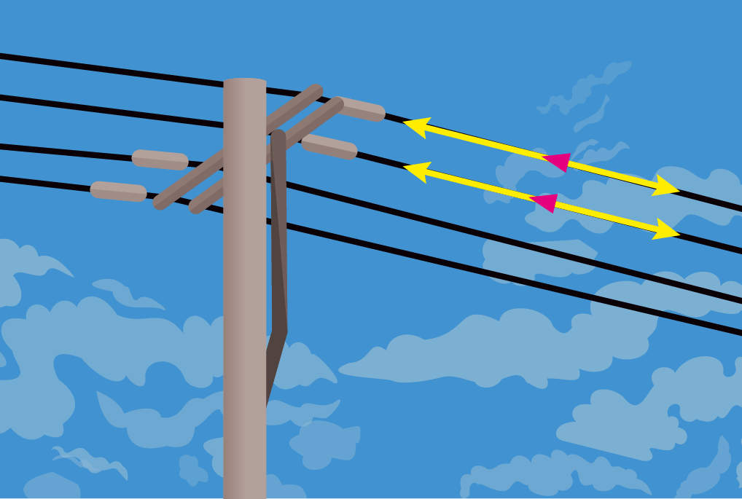
21. TELEPHONE WIRES Isaiah works for a telephone company. He rewired some telephone wires on a pole. How can Isaiah use perpendicular distances to confirm that the wires
are parallel?

22. STATE YOUR ASSUMPTION A city planner is designing a new park using a map of the city on a coordinate plane. The planner wants the entrance of the park to be at least 4 meters away from Washington Avenue. On the map, Washington Avenue contains the points (2, –4) and (11, –1).

- If the city planner wants to build the entrance of the park at (3, 3), will the entrance be at least 4 meters away from Washington Avenue? If yes, how far away will the entrance be from the street? Let every unit represent 1 meter. Round your answer to the nearest hundredth, if needed.

b. What assumption did you make while solving this problem?

23. Construct the line through G perpendicular 24. Construct the line through P perpendicular to m.
to $\overset{⃡}{EF}$.
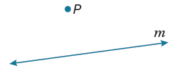
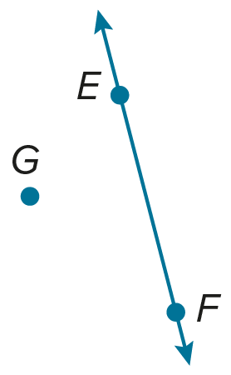

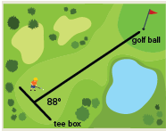
25. REASONING The diagram at the right shows the path that Mark walked from the tee box to where his ball landed on the green. Is the path the shortest possible one from the tee box to the golf ball? Explain why or why not.

26. $\overline{AB}$ has a slope of 2 and midpoint M(3, 2). A segment perpendicular to $\overline{AB}$ has midpoint P(4, –1) and shares endpoint B with $\overline{AB}$.
a. Graph the segments.
b. Find the coordinates of A and B.

27. What does it mean if the distance between a point P and a line ℓ is zero? If the distance between two lines is zero?

28. PROOF Complete the two-column proof of Theorem 3.24.
Given: $l$ is equidistant to m, and n is equidistant to m.
Prove: $l$ $∥$ n
Proof:
Statements | Reasons
1. $l$ is equidistant to m, and n is equidistant to m.  2.  3.  4.  5. $l$ $∥$ n | 1. _____?_____  2. Definition of equidistant  3. Definition of parallel lines  4. Transitive Property of Equality  5. _____?_____

29. WRITE Summarize the steps that are necessary to find the distance between a pair of parallel lines given the equations of the two lines.

30. PERSEVERE Suppose a line perpendicular to a pair of parallel lines intersects the lines at the points (a, 4) and (0, 6). If the distance between the parallel lines is $\sqrt{5}$, find the value of a and the equations of the parallel lines.

31. ANALYZE Determine whether the following statement is sometimes, always, or never true. Justify your argument.
The distance between a line and a plane can be found.

32. CREATE Draw an irregular convex pentagon using a straightedge.
a. Use a compass and straightedge to construct a perpendicular line between one vertex and a side opposite the vertex.

b. Use measurement to justify that the line constructed line is perpendicular to the side chosen.

c. Use mathematics to justify this conclusion.

33. WRITE Rewrite Theorem 3.24 in terms of two planes that are equidistant from a third plane. Sketch an example.

34. FIND THE ERROR Harold draws the segments AB and CD shown below using a straightedge. He claims that these two lines, if extended in both directions, will never intersect. Olga claims that the lines will eventually intersect. Who is correct? Explain your reasoning.

