Reflections ⸱ Practice

Examples 1 and 2
Graph the image of each figure under the given reflection. Determine the coordinates
of the image.
1. △ABC in the line y = x 2. trapezoid DEFG in the line x = –1

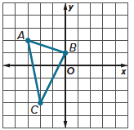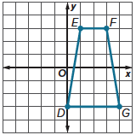

3. parallelogram RSTU in the line y = x 4. square KLMN in the line y = –2

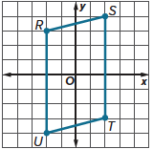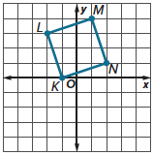

5. Determine the coordinates of S(–7, 1) after a reflection in the line y = 3.

6. Determine the coordinates of Q(6, –4) after a reflection in the line x = 2.

7. BANNERS Fiona is making a banner in the shape of a triangle for a school project. She graphs the banner on a coordinate plane with vertices at P(0, 4), Q(2, 8), and R(–3, 6). She wants to reflect the banner over the line x = 1. Draw the image of the banner reflected in the line x = 1.

8. SANDBOX Aliyah is drawing the top view of a square sandbox on a coordinate plane with vertices at D(1, 1), E(1, 6), F(6, 6), and G(6, 1). She wants to change the location of the sandbox so that it is in the shade. She reflects the sandbox in the line x = 1. Find the coordinates of the image of the sandbox.

Mixed Exercises
9. Determine the coordinates of W(–7, 4) after a reflection in the line y = 9.

Graph each figure and its image under the given reflection.
10. rectangle ABCD with vertices A(–5, 2), B(1, 2), C(1, –1), and D(–5, –1) in the line y = –2

11. △FGH with vertices F(–3, 2), G(–4, –1), and H(–6, –1) in the line y = x

12. △STU with vertices S(–3, –2), T(–2, 3), and U(2, 2) in the line y = x

13. △CDE with vertices C(–3, 6), D(–1, 1), and E(3, 5) in the line y = x

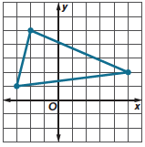
14. Naveen plotted his triangular garden on a coordinate plane. What are the vertices of the image of his garden if it is reflected in the line y = x?

15. The image of A(–1, 1) after a reflection is A′(–1, –3). Which reflection produces the image of A?

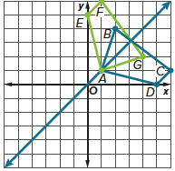
16. FIND THE ERROR For the graph at the right, Evelyn maintains that AEFG is a reflection of ABCD because it fits the definition of a reflection in the line y = x. She reasons that A is the same point in each figure because it is on the line of reflection and the remaining vertices are equidistant from that line. Do you agree with Evelyn’s analysis? Explain your reasoning.

17. CREATE Create five points on the coordinate plane to form the letter M. Find their image under a reflection in the line y = x.

18. WRITE Describe how to reflect a figure not on the coordinate plane in a line.

19. PERSEVERE A point in the second quadrant with coordinates (–a, b) is reflected in the line y = –x. What are the coordinates of the image?

20. ANALYZE Is the image of a point reflected in a line sometimes, always, or never located on the other side of the line of reflection? Justify your argument.

