Translations ⸱ Practice

Examples 1 and 2
1. Determine whether a translation maps 2. Determine whether a translation maps
$∆JKL$ onto ​​$∆J'K'L'$​​. If so, find the quadrilateral LMNP onto quadrilateral
translation vector. If not, explain why. $L'M'N'P'$​​. If so, find the translation
vector. If not, explain why.
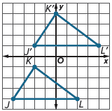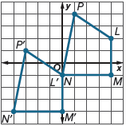

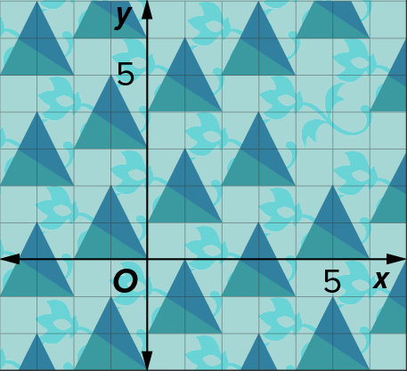
3. WALLPAPER A wallpaper design consists of repeated translations of a single isosceles triangle. The pattern is shown overlaid on a coordinate plane. The space above the triangle around the coordinate (5, 1) should be filled with a missing triangle. What are the coordinates of the vertices of the triangle that fill this space consistently with the rest of the pattern?

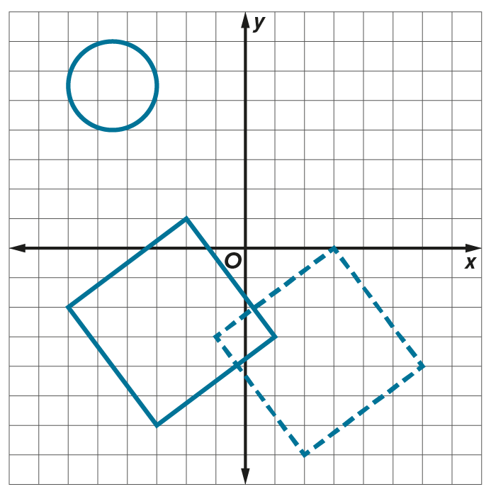
4. FURNITURE Alejandro plotted the location of a reclining chair and an end table on a coordinate plane. The end table is represented by the circle, and the chair is represented by the square with solid sides. The image of the chair along a translation is represented by the square with dashed sides.

a. Describe this translation of the chair.

b. Draw the image of the end table under the same translation that you described in part a.

Mixed Exercises
Draw and label the image of each figure after the given translation.
5. 3 units to the left 6. translation vector 〈1, –2.5〉 7. translation vector 〈–5, –7〉

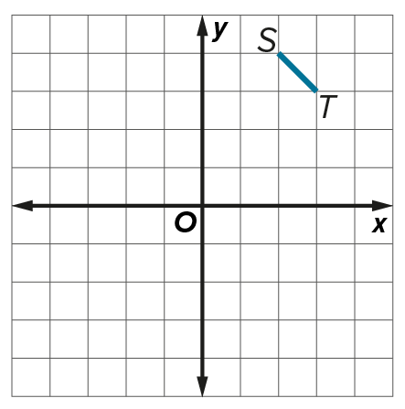
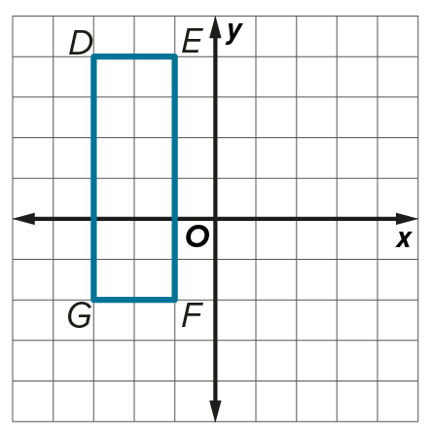
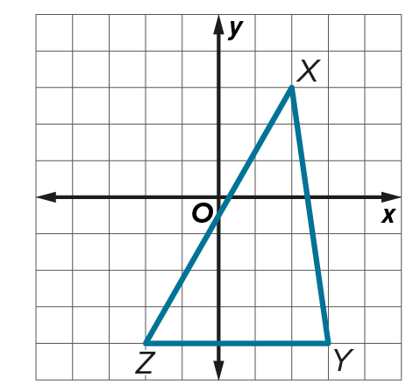

Name the image of each point after the given translation vector.
8. F(–3, 1); 〈5, –1〉 9. Q(4, –2); 〈–2, –5〉 10. P(9, 1.5); 〈3, –0.5〉

11. The image of A(–3, –5) under a translation is A′(6, –1). Find the image of B(3, –2) under the same translation.

12. CONSTRUCT ARGUMENTS Explain why △A′B′C′ with vertices A′(–1, –2), B′(0, 0), and C′(–6, 0) is not a translation image of △ABC with vertices A(1, 2), B(0, 0), and C(6, 0).

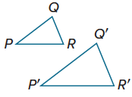

13. Determine whether △P′Q′R′ is a translation image of △PQR. Explain.

14. Determine the translation vector that moves every point of a preimage
4 units left and 6 units up.

15. PERSEVERE Yolanda reflects an object in the line y = –1. Then she reflects it in the line y = 1. Describe the translation.

16. ANALYZE Determine whether each statement is always, sometimes, or never true for translations. Justify your argument.
a. Lengths and angle measures of the image are preserved.

b. All the segments drawn from a vertex of the preimage to the corresponding vertex of the image are parallel.

c. The vector 〈a, b〉 will translate each coordinate of a preimage a units right and b units up.

17. WRITE A square in the coordinate plane has vertices of (2, 3), (4, 3), (2, 1), and (4, 1). It is translated such that one of the vertices is at the origin. Find the coordinates of each vertex of the image if the translation vector has the least possible length. Explain your reasoning. Draw the image and preimage on a coordinate plane.

18. PERSEVERE A triangle with vertices (–3, 1), (–1, 4), and (1, 1) represents the area on a map covered by a fleet of fishing ships, where each square represents a square mile. This region is translated along the vector 〈4, –5〉. Draw the fleet and its image. List the vertices of the image. What distance has the coverage area been moved?

