Rotations ⸱ Practice

Examples 1 and 2
1. Triangle XYZ has vertices X(0, 2), Y(4, 4), and Z(3, –1). Graph △XYZ and its image after a rotation of 180° about ​​(2, –3).

2. Triangle ABC has vertices A(1, 7), B(3, 2), and C(–2, –2). Graph △ABC and its image after a rotation of 270° counterclockwise about ​(–4, 2).

3. Triangle FGH has vertices F(–3, 4), G(2, 0), and H(–1, –2). Graph △FGH and its image after a rotation of 180° about ​​(–3, –6).
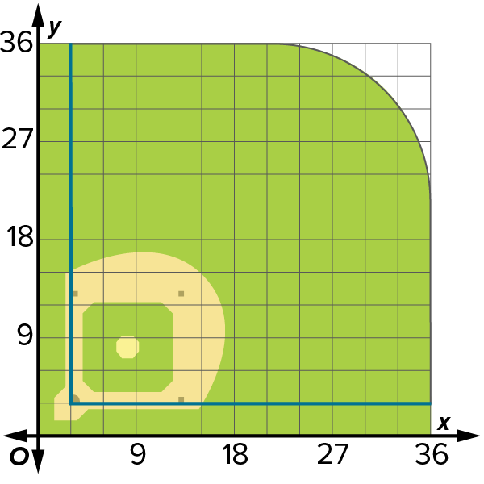

4. Quadrilateral ABCD has vertices A(–2, 4), B(1, 3), C(2, –3), and D(–3, –1).
Graph quadrilateral ABCD and its image after a rotation of 90° counterclockwise about ​​(–1, 2).

5. BASEBALL A scale drawing of a baseball field is shown on the coordinate plane, where home plate is at (3, 3), first base is at (13, 3), second base is at (13, 13), and third base is at (3, 13). Suppose the baseball field is rotated 270° counterclockwise about second base, what are the coordinates of each base?

Mixed Exercises
6. Point Q with coordinate (4, –7) is rotated 270° clockwise about (5, 1). What are the coordinates of its image?

7. Parallelogram JKLM has vertices J(2, 1), K(7, 1), L(6, −3), and M(1, −3). What are the coordinates of the image of K if the parallelogram is rotated 270° counterclockwise about (–2, –1)?
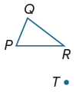

8. USE TOOLS Use a protractor and ruler to draw a rotation of △PQR 210° about T.

9. The line segment XY with endpoints X(3, 1) and Y(2, –2) is rotated 90° counterclockwise about (–6, 4). What are the endpoints of $\overline{X ' Y '}$?

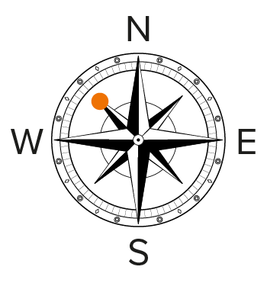
10. HIKING A damaged compass points northwest instead of north. If you travel west by the compass, what is your angle of rotation to true north?

11. A circular dial with the digits 0 through 9 evenly spaced around its edge is rotated clockwise 36°. How many times would you have to perform this rotation to bring the dial back to its original position?

12. Under a rotation about the origin, the point A(5, –1) is mapped to the point A’(1, 5). What is the image of the point B(–4, 6) under this rotation? Explain.

13. CREATE Draw a right triangle ABC and point P not on the triangle.

a. Rotate triangle ABC about point P 90° counterclockwise.

b. Name a clockwise rotation that would map triangle ABC onto triangle A′B′C′.

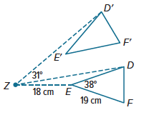
14. In the figure, △D’E’F’ is the image of △DEF after a rotation about point Z.

a. What is the distance from E’ to Z? Justify your reasoning.
b. What is m$∠$FZF’? Justify your reasoning.

15. ANALYZE What is the result of a rotation followed by another rotation about the same point? Give an example.

16. FIND THE ERROR Thomas claims that a reflection in the x-axis followed by a reflection in the y-axis is the same thing as a rotation. Is Thomas correct? Explain your reasoning.

17. WRITE Which properties of a figure are preserved under a rotation from the preimage to the image? Explain.

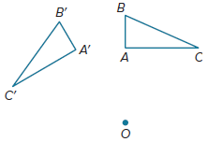
18. FIND THE ERROR Shanice is looking at the figure shown, which shows two congruent triangles. She measures the angle that rotates A to A’ around O and finds it to be 30°. She measures the angle that rotates B to B’ around O and also finds it to be 30°. She then claims that because the two triangles are congruent, a 30° rotation has occurred about point O. Is Shanice correct? Explain your reasoning.

19. WRITE Are collinearity and betweenness of points maintained under rotations? Explain.

