Compositions of Transformations ⸱ Practice

Example 1
Graph each figure with the given vertices and its image after the indicated glide reflection.
1. △RST: R(1, –4), S(6, –4), T(5, –1) 2. △JKL: J(1, 3), K(5, 0), L(7, 4)
Translation: along $〈2, 0〉$ Translation: along $〈-3, 0〉$
Reflection: in x-axis Reflection: in x-axis

3. △DFG: D(2, 8), F(1, 2), G(4, 6) 4. △MPQ: M(–4, 3), P(–5, 8), Q(–1, 6)
Translation: along $〈3, 3〉$ Translation: along $〈-4, -4〉$
Reflection: in y = x Reflection: in y = x

Example 2
Graph each figure with the given vertices and its image after the indicated composition
of transformations.
5. $\overline{WX}$: W(–4, 6) and X(–4, 1) 6. $\overline{AB}$: A(–3, 2) and B(3, 8)
Reflection: in x-axis Rotation: 90$°$ about origin
Rotation: 90$°$ about origin Translation: along $〈4, 4〉$

7. $\overline{FG}$: F(1, 1) and G(6, 7) 8. $\overline{RS}$: R(2, –1) and S(6, –5)
Reflection: in x-axis Translation: along $〈-2, -2〉$
Rotation: 180$°$ about origin Reflection: in y-axis

Example 3
Copy and reflect figure in line u and then line v. Then describe a single transformation
that maps the preimage onto the image.
9. 10.
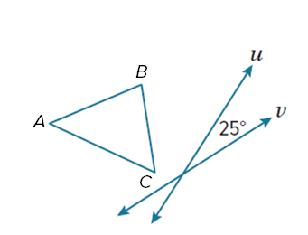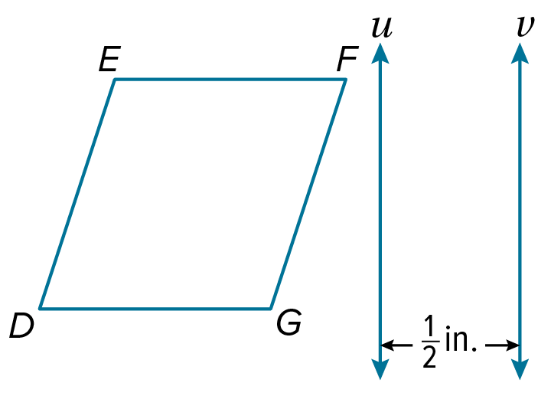

11. 12.
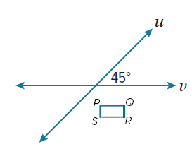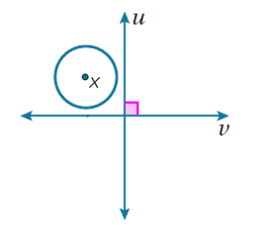

Example 4
Is △JKL congruent to △MNP? If so, what composition of transformations maps △JKL​​ onto ​​△MNP?
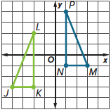
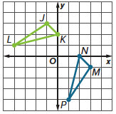
13. 14.

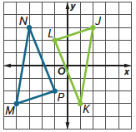
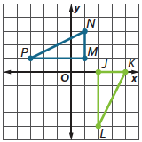
15. 16.

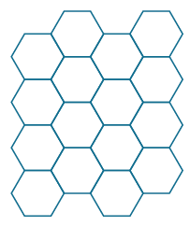

Example 5

17. Describe the transformations that are combined to create the border.

18. Describe the transformations that are combined to create the pattern.

Mixed Exercises
Draw and label the image of each figure after the given composition of transformations.
19. 270° rotation about the origin 20. reflection in the y-axis followed by
followed by translation along $〈2, -2〉$ 180° rotation about the origin
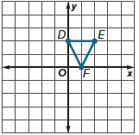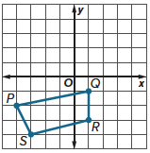

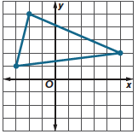
Determine the coordinates of the preimage given the image and composition of transformations.
21. reflection in the x-axis, reflection in the y-axis

22. rotation 180° about origin, translation 3 units up

23. reflection in the y-axis, translation 2 units left

24. Point K is reflected over line p and then over line d. If lines p and d are parallel and 2.8 feet apart, what single translation maps K onto K"?

Determine whether each statement is always, sometimes, or never true. Justify your argument.
25. A composition of two reflections is a rotation.

26. A composition of two translations is a rotation.

27. A reflection in the x-axis followed by a reflection in the y-axis leaves a point in its
original location.

28. A translation along 〈a, b〉 followed by the translation along 〈c, d〉 is the translation
along 〈a + c, b + d〉.

29. PROOF Write a paragraph proof for one case of the Composition of Isometries Theorem.

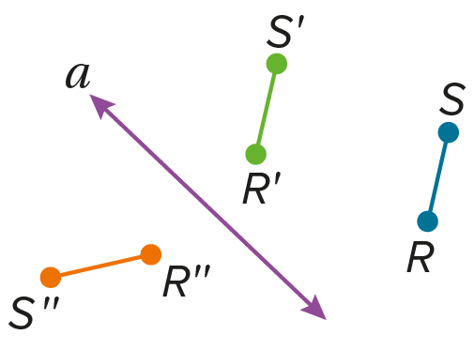
Given: A translation along $〈a,b〉$ maps R to R’ and S to S’.
A reflection in $a$ maps R’ to R’’ and S’ to S’’.
Prove: $\overline{RS}≅\overline{R''S''}$

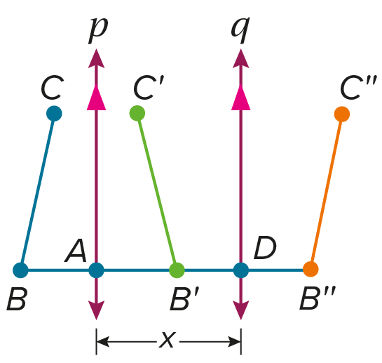
30. PROOF Write a two-column proof of Theorem 4.2.

Given: A reflection in line $p$ maps $\overline{BC}$ to $\overline{B'C'}$.
A reflection in line $q$ maps $\overline{B'C'}$ to $\overline{B''C''}$.
$p∥q$, AD = x
Prove: $\overline{BB''}⊥p$, $\overline{BB''}⊥q$; BB’’ = 2x

31. ANALYZE When a rotation and a reflection are performed as a composition of transformations on a figure, does the order of the transformations sometimes, always, or never affect the location of the final image? Justify your argument.

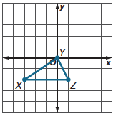
32. FIND THE ERROR Daniel and Lolita are translating △XYZ along 〈2, 2〉 and reflecting it in the line y = 2. Daniel says that the transformation is a glide reflection. Lolita disagrees and says that the transformation is a composition
of transformations. Is either of them correct? Explain your reasoning.

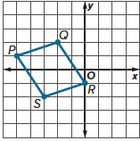
33. PERSEVERE If PQRS is translated along 〈3, –2〉, reflected in y = –1, and rotated 90° about the origin, what are the coordinates of P’’’Q’’’R’’’S’’’.

34. ANALYZE If an image will be reflected in the line y = x and the x-axis, does the order of reflections affect the final image? Explain.

