Tessellations ⸱ Practice

Example 1
Determine whether each regular polygon will tessellate the plane. Explain.
1. pentagon 2. hexagon 3. 9-gon

Example 2
Determine whether a semiregular uniform tessellation can be created from the given shapes, assuming that all sides are 1 unit long. If so, determine the number of each shape needed at each vertex to create the tessellation.
4. regular pentagons and squares

5. regular hexagons and equilateral triangles

Example 3
Determine whether the pattern is a tessellation. If so, describe it as uniform, not uniform, regular, not regular, or semiregular.
6. 7. 8.
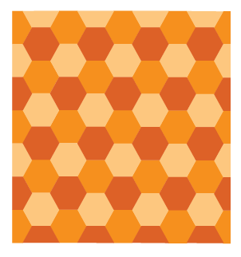
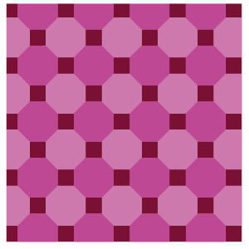


Example 4
Determine whether a tessellation can be created from each figure. If so, describe the transformation(s) that can be used to create the tessellation and draw a picture to support
your reasoning.
9. scalene triangle 10. rhombus

11. Determine whether a tessellation can be created from a regular dodecagon. If so, describe the transformation(s) that can be used to create the tessellation. Will a regular dodecagon sometimes, always, or never tessellate the plane? Justify your argument.

12. Sketch a tessellation that can be created from an isosceles trapezoid. Describe the transformation(s) that can be used to create the tessellation.

13. Will a regular 15-gon sometimes, always, or never tessellate the plane? Justify your argument.

14. Determine whether a tessellation can be created from a parallelogram. If so, describe the transformation(s) that can be used to create the tessellation and draw a picture to support your reasoning.

Mixed Exercises
Determine the transformation(s) used to make each tessellation.
15. 16. 17.
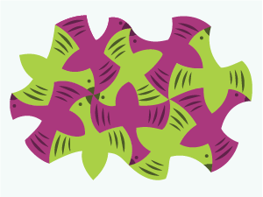



18. HOME IMPROVEMENT A hardware store sells various shapes of regular polygon paving stones. Kiyoko wants a simple design and only wants to buy one shape of stone. To build a solid base floor for her patio, what type of shape should Kiyoko buy?

19. GIFTS Matthew wants to surprise his girlfriend with a special homemade gift. He wants to make a puzzle by tessellating one piece with a picture of a heart on it. What types of transformations can Matthew perform to create his puzzle? Explain.

20. FIND THE ERROR Heather says that if an interior angle of a regular n-gon measures 180°, then the n-gon will tessellate because 180° is a factor of 360°. Do you agree? Explain your reasoning.

21. CREATE Draw a tessellation that can be created by translations or rotations.

22. WRITE How would you accurately describe a tessellation to a person who had never heard the term before?

