Symmetry ⸱ Practice

Example 1
Determine whether each figure has a line of symmetry. If so, draw the lines of symmetry and state how many lines of symmetry it has.
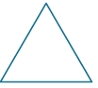

1. 2.

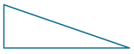

3. 4.



5. 6.

Example 2
7. CARS Steve found the hubcaps shown below at his local junkyard. Determine whether each hubcap has rotational symmetry. Explain.



a. b. c.


8. FLAGS The figure shows the Union Jack, which is the flag of the United Kingdom. Does the flag have rotational symmetry? Explain.


9. RECYCLING A waste management company offers recycling programs for its clients. Recycling is denoted by the symbol shown. Does the recycling symbol have rotational symmetry? Explain.

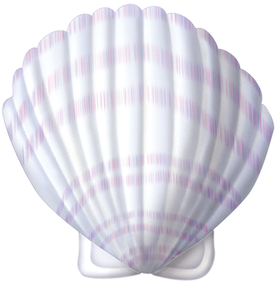
10. VACATION Annabel and her family went to a beach for vacation. While she was on the beach, Annabel collected seashells. Does the seashell shown have rotational symmetry? Explain.

Example 3
Determine whether each figure has rotational symmetry. If so, locate the center of symmetry, and state the order and magnitude of symmetry.
11. 12.



13. 14.



Mixed Exercises

Refer to the figure at the right.
15. Draw the line(s) of symmetry in the figure.

16. Locate the center of symmetry for the figure.

17. What is the order and magnitude of symmetry for the figure?

18. LETTERS Examine each capital letter in the alphabet. Determine which letters have 180° rotational symmetry about a point in the center of the letter.

19. STRUCTURE A regular polygon has rotational symmetry with an order of 5 and a magnitude of 72°. What is the figure?

20. CONSTRUCT ARGUMENTS Consider the symmetry of a circle.
a. How many lines of symmetry does a circle have? Justify your argument.

b. What is the order of rotation for a circle? Justify your argument.

State whether each figure has rotational symmetry. If so, describe the rotations that map the figure onto itself by giving the order of symmetry and magnitude of symmetry.
21. equilateral triangle

22. scalene triangle

23. regular hexagon

24. PERSEVERE Draw a three-dimensional object that has a base with line symmetry.

25. CREATE Draw an object that has at least one line of symmetry. Describe the lines of symmetry in this object.

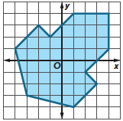
26. ANALYZE The figure shows the floor plan for a new gallery in an art museum. Describe every reflection or rotation that maps the gallery onto itself.

27. WRITE A regular polygon has magnitude of symmetry 15°. How many sides does the polygon have? Explain.

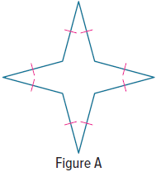
28. FIND THE ERROR Jaime says that Figure A has only line symmetry, and Jewel says that Figure A has only rotational symmetry. Is either of them correct? Explain your reasoning.

29. PERSEVERE A quadrilateral in the coordinate plane has exactly two lines
of symmetry, y = x – 1 and y = –x + 2. Find possible vertices for the figure.
Graph the figure and the lines of symmetry.

30. CREATE Draw a figure that has line symmetry but not rotational symmetry. Explain.

31. WRITE How are line symmetry and rotational symmetry related?

