Angles of Triangles ⸱ Practice

Example 1
Find the measure of each numbered angle.

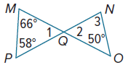
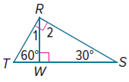
1. 2.

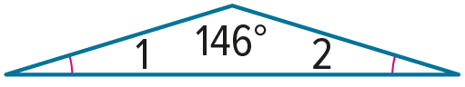
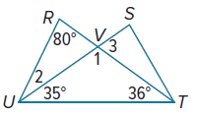
3. 4.

Example 2
Find each measure.
5. m∠ABC 6. m∠F
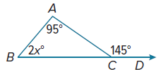
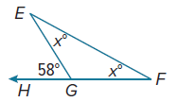

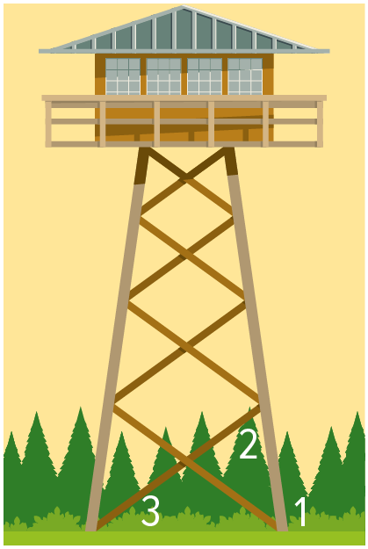

7. TOWERS A lookout tower sits on a network of struts and posts. Leslie measured two angles on the tower. If $m∠1=\left(7x-7\right)°$, $m∠2=\left(4x+2\right)°$, and $m∠3=\left(2x+6\right)°$, what is $m∠1$?

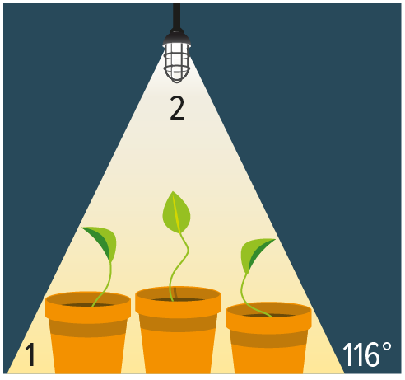
8. GARDENING A gardener uses a grow light to grow vegetables indoors. If $m∠1=\left(8x\right)°$ and $m∠2=\left(7x-4\right)°$, what is $m∠1$?

Example 3
Find each measure.
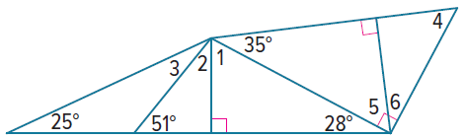
9. m∠1 10. m∠2

11. m∠3 12. m∠4

12. m∠5 14. m∠6

Mixed Exercises
Find the value of x. Then find the measure of each angle.
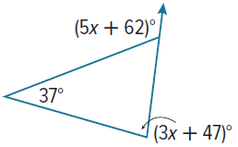
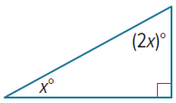
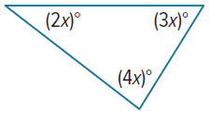
15. 16. 17.

18. CONSTRUCT ARGUMENTS Determine whether the following statement is true or false. If false, give a counterexample. If true, give an argument to support your conclusion.
If the sum of two acute angles of a triangle is greater than 90°,
then the triangle is acute.

PROOF Write the specified type of proof for each corollary.

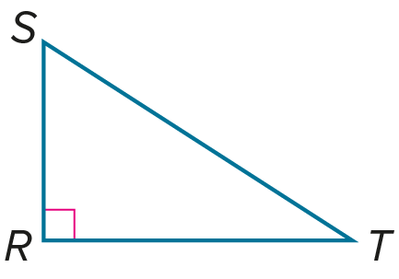
19. flow proof of Corollary 5.1
Given: $∠R$ is a right angle.
Prove: $∠S$ and $∠T$ are complementary.

20. paragraph proof of Corollary 5.2
a. Case 1 b. Case 2
Given: $△MNO$; $∠M$ is a right angle. Given: $△PQR$; $∠P$ is an obtuse angle.
Prove: There can be at most one right Prove: There can be at most one obtuse
angle in a triangle. angle in a triangle.

REASONING Solve each problem.
21. In triangle DEF, m∠E is three times m∠D, and m∠F is 9° less than m∠E. What is the measure of each angle?

22. In triangle RST, m∠T is 5° more than m∠R, and m∠S is 10° less than m∠T. What is the measure of each angle?

23. In triangle JKL, m∠K is four times m∠J, and m∠L is five times m∠J. What is the measure of
each angle?

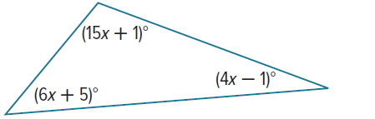
24. Classify the triangle shown by its angles. Justify your reasoning.

25. In ΔXYZ, m∠X = 157°, m∠Y = y°, and m∠Z = z°. Write an inequality to describe the possible measures of ∠Z. Justify your reasoning.

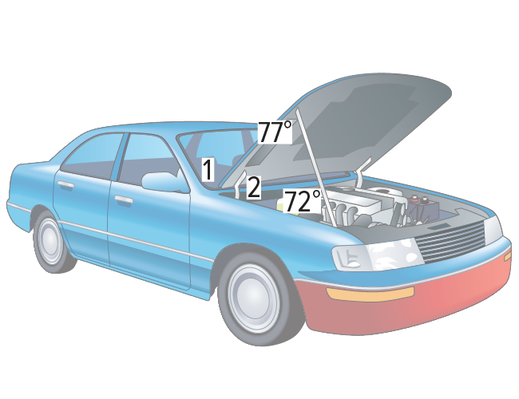
26. AUTOMOBILES Refer to the image at the right.
a. Find m∠1 and m∠2.

b. If the hood prop rod were shorter than the one shown, how would m∠1 change? Explain.

c. If the hood prop rod were shorter than the one shown, how would m∠2 change? Explain.
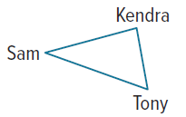

27. BASKETBALL Sam, Kendra, and Tony are passing a basketball. If Sam is looking at Kendra, then he needs to turn 40° to pass to Tony. If Tony is looking at Sam, then he needs to turn 50° to pass to Kendra. How many degrees would Kendra have to turn her head to look at Tony if she is looking at Sam?

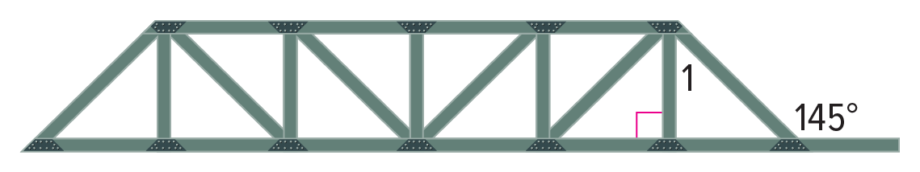
28. CONSTRUCTION The diagram shows an example of the Pratt Truss used in bridge construction. Find $m∠1$.

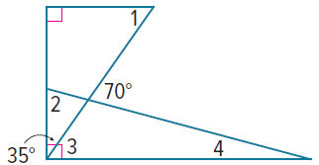
Find the measure of each numbered angle.
29.

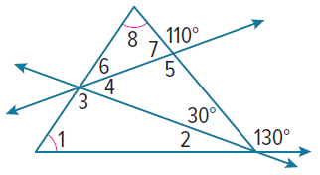
30.

31. USE TOOLS Use tracing paper to verify the Triangle Angle-Sum Theorem. Describe your method and include a sketch.

32. ANALYZE In ΔABC, if an exterior angle adjacent to ∠A is acute, is the triangle acute, right, or obtuse, or can its classification not be determined? Explain your reasoning.

33. WRITE Explain why a triangle cannot have an obtuse, acute, and a right exterior angle.

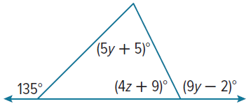
34. PERSEVERE Find the values of y and z in the figure at the right.

35. CREATE Construct a right triangle and measure one of the acute angles. Calculate the measure of the second acute angle and explain your method. Confirm your result using a protractor.

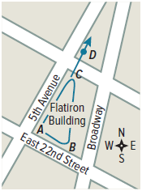
36. PERSEVERE The Flatiron Building in New York City is one of America’s oldest skyscrapers, completed in 1902. Its floor plan is approximately a right triangle. As shown in the figure, 5th Avenue is perpendicular to East 22nd Street, and m∠B is 10 less than
3 times m∠C.

a. Find the angle measures in the floor plan.

b. Find m∠BCD in two ways. Explain each method.

