Congruent Triangles ⸱ Practice

Example 1
Show that the polygons are congruent by identifying all the congruent corresponding parts. Then write a congruence statement.
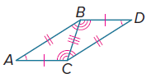
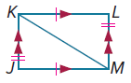
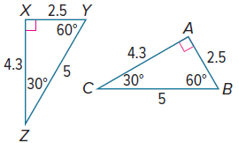
1. 2. 3.

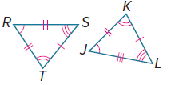
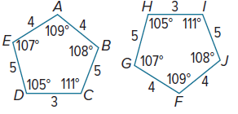
4. 5.

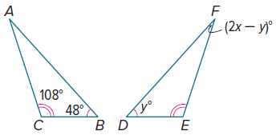
Example 2
In the diagram, △ABC ≅ △FDE.

6. Find the value of x.

7. Find the value of y.

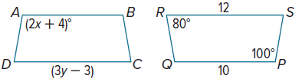
In the diagram, polygon ABCD ≅ polygon PQRS.

8. Find the value of x.

9. Find the value of y.

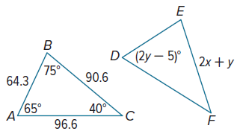

In the diagram, △ABC ≅ △DEF.

10. Find the value of x.

11. Find the value of y.

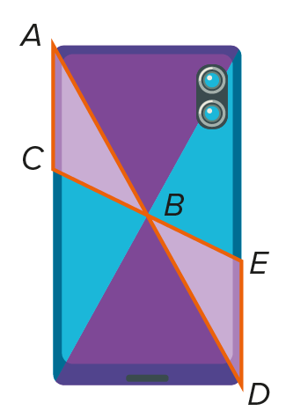
Example 3
12. DESIGN Camila is designing a new image for her cell phone case. If $m∠ABC=35°$, $m∠BAC=29°$, and $∠ACB≅∠DEB$, what is $m∠DEB$?

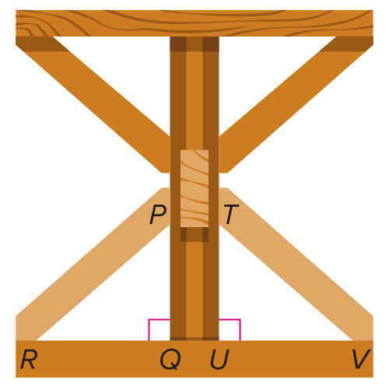
13. CARPENTRY Mr. Lewis is building a rustic dining table. Instead of having four legs, the table has a set of supports at each end. If $∠PRQ≅∠TVU$ and $m∠RPQ=49°$, what is $m∠TVU$?

Example 4
PROOF For 14-16, write a two-column proof.
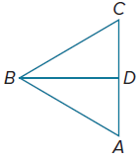
14. Given: $\overline{AB}$ ≅ $\overline{CB}$, $\overline{AD}$ ≅ $\overline{CD}$, ∠BAD≅ ∠BCD, $\overline{BD}$ bisects ∠ABC.
Prove: △ABD≅ △CBD

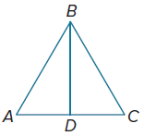
15. Given: $\overline{AB}$ ≅ $\overline{CB}$, $\overline{ AD}$ ≅ $\overline{CD}$, ∠ABD ≅ ∠CBD, ∠ADB ≅∠CDB
Prove: △ABD≅ △CBD

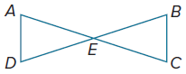
16. Given: ∠A ≅∠C, ∠D ≅∠B, $\overline{AD}$ ≅ $\overline{CB}$, $\overline{AE}$ ≅ $\overline{CE}$, $\overline{AC}$ bisects$\overline{BD}$.
Prove: △AED ≅ △CEB

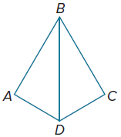
PROOF Write a paragraph proof.

17. Given: $\overline{BD}$ bisects ∠ABC and ∠ADC, $\overline{AB}$≅$\overline{CB}$, $\overline{AD}$ ≅$\overline{CD}$
Prove: △ABD≅ △CBD


Mixed Exercises
18. PRECISION Beverly is using loyalty cards at her coffee shop. When a customer purchases a cup of coffee, he or she can present a loyalty card to be stamped with a star-shaped stamp that Beverly purchased specifically for this use. When the customer collects nine stamps, they receive their tenth cup of coffee for free. What property guarantees that the stamped designs are congruent?

Draw and label a figure to represent the congruent triangles. Then find the values of x and y.
19. ΔABC ≅ ΔDEF, AB = 7, BC = 9, AC = 11 + x, DF = 3x‒ 13, and DE = 2y ‒ 5

20. ΔLMN ≅ ΔRST, m∠L = 49°, m∠M = 10y°, m∠S = 70°, and m∠T = (4x + 9)°

21. ΔJKL ≅ ΔMNP, JK = 12, LJ = 5, PM = 2x‒ 3, m∠L = 67°, m∠K = (y + 4)° and m∠N = (2y ‒ 15)°


22. SIERPINSKI TRIANGLE The figure shown is a portion of the Sierpinski triangle. The triangle has the property that any triangle made from any combination of edges is equilateral. How many triangles in this portion are congruent to the black triangle at the bottom?

23. LOGO DESIGNS Refer to the design shown.
a. Indicate the triangles that appear to be congruent.
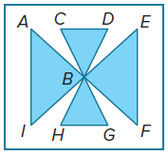
b. Name the congruent angles and congruent sides of a pair of congruent triangles.

24. REASONING Igor noticed on a map that the triangle with vertices that are at the supermarket, the library, and the post office (△SLP) is congruent to the triangle
with vertices that are at Igor’s home, Jasen’s home, and Daran’s home (△IJD). That is, △SLP ≅ △IJD.

a. The distance between the supermarket and the post office is 1 mile. Which path along the triangle △IJD is congruent to this?

b. The measure of ∠LPS is 40°. Identify the angle that is congruent to this angle
in △IJD.

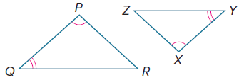
25. PROOF Complete the two-column proof of the Third Angles Theorem by providing the reason for each statement.

Given: ∠P ≅ ∠X and ∠Q ≅ ∠Y
Prove: ∠R ≅ ∠Z

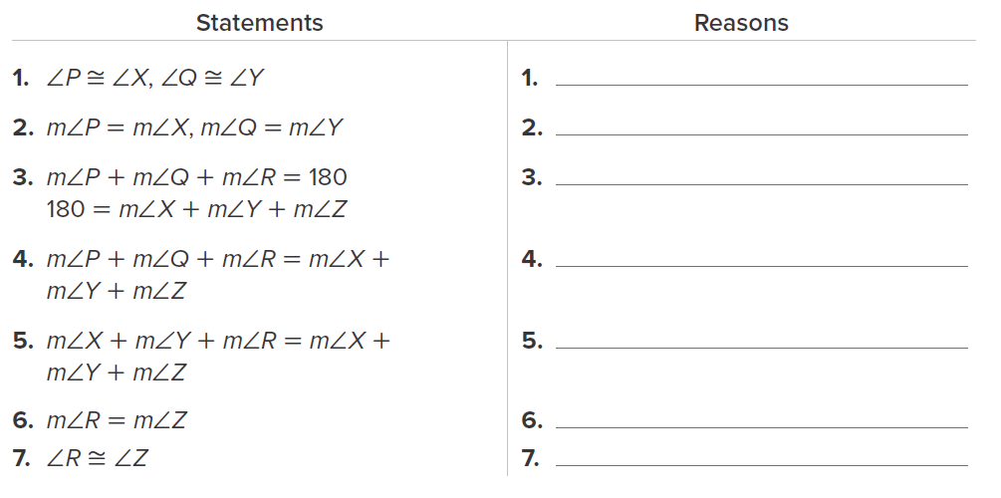

26. ANALYZE Determine whether the following statement is sometimes, always, or never true. Justify your argument.
Equilateral triangles are congruent.

27. CREATE A classmate is using the Third Angles Theorem to show that if two corresponding pairs of the angles of two triangles are congruent, then the third pair is also congruent. Write a question to help him decide if he can use the same strategy for quadrilaterals.

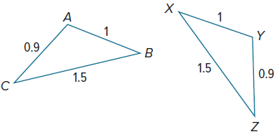

28. FIND THE ERROR Jasmine and West are evaluating the congruent figures at the right. Jasmine says that ΔCAB ≅ ΔZYX, and West says that ΔABC ≅ ΔYXZ. Is either of them correct? Explain your reasoning.

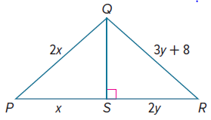
29. WRITE Justify why the order of the vertices is important when naming congruent triangles. Give an example to support your argument.

30. PERSEVERE Find the values of x and y if ΔPQS ≅ ΔRQS.

