Proving Triangles Congruent: SSS, SAS ⸱ Practice

Example 1
PROOF Write the specified type of proof.

1. two-column proof 2. flow proof
Given:$\overline{AB}$ ≅ $\overline{XY}$, $\overline{AC}$ ≅ $\overline{XZ}$, $\overline{BC}$ ≅ $\overline{YZ}$ Given: $\overline{RS}$ ≅ $\overline{UT}$, $\overline{RT}$ ≅ $\overline{US}$
Prove: △ABC ≅ △XYZ Prove: △RST ≅ △UTS
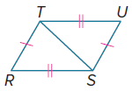
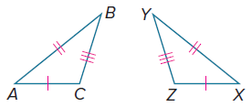

3. two-column proof 4. flow proof
Given: $\overline{AB}$ ≅ $\overline{CB}$, D is the midpoint of $\overline{AC.}$ Given: $\overline{RS}$ ≅ $\overline{TS}$, V is the midpoint of $\overline{RT}$.
Prove: △ABD ≅ △CBD Prove: △RSV ≅ △TSV
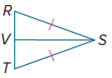
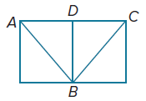

5. paragraph proof 6. two-column proof
Given: $\overline{QR}$ ≅ $\overline{SR}$, $\overline{ST}$ ≅ $\overline{QT}$ Given: $\overline{AB}$ ≅ $\overline{ED}$, $\overline{CA}$ ≅ $\overline{CE}$, $\overline{AC}$ bisects $\overline{BD}$
Prove: △QRT ≅ △SRT Prove: △ABC ≅ △EDC
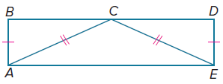
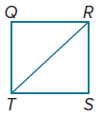

Example 2
REGULARITY Determine whether △DEF ≅ △PQR. Explain.
7. D(–6, 1), E(1, 2), F(–1, –4), P(0, 5), Q(7, 6), R(5, 0)

8. D(–7, –3), E(–4, –1), F(–2, –5), P(2, –2), Q(5, –4), R(0, –5)

Determine whether △ABC ≅ △KLM. Explain.
9. A(–3, 3), B(–1, 3), C(–3, 1), K(1, 4), L(3, 4), M(1, 6)

10. A(–4, –2), B(–4, 1), C(–1, –1), K(0, –2), L(0, 1), M(4, 1)

Example 3
PROOF Write the specified type of proof.

11. two-column proof 12. two-column proof
Given: NP = PM, $\overline{NP }$⊥$\overline{PL}$ Given: AB = CD, $\overline{AB}$ ∥ $\overline{CD}$
Prove: △NPL ≅ △MPL Prove: △ACD ≅ △DBA
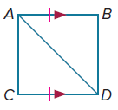
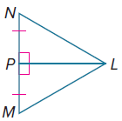

13. paragraph proof 14. flow proof
Given: V is the midpoint of $\overline{WX}$ and $\overline{YZ.}$ Given: $\overline{PR}$ ≅ $\overline{DE}$, $\overline{PT}$ ≅ $\overline{DF}$, ∠R ≅ ∠E, ∠T ≅ ∠F
Prove: △XVZ ≅ △WVY Prove: △PRT ≅ △DEF
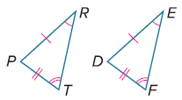
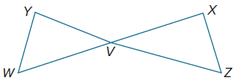

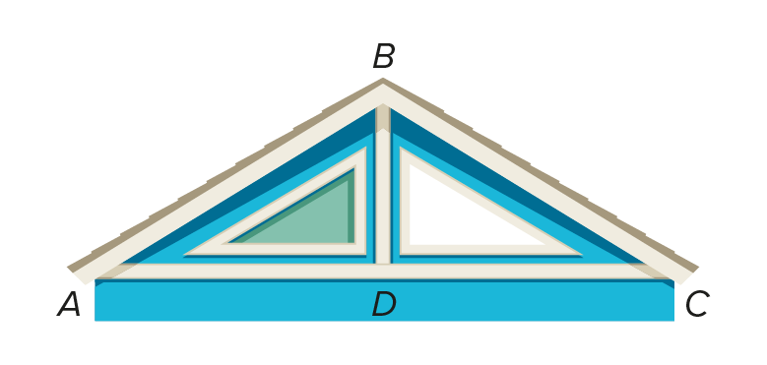

15. GAMING Devontae is building a house in a simulation video game. He wants the roof of the house and the main support beam to create congruent triangles. If $\overline{BD}⊥\overline{AC}$ and $\overline{BD}$ bisects $\overline{AC}$, write a two-column proof to prove $△$ABD ≅ $△$CBD.

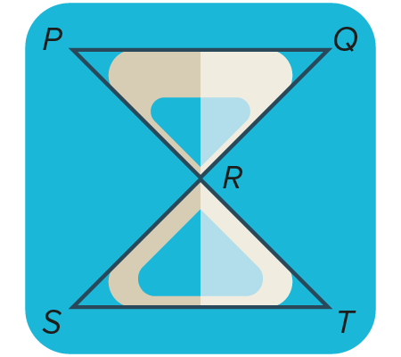

16. TECHNOLOGY Nevaeh has developed a new timer app. The icon for the app contains an hourglass that can be modeled by two triangles. If R is the midpoint of $\overline{QS}$ and $\overline{PT}$, write a paragraph proof to prove
$△$PRQ ≅ $△$TRS.

Mixed Exercises
Explain whether there is enough information given in each figure to prove that the triangles are congruent using SSS or SAS.

17. 18.
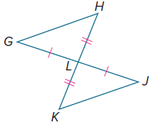
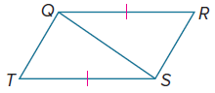

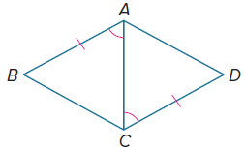
19. 20.
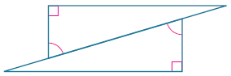

21. REASNONING Tyson had three sticks of lengths 24 inches, 28 inches, and 30 inches. Is it possible to make two non-congruent triangles using the same three sticks? Explain.


22. BAKERY Sonia made a sheet of baklava. She has markings on her pan so that she can cut them into large squares. After she cuts the pastry in squares, she cuts them diagonally to form two congruent triangles, as shown. Which postulate could you use to prove the two triangles congruent?

23. TILES Tammy installs bathroom tiles. Her current job requires tiles that are equilateral triangles, and the tiles have to be congruent to each other. She has a sack of tiles that are in the shape of equilateral triangles. She knows that all the tiles are equilateral, but she is not sure whether they are the same size. What must she measure on each tile to be sure that they are congruent?

24. CAKE Carl had a piece of cake in the shape of an isosceles triangle with angles measuring 26°, 77°, and 77°. He wanted to divide it into two equal parts, so he cut it through the middle of the 26°-angle to the midpoint of the opposite side. He claims that the two pieces are congruent. Do you agree? Explain.

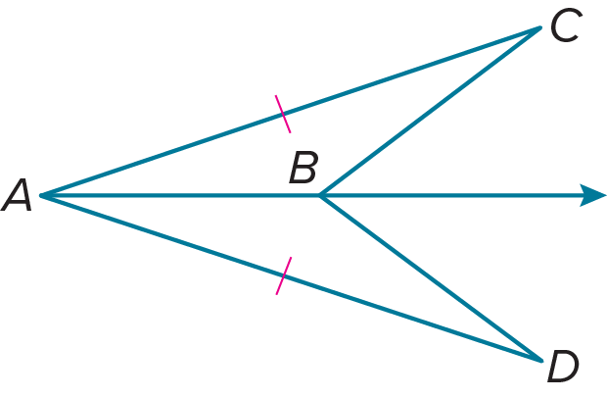
25. In the figure, $\overline{AC}≅ \overline{AD}$. Suppose you know $∠C≅∠D$. Can you prove that $△$ABC ≅ $△$ABD? Why or why not?

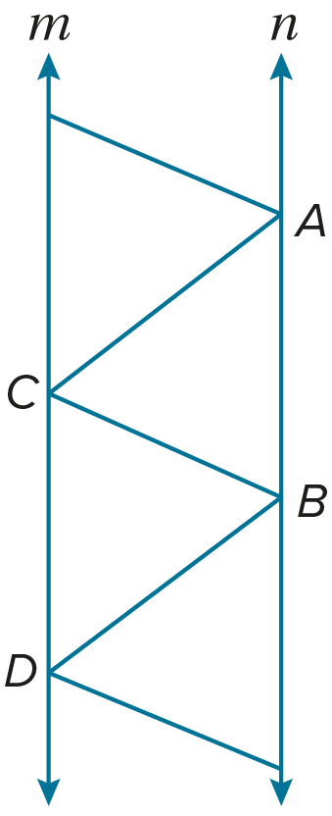
26. USE A SOURCE An engineer is designing a new cell phone tower. Part of the tower is shown in the figure. The engineer makes sure that line m is parallel to line n and that $\overline{AB}$ ≅ $\overline{CD}$.

a. Can the engineer prove that $△$ABC ≅ $△$DCB? Explain why or why not.

b. Go online to find an image of a bridge or a tower that is designed in such a way that you can prove that two triangles are congruent. Justify your image.

27. WHICH ONE DOESN’T BELONG? Determine which pair of triangles cannot be proven congruent using the SSS or SAS postulates. Justify your conclusion.

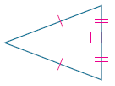
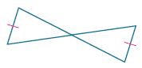
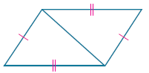

28. ANALYZE Determine whether the following statement is true or false. If true, justify your reasoning. If false, provide a counterexample.

If the congruent sides in one isosceles triangle have the same measure as the congruent sides in another isosceles triangle, then the triangles are congruent.

29. WRITE Two pairs of corresponding sides of two right triangles are congruent. Are the triangles congruent? Explain your reasoning.

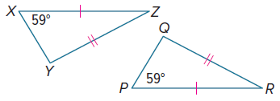
30. CREATE Use a straightedge to draw obtuse triangle ABC. Then construct ΔXYZ so that it is congruent to ΔABC using either SSS or SAS. Justify your construction mathematically and verify it using measurement.

31. FIND THE ERROR Bonnie says that $△$PQR ≅ $△$XYZ by SAS. Shada disagrees. She says that there is not enough information to prove that the two triangles are congruent. Is either of them correct? Explain your reasoning.

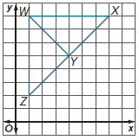
32. PERSEVERE Refer to the graph shown.

a. Describe two methods you could use to prove $△$WYZ ≅ $△$WYX. You may not use a ruler or protractor. Which method do you think is more efficient? Explain.

b. Are $△$WYZ and $△$WYX congruent? Explain your reasoning.

