Proving Triangles Congruent: ASA, AAS ⸱ Practice

Example 1
PROOF Write the specified type of proof.

1. two-column proof 2. two-column proof
Given: $\overline{AB}$ ∥ $\overline{CD}$, ∠CBD ≅ ∠ADB Given: ∠S ≅ ∠V, T is the midpoint of $\overline{SV}$.
Prove: △ABD ≅ △CDB Prove: △RTS ≅ △UTV
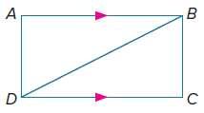
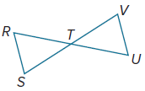

3. flow proof 4. paragraph proof
Given: $\overline{AB}$ ≅ $\overline{CB}$, ∠A ≅ ∠C, and Given: $\overline{CD}$ bisects $\overline{AE}$, $\overline{AB}$ ∥ $\overline{CD}$, and
$\overline{DB}$ bisects ∠ABC ∠E ≅ ∠BCA
Prove: $\overline{AD}$ ≅ $\overline{CD}$ Prove: △ABC ≅ △CDE
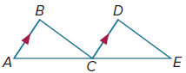
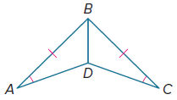

5. paragraph proof 6. paragraph proof
Given: $\overline{CE}$ bisects ∠BED; ∠BCE Given: ∠W ≅ ∠Y, $\overline{WZ}$ ≅ $\overline{YZ}$, and
and ∠ECD are right angles. $\overline{XZ}$ bisects ∠WZY
Prove: △ECB ≅ △ECD Prove: △XWZ ≅ △XYZ
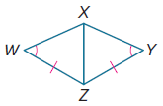
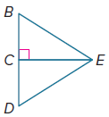

Example 2
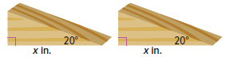
7. REASONING Two doorstops have cross sections that are right triangles. Both have a 20° angle, and the length of the side between the 90° and 20° angles are equal.

- Are the cross sections congruent? Explain.

- If each cross section has a height of 2 inches and x = 5, what is the combined area of the two cross sections?

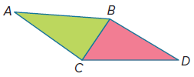
8. ARCHITECTURE An architect used the stained-glass window design in the diagram when remodeling an art studio.

- If ∠ABC ≅ ∠DCB and ∠ACB ≅ ∠DBC, prove that △BCA ≅ △CBD.
- If the height of △CBD is 1.4 meters and CD is 3.5 meters, how much glass is needed to make the entire window?

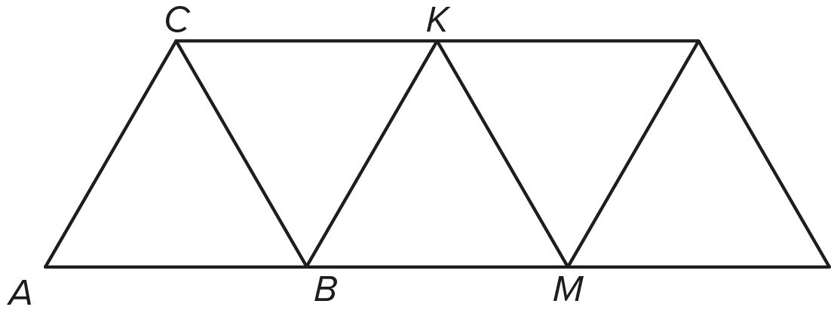
9. BRIDGES An engineering company that restores bridges needs to determine the amount of steel required to replace some trusses.
$\overline{AC}$ ∥ $\overline{BK}$, $\overline{CB}$ ∥ $\overline{KM}$, and B is the midpoint of $\overline{AM}$.
- Use the given information to confirm that △ABC ≅ △BMK.

b. △ABC is equilateral, and AB is 18.5 feet. What is the perimeter of quadrilateral ACKB?

PROOF Write the specified type of proof.
10. two-column proof 11. flow proof
Given: $\overline{BC}$ ∥ $\overline{EF}$, $\overline{AB}$ ≅ $\overline{DE}$, Given: ∠S ≅ ∠U, and $\overline{TR}$bisects ∠STU
∠C ≅ ∠F
Prove: △ABC ≅ △DEF Prove: △SRT ≅ △URT

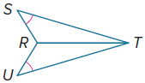
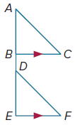

Example 3
PROOF Write the specified type of proof.

12. flow proof 13. paragraph proof
Given: $\overline{JK}$ ≅ $\overline{MK}$, ∠N ≅ ∠L Given: $\overline{DE}$ ∥ $\overline{FG}$, ∠E ≅ ∠G
Prove: △JKN ≅ △MKL Prove: △DFG ≅ △FDE
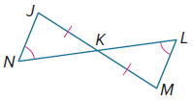
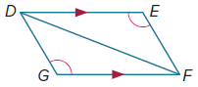

14. two-column proof 15. two-column proof
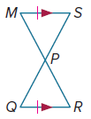
Given: V is the midpoint of $\overline{YW}$; Given: $\overline{MS}$ ≅ $\overline{RQ}$,
$\overline{UY}$ ∥ $\overline{XW}$. $\overline{MS}$ ∥ $\overline{RQ}$
Prove: △UVY ≅ △XVW Prove: △MSP ≅ △RQP
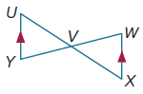

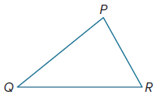
Mixed Exercises

16. USE TOOLS Use a compass and straightedge and the ASA Congruence Postulate to construct a triangle congruent to △PQR.

17. PRECISION Two people decide to take a walk. One person is in Bombay and the other is in Milwaukee. They start by walking straight for 1 kilometer. Then both turn right at an angle of 110° and continue to walk straight again. After a while, both turn right again, but this time at an angle of 120°. Both walk straight for a while in this new direction until they end up where they started. Each person walked in a triangular path at their location. Are the two triangles they formed congruent? Explain.

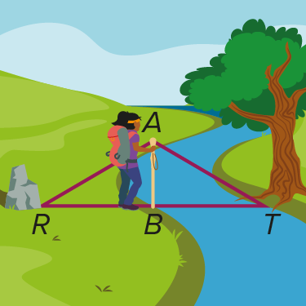
18. USE ESTIMATION Delma came to a river during a hike, and she wanted to estimate the distance across it. She held her walking stick $\overline{AB}$ vertically on the ground at the edge of the river and sighted along the top of the stick across the river to the base of a tree T. Then she turned without changing the angle of her head and sighted along the top of the stick to a rock, R, located on her side of the river.

a. Explain why △ABT ≅ △ABR.

b. Delma finds that it takes 27 paces to walk from her current location to the rock. She also knows that each of her paces is 14 inches long. Explain how she can use this information to estimate the distance across the river.

19. PROOF Write a paragraph proof.
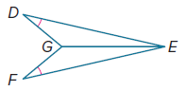
Given: ∠D ≅ ∠F
$\overline{GE}$ bisects ∠DEF.
Prove: $\overline{DG}$ ≅ $\overline{FG}$

20. ANALYZE Find a counterexample to show why SSA (Side-Side-Angle) cannot be used to prove the congruence of two triangles.

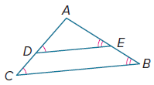
21. FIND THE ERROR Tyrone says it is not possible to show that △ADE ≅ △ACB. Lorenzo disagrees, explaining that because ∠ADE ≅ ∠ACB, $∠AED≅∠ABC$, and ∠A ≅ ∠A by the Reflexive Property, △ADE ≅ △ACB. Who is correct? Explain your reasoning.

22. CREATE Draw and label two triangles that could be proved congruent by ASA.

23. WRITE How do you know which method (SSS, SAS, and so on) to use when you are proving triangle congruence? Use a table to explain your reasoning.
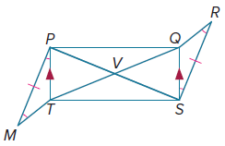

24. PROOF Using the information given in the diagram, write a flow proof to show that △PVQ ≅ △SVT.

