Proving Right Triangles Congruent ⸱ Practice

Example 1
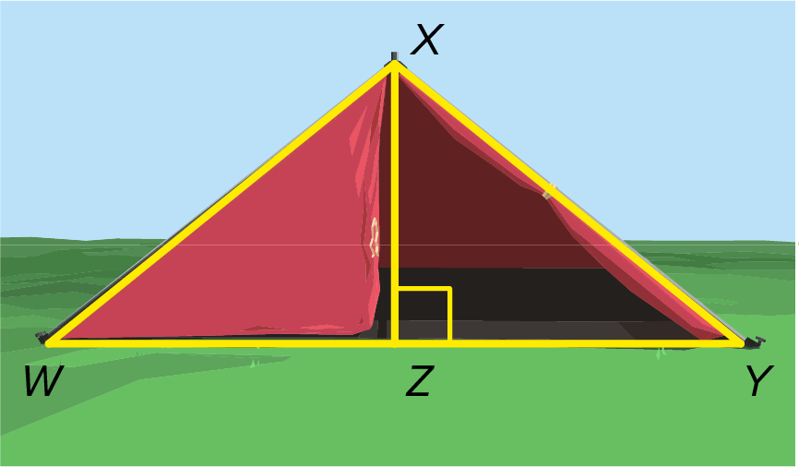
1. CAMPING In the diagram of the pup tent, the support pole is perpendicular to the ground. The base of the support pole is located at the midpoint of the segment connecting the bottom of the sides of the tent. Write a two-column proof to show that the triangles formed by the support pole are congruent.

Given: $\overline{XZ}$ ⊥ $\overline{WY}$, Z is the midpoint of $\overline{WY}$.

Prove: △WXZ ≅ △YXZ.
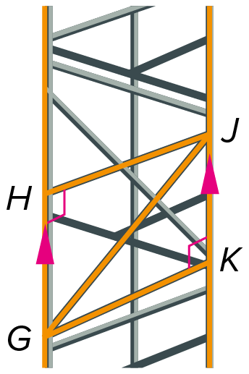
2. TOWERS The cell phone tower has parallel poles and diagonal support beams that form two triangles. Write a two-column proof to show that the triangles are congruent.

Given: ∠H and ∠K are right angles.
$\overline{GH}$ ∥ $\overline{KJ}$
Prove: △GKJ ≅ △JHG

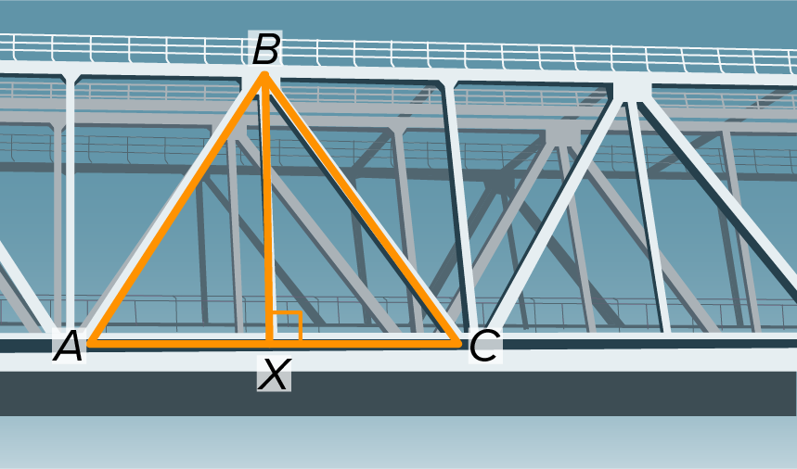
3. BRIDGES In the diagram, the vertical support beam, $\overline{BX}$, is perpendicular to the deck of the bridge. The two diagonals, $\overline{AB}$ and $\overline{CB}$, are equal in length. Write a two-column proof to show that the triangles formed by the vertical support beam are congruent.

Given: $\overline{BX}$ ⊥ $\overline{AC}$; AB = CB

Prove: △AXB ≅ △CXB

Mixed Exercises
Determine whether each pair of triangles is congruent. If yes, include the theorem that applies.

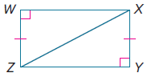
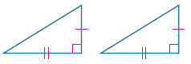
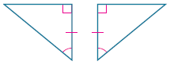
4. 5. 6.

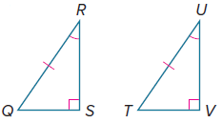
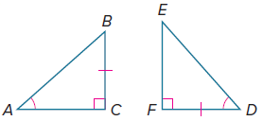
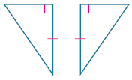
7. 8. 9.

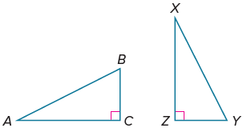
10. Which pairs of corresponding parts need
to be congruent to prove that △ABC ≅ △XYZ using the
indicated theorem?

a. HA

b. LL

11. PROOF Write a two-column proof.
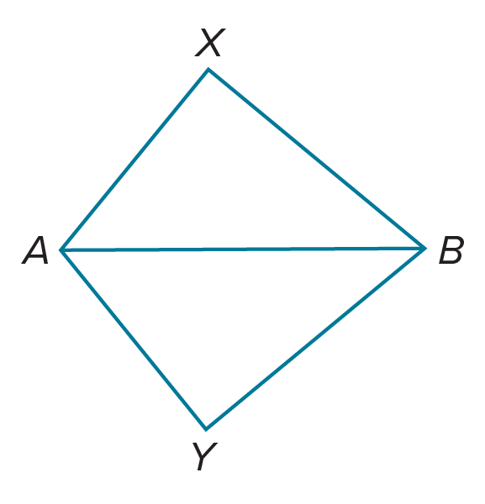
Given: $\overline{BX}$ ⊥ $\overline{XA},$ $\overline{BY}$ ⊥ $\overline{YA},$ and $\overline{XA}$ $≅$ $\overline{YA}$

Prove: △BXA ≅ △BYA

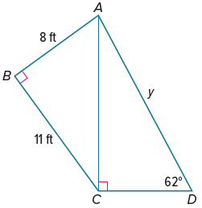

12.WRITE The sketch shows the side view of a sculpture that is being designed by an artist. Determine whether △ABC ≅ △DCA. If yes, then provide a paragraph proof. If no, then explain
your reasoning.

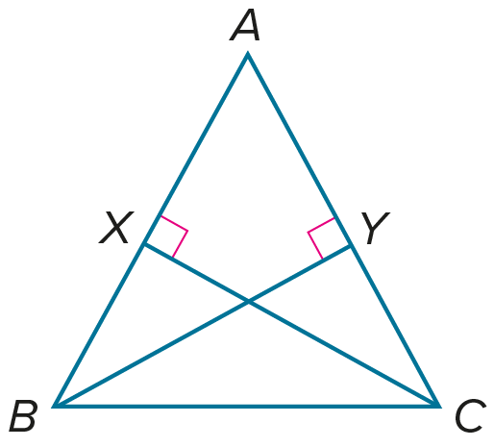
13. PROOF Write a paragraph proof.

Given: $\overline{BY}$ ⊥ $\overline{AC}$; $\overline{CX}$ ⊥ $\overline{AB}$; AX = AY

Prove: △ABY ≅ △ACX

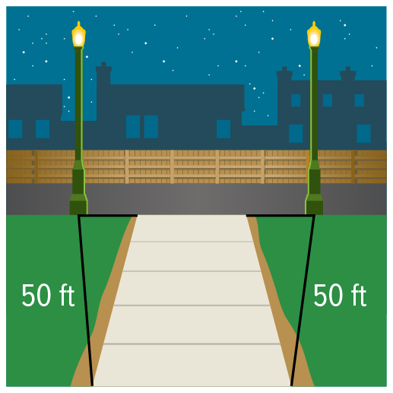
14. FIND THE ERROR The Harding Family recently hired an electrical contractor to install two light posts on opposite sides of the end of the walkway that leads from the rear of their house to the alley. They wanted the contractor to install the posts so their distances from the end of the walkway were equal in length. Suppose two triangles are drawn from the light posts to both ends of the walkway as shown. Josephine says that it can be proved with a right triangle congruency theorem that the posts are equidistant from the end of the driveway. Is Josephine’s conclusion correct? Explain your reasoning.

