Isosceles and Equilateral Triangles ⸱ Practice

Example 1
1. PROOF Write a two-column proof.
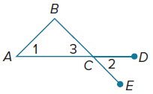
Given: ∠1 ≅ ∠2
Prove: $\overline{AB}$ ≅ $\overline{CB}$

2. PROOF Write a two-column proof.
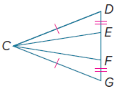
Given: $\overline{CD}$ ≅ $\overline{CG}$
$\overline{DE}$ ≅ $\overline{GF}$
Prove: $\overline{CE}$ ≅ $\overline{CF}$

3. PROOF Write a two-column proof.
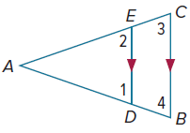
Given: $\overline{DE}$ ∥ $\overline{BC}$
∠1 ≅ ∠2
Prove: $\overline{AB}$ ≅ $\overline{AC}$

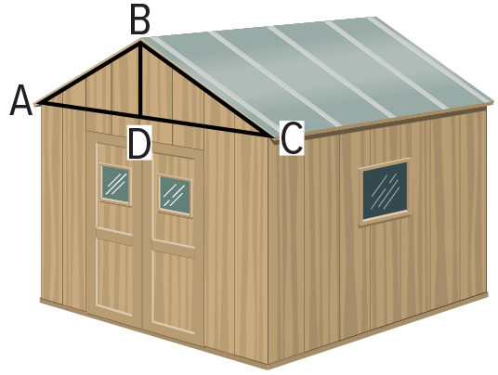
4. ROOFS In the picture, $\overline{BD}$ ⊥ $\overline{AC}$ and ΔABC is an isosceles triangle with base $\overline{AC}$. Write a two-column proof to prove that $\overline{BD}$ bisects the angle formed by the sloped sides of the roof, ∠ABC.

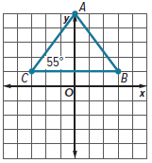
Example 2
5. Refer to the figure.

a. Find the measures of the sides of $△$ABC. Show your work.

b. Find $m∠A$. Show your work.

6. Find SR, ST, RT, m∠TRS, and m∠RST. 7. Find the measures of ∠DEF and ∠EFD.
Round to the nearest tenth, if necessary. Round to the nearest tenth, if necessary.

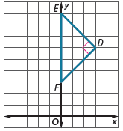
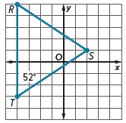

Examples 3 and 4

8. Find the value of x. 9. Find m∠B and AC. 10. Find the value of x.
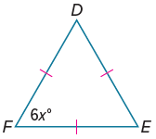
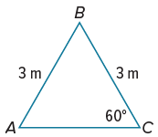
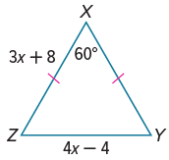

11. Find m∠Y and WY. 12. Find the value of x. 13. Find the value of x.
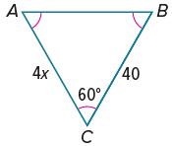
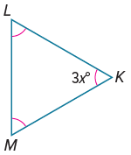
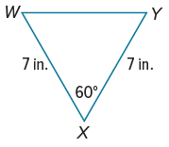

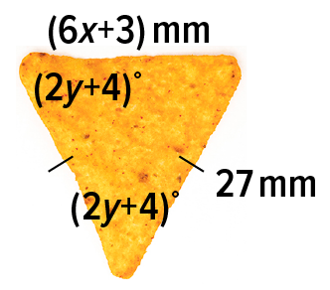
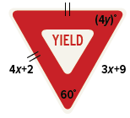
14. CHIPS Some tortilla chips can be 15. SIGNS Yield signs notify drivers to slow
modeled by a triangle. down and allow oncoming vehicles to
proceed first.
a. Solve for x. a. Solve for x.
b. Solve for y. b. Solve for y.

Mixed Exercises
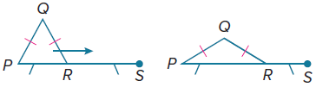
16. PROOF Julita works for a company that makes lounge chairs. As shown in the figure, the back of each chair is an isosceles triangle that can be adjusted so the person sitting on the chair can recline.

Suppose the chair is adjusted so that m∠Q = 50°. What is m∠QRS? Write a paragraph proof to justify your answer.

17. STRUCTURE Each of the triangles shown is isosceles.

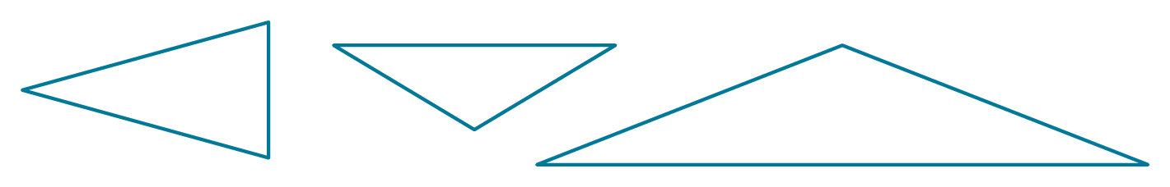

a. Use a ruler to find the midpoint of each side of each triangle. Then draw a triangle formed by connecting the midpoints of each side.

b. Look for patterns in your drawings. Make a conjecture about what you notice.
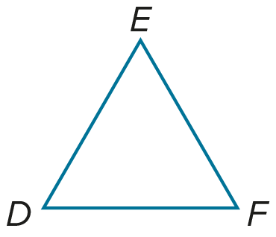

18. PROOF Write a two-column proof to prove each case of Corollary 5.3.
a. Case 1 b. Case 2
Given: $△$DEF is an equilateral triangle. Given: $△$DEF is an equilangular triangle.
Prove: $△$DEF is an equilangular triangle. Prove: $△$DEF is an equilateral triangle.

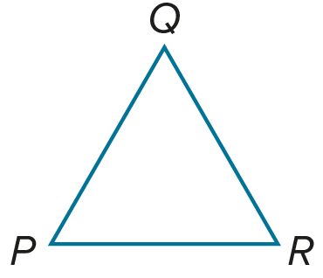
19. PROOF Write a two-column proof to prove Corollary 5.4.
Given: $△$PQR is an equilateral triangle.
Prove: $m∠P= m∠Q=m∠R=60°$

REGULARITY Find each measure.

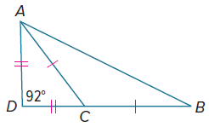
20. m∠CAD

21. m∠ACD

22. m∠ACB

23. m∠ABC
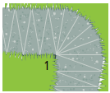
24. PATHS A marble path, as shown at the right, is constructed out of several congruent isosceles triangles. The vertex angles measure 20°. What is the measure of angle 1 in the figure?

25. PRECISION Construct three different isosceles right triangles. Explain your method. Then verify your constructions using measurement and mathematics.

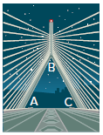
26. STATE YOUR ASSUMPTIONS Every day, cars drive through approximate isosceles triangles when they go over the Leonard Zakim Bridge in Boston. The ten-lane roadway forms the bases of the triangles.

a. If m∠A = 67°, find m∠B.

b. Find m∠C.

c. What assumption is made when approximating that the bridge forms isosceles triangles?

ANALYZE Determine whether the following statements are sometimes, always,
or never true. Justify your argument.

27. If the measure of the vertex angle of an isosceles triangle is an integer, then the measure of each base angle is an integer.

28. If the measures of the base angles of an isosceles triangle are integers, then the measure of its vertex angle is odd.

29. CREATE If possible, draw an isosceles triangle with base angles that are obtuse. If it is not possible, explain why not.

30. WRITE How can triangle classifications help you prove triangle congruence?

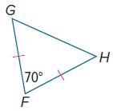
31. FIND THE ERROR Darshan and Miguela are finding m∠G in the figure. Darshan says that m∠G = 35°, and Miguela says that m∠G = 60°. Is either of them correct? Explain your reasoning.

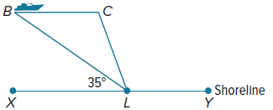
32. PERSEVERE A boat is traveling at 25 mi/h parallel to a straight section of the shoreline, $\overline{XY}$, as shown. An observer in a lighthouse L spots the boat when the angle formed by the boat, the lighthouse, and the shoreline is 35°. The observer spots the boat again when m∠CLX = 70°.

a. Explain how you can prove that $△$BCL is isosceles.

b. It takes the boat about 15 minutes to travel from point B to point C. When the boat is at point C, what is the distance to the lighthouse?

