Triangles and Coordinate Proof ⸱ Practice

Example 1
REGULARITY Position and label each triangle on the coordinate plane.
- isosceles $△$ABC with base $\overline{AB}$ that is a units long and height that is b units

2. right $△$XYZ with hypotenuse $\overline{YZ}$, leg $\overline{XY}$ that is b units long, and leg $\overline{XZ}$ that is three times the length of $\overline{XY}$

3. isosceles right $△$RST with hypotenuse $\overline{RS}$ and legs 3a units long

4. right $△$JKL with legs $\overline{JK}$ and $\overline{KL}$ such that $\overline{JK}$ is a units long and leg $\overline{KL}$ is 4b units long

Example 2
Name the missing coordinate(s) of each triangle.

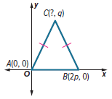
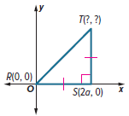
5. 6.

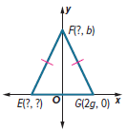
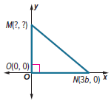
7. 8.

Examples 3 and 4
PROOF For Exercises 9-13, write a coordinate proof for each statement.
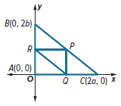
9. The segments joining the midpoints of the sides of a right triangle form a right triangle.
Given: Point R is the midpoint of $\overline{AB}$.
Point P is the midpoint of $\overline{BC}$.
Point Q is the midpoint of $\overline{AC}$.
Prove: $△$RPQ is a right triangle.

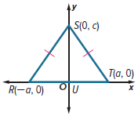
10. A segment from the vertex angle of an isosceles triangle to the midpoint of the base is perpendicular to the base.

Given: Isosceles △RST; U is the midpoint of base $\overline{RT}$.
Prove: $\overline{SU}$ ⊥ $\overline{RT}$

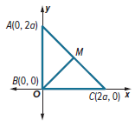
11. In an isosceles right triangle, the segment from the vertex of the right angle to the midpoint of the hypotenuse is perpendicular to the hypotenuse.

Given: isosceles right △ABC with right angle ∠ABC; M the midpoint of $\overline{AC}$.
Prove: $\overline{BM}$ ⊥ $\overline{AC}$

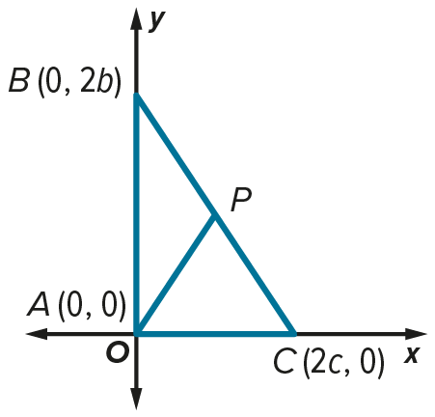
12. The measure of the segment that joins the vertex of the right angle in a right triangle to the midpoint of the hypotenuse is one-half the measure of the hypotenuse.

Given: right △ABC; P is the midpoint of $\overline{BC}$.
Prove: $AP=\frac{1}{2}BC$

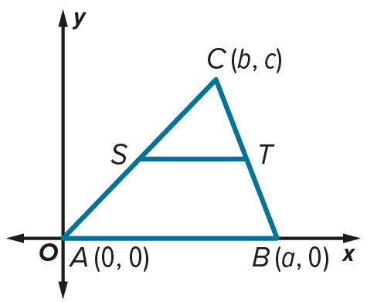
13. If a line segment joins the midpoints of two sides of a triangle, then its length is equal to one half the length of the third side.

Given: S is the midpoint of $\overline{AC.}$
T is the midpoint of $\overline{BC}$.
Prove: $ST=\frac{1}{2}AB$

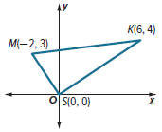
Example 5
14. NEIGHBORHOODS Kalini lives 6 miles east and 4 miles north of her high school. After school, she works part time at the mall in a music store. The mall is 2 miles west and 3 miles north of the school. Use coordinate geometry to determine the type of triangle formed by Kalini’s high school, her home, and the mall.

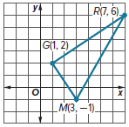
15. COUNTY FAIR The fair committee wants to print a map to distribute to vendors as they arrive to set up their booths at the fairgrounds. On a coordinate grid, the main gate is located at (3, ‒1), the grandstand is located at (1, 2), and the rides and games are located at (7, 6). Use coordinate geometry to determine the type of triangle formed by these locations.

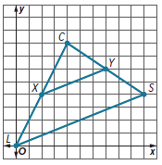
16. USE ESTIMATION A town is preparing for a 5K run. The race will start at city hall C. The course will take runners along straight streets to the library L, to the science museum S, and back to city hall for the finish.
a. Estimate the type of triangle formed by the course.
b. Use coordinate geometry to determine the type of triangle formed.

Mixed Exercises

REASONING For exercises 17 and 18, determine whether the triangle can be a right triangle. Explain.

17. X(0, 0), Y(2h, 2h), Z(4h, 0) 18. X(0, 0), Y(1, h), Z(2h, 0)

19. SHELVES Martha has a shelf bracket shaped like a right isosceles triangle. She wants to know the length of the hypotenuse relative to the sides. She does not have a ruler but remembers the Distance Formula. She places the bracket in Quadrant I of a coordinate grid with the right angle at the origin. The length of each leg is a. What are the coordinates of the vertices that form the two acute angles?


20. FLAGS A flag is shaped like an isosceles triangle. A designer would like to make a drawing of the flag on a coordinate plane. She positions it so the base of the triangle is on the y-axis with one endpoint located at (0, 0). She locates the tip of the flag at $\left(a, \frac{b}{2}\right)$. What are the coordinates of the third vertex?

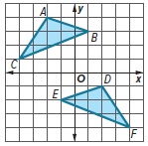
21. DESIGN Andrew is using a coordinate plane to design a quilt. Two of the triangular patches for the quilt are shown in the figure. Andrew wants to be sure that ∠A and ∠D have the same measure. Describe the main steps you can use to prove that ∠A ≅ ∠D.

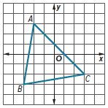
22. COMMUNITY A landscape architect is using a coordinate plane to design a triangular community garden. The fence that will surround the garden is modeled by $△$ABC. The architect wants to know whether any of the three angles in the fence will be congruent. Determine the answer for the architect and give a coordinate proof to justify your response.

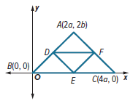
23. $△$ABC is isosceles with $\overline{AB}≅\overline{AC}$. D is the midpoint of $\overline{AB}$, E is the midpoint of $\overline{BC}$, and F is the midpoint of $\overline{AC}$. What are the coordinates of D, E, and F?

24. DRAFTING An engineer is designing a roadway. Three roads intersect to form a triangle. The engineer marks two vertices of the triangle at (–5, 0) and (5, 0) on a coordinate plane.
a. Describe the set of points in the coordinate plane that could not be used as the third vertex of the triangle.
b. Describe the set of points in the coordinate plane that could be the vertex of an isosceles triangle.
c. Describe the set of points in the coordinate plane that would make a right triangle with the other two points if the right angle is located at (‒5, 0).

25. CREATE Draw an isosceles right triangle on the coordinate plane so the midpoint of its hypotenuse is the origin. Label the coordinates of the vertex.

26. WRITE Explain why following each guideline for placing a triangle on the coordinate plane is helpful in proving coordinate proofs.

a. Use the origin as a vertex of the triangle.

b. Place at least one side of the triangle on the x- or y-axis.

c. Keep the triangle within the first quadrant if possible.

PERSEVERE Find the coordinates of point L so $△$JKL is the indicated type of triangle. Point J has coordinates (0, 0), and point K has coordinates (2a, 2b).

27. scalene triangle 28. right triangle 29. isosceles triangle

30. ANALYZE The midpoints of the sides of a triangle are located at (a, 0), (2a, b) and (a, b). If one vertex is located at the origin, what are the coordinates of the other vertices? Explain your reasoning.

