Perpendicular Bisectors ⸱ Practice

Examples 1 and 2
Find each measure.

1. FM 2. XW 3. BF
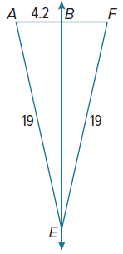
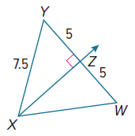
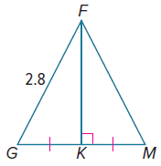

4. KL 5. TP 6. KL
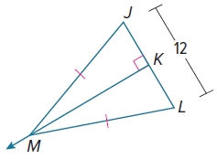
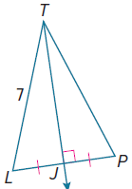
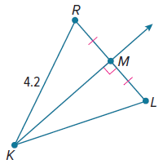

Example 3

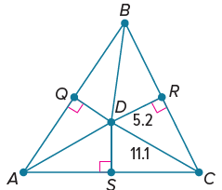  7. Find BR if D is the circumcenter of $△$ABC, CD = 11.1, and RD = 5.2. Round to the nearest tenth. | 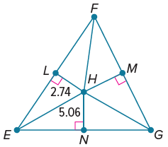  8. Find FL if H is the circumcenter of $△$EFG, EH = 5.06, and LH = 2.74. Round to the nearest hundredth.

Example 4
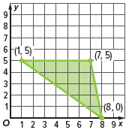
9. A monument will be at the circumcenter of a triangular plot of land at the state capital. On the coordinate grid, the vertices of the triangular plot of land are A(1, 5), B(7, 5), and C(8, 0). Estimate the coordinates of the location where the monument will be built.

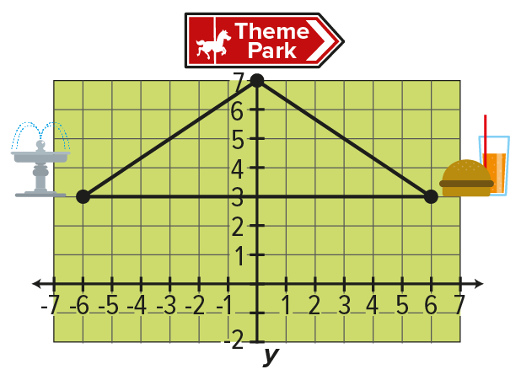
10. The designers of a new amusement park want to locate the restrooms the same distance from the park’s entrance, the fountain, and the food court. Estimate the coordinates of the restrooms.

Mixed Exercises
Find the value of x.
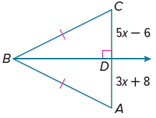
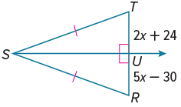
11. 12.

Determine whether there is enough information given in each diagram to find the value of x. If there is, find the value of x. If there is not, explain what needs to be given.
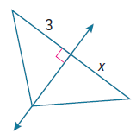
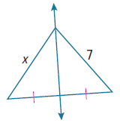
13. 14.

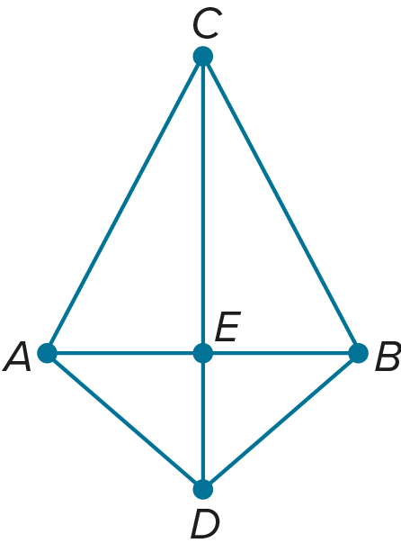
PROOF Use the figure to complete the following proofs.
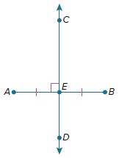
15. Write a paragraph proof of the Perpendicular Bisector Theorem (Theorem 6.1).

Given: $\overset{⃡}{CD}$ is the perpendicular bisector of $\overline{AB}$.
Prove: C is equidistant from A
and B.

16. Write a two-column proof of the Converse of the Perpendicular Bisector Theorem (Theorem 6.2).

Given: $\overline{CA}≅\overline{CB}, \overline{AD}≅\overline{BD}$
Prove: C and D are on the perpendicular bisector of $\overline{AB}$.

Find the coordinates of the circumcenter of the triangle with the given vertices. Explain.
17. A(0, 0), B(0, 6), C(10, 0) 18. J(5, 0), K(5, ‒8), L(0, 0)

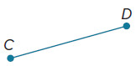
19. Consider $\overline{CD}$. Describe the set of all points in space that are equidistant from C and D.

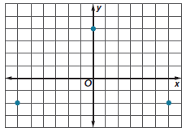
20. YARDWORK Martina has a front yard with three trees. The figure shows the locations of the trees on a coordinate plane. Martina would like to place an inground sprinkler at a location that is the same distance from all three trees. At what point on the coordinate grid should Martina place the sprinkler?

21. CREATE On a baseball diamond, home plate and second base lie on the perpendicular bisector of the line segment that joins first and third base. First base is 90 feet from home plate. How far is it from third base to home plate? Sketch a baseball diamond, labeling home plate as point A, first base as B, second base as C, and third base as D. Label the intersection of $\overline{AC}$ and $\overline{BD}$ as E. Using the Perpendicular Bisector Theorem, determine how far it is from third base to home plate. Describe your conclusion in the context of the situation.

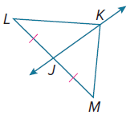
22. FIND THE ERROR Thiago says that from the information supplied in the diagram, he can conclude that K is on the perpendicular bisector of $\overline{LM}$. Caitlyn disagrees. Is either of them correct? Explain your reasoning.

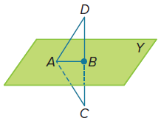
23. PROF Write a two-column proof.
Given: Plane Y is a perpendicular bisector of $\overline{DC}$.
Prove: ∠ADB ≅ ∠ACB.

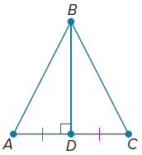
24. PROOF Write a paragraph proof.
Given: $\overline{BD}$ is the perpendicular bisector of $\overline{AC}$.
$△$ABC is isosceles with base $\overline{AC}$.
Prove: $△$ADB ≅ $△$CDB.

