Angle Bisectors ⸱ Practice

Examples 1 and 2
Find each measure.

1. m∠ABE 2. m∠YBA 3. MK
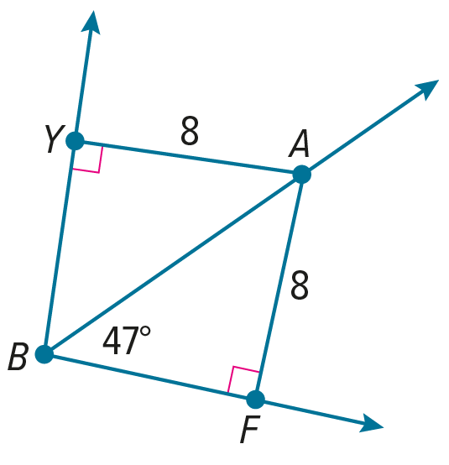
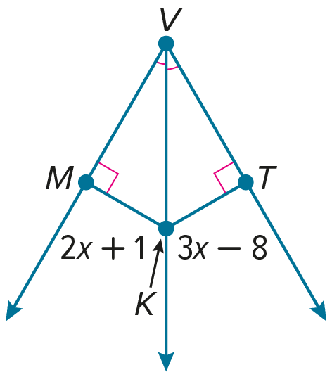
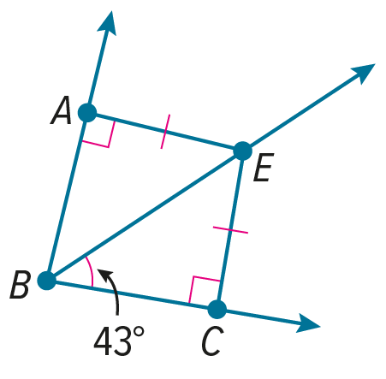

4. m∠EWL 5. IU 6. m∠MYW
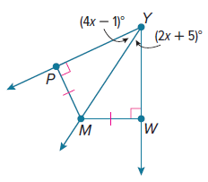
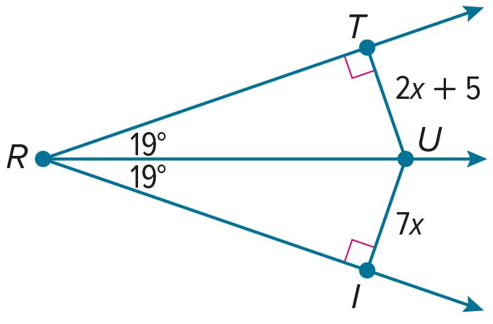
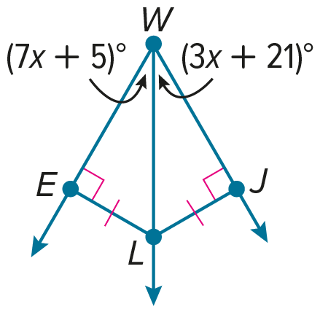

Example 3
A is the incenter of $△$PQR. Find each measure.
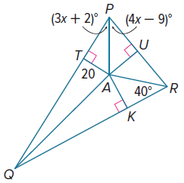
7. m∠ARU

8. AU

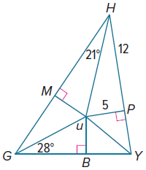
U is the incenter of $△$GHY. Find each measure.

9. m∠UGM

10. m∠PHU

11. HU

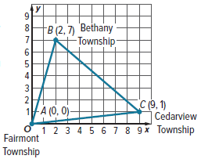
Example 4
12. CITY PLANNING City planning officials want the location of a new electric car charging station to be equidistant from the three townships shown on the coordinate plane. Find the approximate location of the charging station so that it is equidistant from the roads connecting the townships of Fairmont, Bethany, and Cedarview.

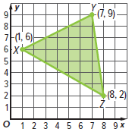
13. SCHOOL The alumni foundation will donate a new fountain for the high school’s courtyard. The entrances to the courtyard are located at points X¸ Y, and Z. Find the approximate location of the center of the fountain so that it is equidistant from the sides of the courtyard.

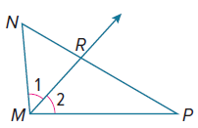
Mixed Exercises
14. REASONING $\vec{MR}$ is the angle bisector of
∠NMP. Find the value of x if m∠1 = 5x + 8 and
m∠2 = 8x – 16.

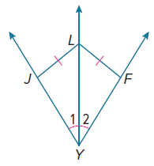

15. REASONING $\vec{YL}$ is the angle bisector of ∠JYF. Find the value of x if m∠1 = 8x + 10 and m∠2 = 11x – 8.

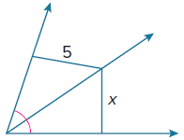
16. Determine whether there is enough information given in the diagram to find the value of x. Explain your reasoning.

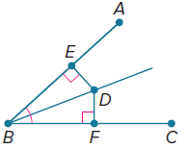
17. PROOF Write a paragraph proof of the Angle Bisector Theorem.
Given: $\overline{BD}$ is the angle bisector of ∠ABC.
Prove: D is equidistant from $\overline{AB}$ and $\overline{BC}$.

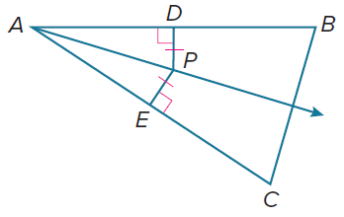
18. PROOF Write a paragraph proof of the Converse of the Angle Bisector Theorem.
Given: P is in the interior of $∠BAC$, and P is equidistant from $\overline{AB}$ and $\overline{AC}$at D and E, respectively.
Prove: $\overline{AP}$ is the angle bisector of $∠BAC.$

19. PROOF Write a two-column proof of the Incenter Theorem.
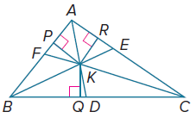
Given: $△$ABC has angle bisectors $\overline{AD}$, $\overline{BE}$, and $\overline{CF}$.
$\overline{KP}$ ⊥ $\overline{AB}$, $\overline{KQ}$ ⊥ $\overline{BC}$, $\overline{KR}$ ⊥ $\overline{AC}$
Prove: KP = KQ = KR

20. CONSTRUCT ARGUMENTS State whether the following sentence is sometimes, always, or never true. Justify your argument.

The three angle bisectors of a triangle intersect at a point in the exterior of the triangle.

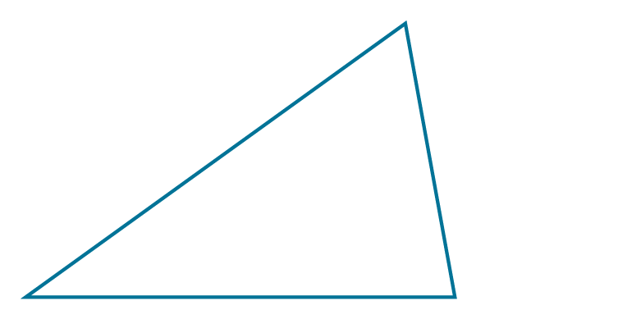
21. USE TOOLS Construct the incenter of the triangle shown. How could you use a ruler to verify your construction?

22. CREATE Draw a triangle with an incenter located inside the triangle and a circumcenter
located outside. Justify your drawing using a straightedge and a compass to find both
points of concurrency.

ANALYZE Determine whether each statement is sometimes, always, or never true. Justify your argument using a counterexample or proof.

23. The angle bisectors of a triangle intersect at a point that is equidistant from the vertices of
the triangle.

24. In an isosceles triangle, the perpendicular bisector of the base is also the angle bisector of the opposite vertex.

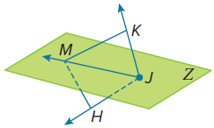
25. PROOF Write a two-column proof.
Given: Plane Z is an angle bisector of ∠KJH.
$\overline{KJ}≅\overline{HJ}$
Prove: $\overline{MH}≅\overline{MK}$

26. WRITE Compare and contrast the perpendicular bisectors and angle bisectors of a triangle. How are they alike? How are they different? Be sure to compare their points of concurrency.

27. WRITE Write a biconditional statement for Theorem 6.4 and its converse.

