Medians and Altitudes of Triangles ⸱ Practice

Examples 1 and 2
In $△$CDE, U is the centroid, UK = 12, EM = 21, and UD = 9. Find each measure.
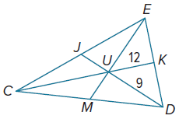
1. CU 2. MU

3. EU 4. JD

In $△$ABC, AU = 16, BU = 12, and CF = 18. Find each measure.
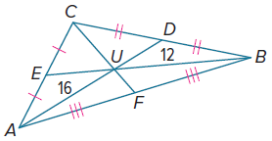
5. CU 6. AD

7. UF 8. BE

Example 3
Find the coordinates of the centroid of the triangle with the given vertices.

9. X(–3, 15), Y(1, 5), Z(5, 10) 10. S(2, 5), T(6, 5), R(10, 0)

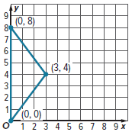
11. DECORATING Camilla made a collage with pictures of her trip to Europe. She wants to hang the collage from the ceiling in her room so that it is parallel to the ceiling. She draws a model of the collage on a coordinate grid. At what point should she place the string?

Example 4
Find the coordinates of the orthocenter of the triangle with the given vertices.

12. J(1, 0), H(6, 0), I(3, 6) 13. S(1, 0), T(4, 7), U(8, −3)

14. L(8, 0), M(10, 8), N(14, 0) 15. D(–9, 9), E(–6, 6), F(0, 6)

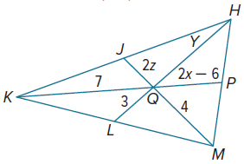
Mixed Exercises
16. REASONING In the figure at the right, if J, P, and L are the midpoints of $\overline{KH}$, $\overline{HM}$, and $\overline{MK}$, respectively, find x, y, and z.

Given $△$RST for medians $\overline{RM}$, $\overline{SL}$, and $\overline{TK}$, and centroid J, find each value of x.
17. SL = x(JL) 18. JT = x(TK) 19. JM = x(RJ)

For Exercises 20 and 21, refer to the figure at the right.
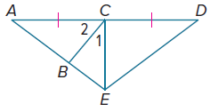
20. If $\overline{EC}$ is an altitude of $△$AED, m∠1 = 2x + 7, and m∠2 = 3x + 13, find m∠1 and m∠2.

21. Find the value of x if AC = 4x ‒ 3, DC = 2x + 9, m∠ECA = 15x + 2, and $\overline{EC}$ is a median of $△$AED. Is $\overline{EC}$ also an altitude of $△$AED? Explain.

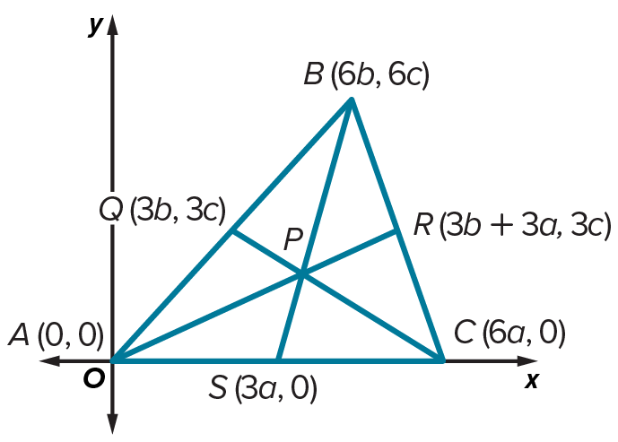
22. PROOF Write a coordinate proof to prove the Centroid Theorem.
Given: $△ABC$, medians $\overline{AR}$, $\overline{BS}$, and $\overline{CQ}$
Prove: The medians intersect at point P, and P is two thirds of the distance from each vertex to the midpoint of the opposite side.

(Hint: First, find the equations of the lines containing the medians. Then find the coordinates of point P and show that all three medians intersect at point P. Next, use the Distance Formula and multiplication to show
$AP=\frac{2}{3}AR, BP=\frac{2}{3}BS,$ and $CP=\frac{2}{3}CQ.$)

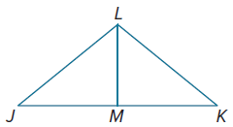
CONSTRUCT ARGUMENTS Use the given information to determine whether $\overline{LM}$ is a perpendicular bisector, median, and/or altitude of $△$JKL.

23. $\overline{LM}$ ⊥ $\overline{JK}$ 24. $△$JLM ≅ $△$KLM

25. $\overline{JM}≅\overline{KM}$ 26. $\overline{LM}$ ⊥ $\overline{JK}$ and $\overline{JL}≅\overline{KL}$

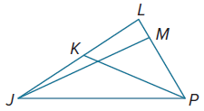
REASONING In $△$JLP, m∠JMP = 3x ‒ 6, JK = 3y ‒ 2, and LK = 5y ‒ 8.
27. If $\overline{JM}$ is an altitude of $△$JLP, find the value of x.

28. Find LK if $\overline{PK}$ is a median.

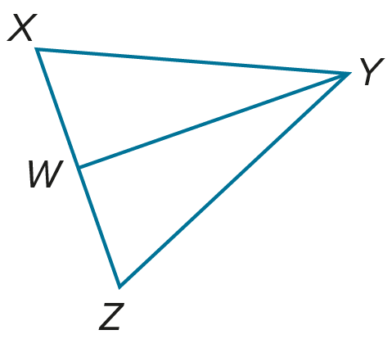
22. PROOF Write a paragraph proof.
Given: $△XYZ$ is isosceles.
$\overline{WY}$ bisects $∠Y$.
Prove: $\overline{WY}$ is a median.

30. WRITE Compare and contrast the perpendicular bisectors, medians, and altitudes of a triangle.

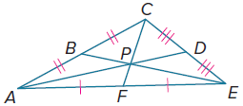

31. FIND THE ERROR Based on the figure at the right, Laura says that $\frac{2}{3}AP=AD$. Kareem disagrees. Is either of them correct? Explain your reasoning.

32. PERSEVERE $△$ABC has vertices A(‒3, 3), B(2, 5), and C(4, ‒3). What are the coordinates of the centroid of $△$ABC? Explain the process you used to reach your conclusion.

33. CREATE In this problem, you will investigate the relationships among three points of concurrency in a triangle.
a. Draw an acute triangle and find the circumcenter, centroid, and orthocenter.

b. Draw an obtuse triangle and find the circumcenter, centroid, and orthocenter.

c. Draw a right triangle and find the circumcenter, centroid, and orthocenter.

d. Make a conjecture about the relationships among the circumcenter, centroid,
and orthocenter.

34. ANALYZE Determine whether the following statement is true or false. If true, explain your reasoning. If false, provide a counterexample.

The orthocenter of a right triangle is always located at the vertex of the right angle.

35. WHICH ONE DOESN’T BELONG? Choose the term pairing that is not correct. Explain.

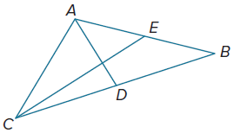
36. PERSEVERE In the figure at the right, segments $\overline{AD}$ and $\overline{CE}$ are medians of $△$ACB, $\overline{AD}$ ⊥ $\overline{CE}$, AB = 10, and CE = 9. Find CA.

