Inequalities in One Triangle ⸱ Practice

Example 1
List all the angles that satisfy the stated condition.

1. measures are greater than m∠3

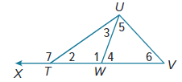
2. measures are less than m∠1

3. measures are greater than m∠1

4. measures are less than m∠7

5. measures are greater than m∠2

Examples 2 and 3
List the angles and sides of each triangle in order from smallest to largest.

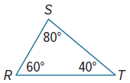
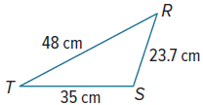
6. 7. 8.
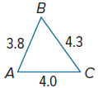

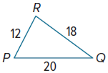
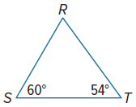
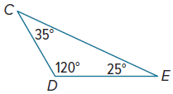
9. 10. 11.

Example 4
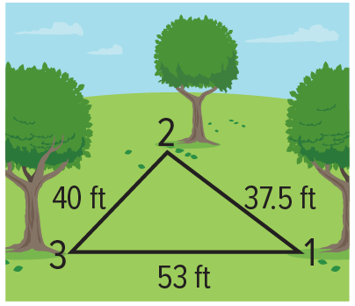
12. SPORTS The figure shows the position of three trees on one part of a
disc golf course. At which tree position is the angle between the trees
the greatest?

13. NEIGHBORHOOD Cain and Remy live on the same straight road. From their balconies, they can see a flagpole in the distance. The angle that each person’s line of sight to the flagpole makes with the road is the same. How do their distances from the flagpole compare?

Mixed Exercises
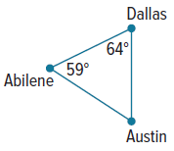
14. MAPS Sata is going to Texas to visit a friend. As she looked at a map to see where she might want to go, she noticed that Austin, Dallas, and Abilene form a triangle. She wanted to determine how the distances between the cities were related, so she used a protractor to measure two angles.

a. Based on the information in the figure, which of the two cities are nearest to each other?

b. Based on the information in the figure, which of the two cities are farthest apart from
each other?

c. If you were going to use the information from Sata’s sketch in order to plan a road trip between these cities, what is an assumption you would have to make?

REASONING List the angles and sides of each triangle in order from smallest to largest.
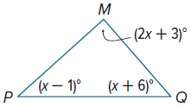
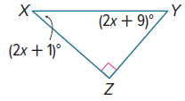
15. 16.

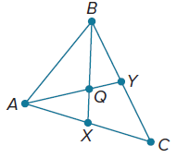
In $△$ABC, $\overline{AY}$ bisects ∠A, $\overline{BX}$ bisects ∠B, and Q is the intersection of $\overline{AY}$ and $\overline{BX}$. Use the figure for Exercises 17-19.

17. Suppose BC > AC. Compare m∠BAY and m∠ABX. Justify your
reasoning.

18. Cynda claims that $\overline{XC}$ ≅ $\overline{YC}$ if BC > AC. Is she correct? Justify your argument.

19. If m∠AQB > m∠BQY, which side of $△$ABQ has the greatest length?

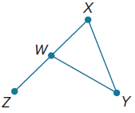
20. PROOF Write a paragraph proof.
Given: WY > YX
Prove: m∠ZWY > m∠YWX

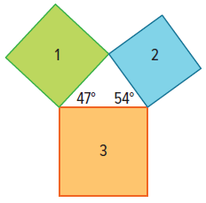
21. SQUARES Mahlik has three different squares. He arranges the squares to form a triangle as shown. Based on the information, list the squares in order from the one with the least perimeter to the one with the greatest perimeter.

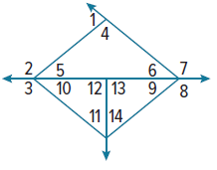
Use the figure at the right to determine which angle has the greatest measure.
22. ∠1, ∠5, ∠6 23. ∠2, ∠4, ∠6

24. ∠7, ∠4, ∠5 25. ∠3, ∠11, ∠12

26. ∠3, ∠9, ∠14 27. ∠8, ∠10, ∠11

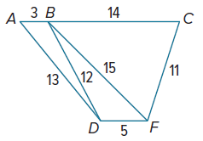
Use the figure at the right to determine the relationship between the measures
of the given angles.
28. ∠ABD, ∠BDA 29. ∠BCF, ∠CFB

30. ∠BFD, ∠BDF 31. ∠DBF, ∠BFD

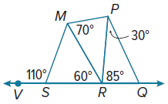
Use the figure at the right to determine the relationship between the given lengths.
32. SM, MR 33. RP, MP

34. RQ, PQ 35. RM, RQ

36. PERSEVERE Using only a ruler, draw $△$ABC such that m∠A > m∠B > m∠C. Justify your drawing.

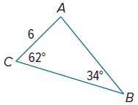
37. CREATE Give a possible measure for $\overline{AB}$ in $△$ABC shown. Explain
your reasoning.

38. ANALYZE Is the base of an isosceles triangle sometimes, always, or never the longest side of the triangle? Justify your argument.

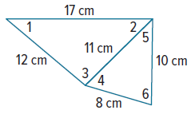
39. PERSEVERE Use the side lengths in the figure to list the numbered angles in order from smallest to largest given that m∠2 = m∠5. Explain your reasoning.

