The Triangle Inequality ⸱ Practice

Example 1
REASONING Is it possible to form a triangle with the given side lengths? If not, explain why not.

1. 9, 12, 18 2. 8, 9, 17

3. 14, 14, 19 4. 23, 26, 50

5. 32, 41, 63 6. 2.7, 3.1, 4.3

7. 0.7, 1.4, 2.1 8. 12.3, 13.9, 25.2

Example 2
Find the range for the measure of the third side of a triangle given the measures of two sides.

9. 6 ft and 19 ft 10. 7 km and 29 km

11. 13 in. and 27 in. 12. 18 ft and 23 ft

13. CITIES The distance between New York City, New York, and Boston, Massachusetts, is 187 miles, and the distance between New York City and Hartford, Connectitcut, is 97 miles. Hartford, Boston, and New York City form a triangle on a map. What must the distance between Boston and Hartford be greater than?

14. FENCING Capria is planning to fence a triangular plot of land. Two of the sides of the plot measure 230 yards and 490 yards.

- Find the range for the measure of the third side of the triangular plot of land.

- What are the maximum and minimum lengths of fencing Capria will need?

Example 3
PROOF Write a two-column proof.

15. Given: $\overline{PL}$ ∥ $\overline{MT}$; K is the midpoint of $\overline{PT}$. 16. Given: △ABC ≅ △DEC
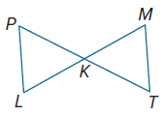
Prove: PK + KM > PL Prove: AB + DE > AD ‒ BE
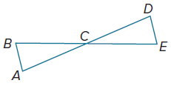

Mixed Exercises
Find the range of possible measures of x if each set of expressions represents measures of the sides of a triangle.
17. x, 4, 6 18. x ‒ 2, 10, 12

REGULARITY Determine whether the given coordinates are the vertices of a triangle. Explain.
19. X(1, ‒3), Y(6, 1), Z(2, 2) 20. J(‒7, ‒1), K(9, ‒5), L(21, ‒8)

21. GARDENING Ennis has 4 lengths of wood from which he plans to make a border for a triangular-shaped herb garden. The lengths of the wood borders are 8 inches, 10 inches,
12 inches, and 18 inches. How many different triangular borders can Ennis make?

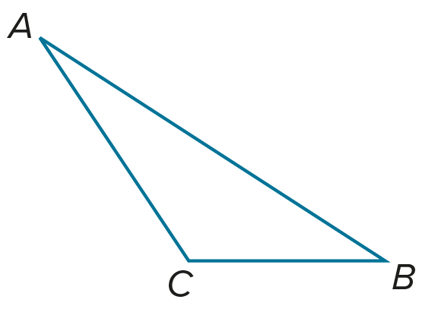
22. PROOF Write a two-column proof. (Theorem 6.11)
Given: △ABC

Prove: AC + BC > AB

(Hint: Draw an auxiliary segment $\overline{CD}$, so that C is between B and D and $\overline{CD}≅\overline{AC}$.)

23. PERSEVERE The sides of an isosceles triangle are whole numbers, and its perimeter is 30 units. What is the probability that the triangle is equilateral?

24. CREATE The length of one side of a triangle is 2 inches. Draw a triangle in which the 2-inch side is the shortest side and one in which the 2-inch side is the longest side. Include side and angle measures on your drawing.

25. WRITE What can you tell about a triangle when given three side lengths? Include at least
two items.

26. ANALYZE What is the range of lengths of each leg of an isosceles triangle if the measure of the base is 6 inches? Explain.

