Inequalities in Two Triangles ⸱ Practice

Example 1

1. FLIGHT Two planes take off from the same airstrip. The first plane flies west for 150 miles and then flies 30° south of west for 220 miles. The second plane flies east for 220 miles and then flies x° south of east for 150 miles. If x < 30, which plane is farther from the airstrip after the second leg? Justify your answer.

2. HIKING Gen and Ari start hiking from the same point. Gen hikes 5 miles due east and turns to hike
4.5 miles 30° south of east. Ari hikes 5 miles due west and turns to hike 4.5 miles 15° north of west.
a. Draw a model to represent the situation.

b. Who is closer to the starting point? Explain your reasoning.

Example 2
PROOF Write a two-column proof.
3. Given: RX = XS; m∠SXT = 97° 4. Given: $\overline{LK}≅\overline{JK}$, $\overline{RL}≅\overline{RJ}$, K is the midpoint of $\overline{QS},$
and m∠SKL > m∠QKJ.
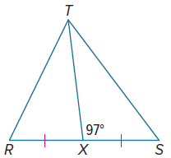
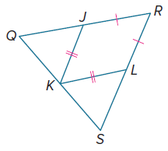
Prove: ST > RT Prove: RS > QR

Example 3
Find the range of values of x.

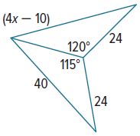
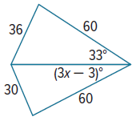
5. 6.

Example 4
PROOF Write a two-column proof.
7. Given: $\overline{XU}≅\overline{VW}$, VW > XW 8. Given: $\overline{AF}≅\overline{DJ}$, $\overline{FC}≅\overline{JB}$
$\overline{XU}$ ∥ $\overline{VW}$ AB > DC
Prove: m∠XZU > m∠UZV Prove: m∠AFC > m∠DJB
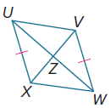
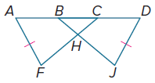

Mixed Exercises
Compare the given measures.
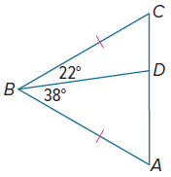
9. MR and RP 10. AD and CD
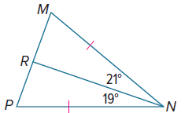

11. m∠C and m∠Z 12. m∠XYW and m∠WYZ
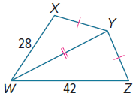
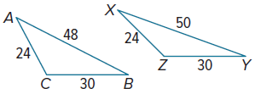

13. m∠BXA and m∠DXA
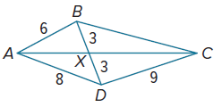

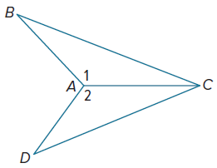

14. PROOF Write a two-column proof.
Given: $\overline{BA}≅\overline{DA}$, BC > DC
Prove: m∠1 > m∠2

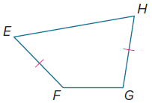
15. PROOF Write a paragraph proof.
Given: $\overline{EF}≅\overline{GH}$, m∠F > m∠G.
Prove: EG > FH

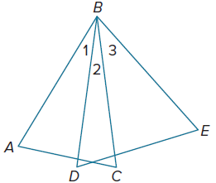
16. REASONING In the figure, $\overline{BA}$, $\overline{BD}$, $\overline{BC}$, and $\overline{BE}$ are congruent and
AC < DE. How does m∠1 compare with m∠3? Explain your thinking.

17. CLOCKS The minute hand of a grandfather clock is 3 feet long, and the hour hand is 2 feet long. Is the distance between their ends greater at 3:00 or at 8:00?

18. PROOF Write a paragraph proof to prove the Hinge Theorem. (Theorem 6.12)
Given: $△ABC$ and $△DEF$
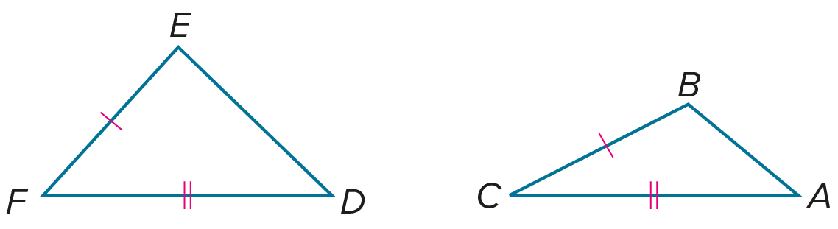
$\overline{AC}≅\overline{DF}$, $\overline{BC}≅\overline{EF}$
m∠F > m∠C
Prove: DE > AB

19. PROOF Use an indirect proof to prove the Converse of the Hinge Theorem. (Theorem 6.13)
Given: $\overline{RS}≅\overline{UW}$
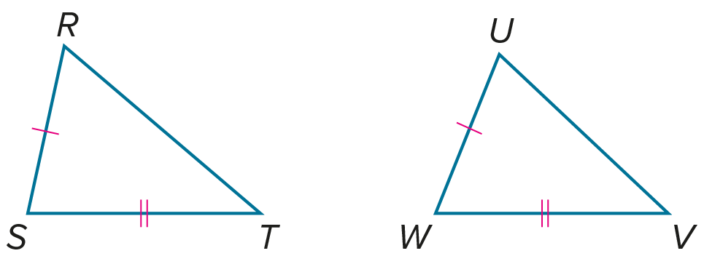
$\overline{ST}≅\overline{WV}$
RT > UV
Prove: m∠S > m∠W

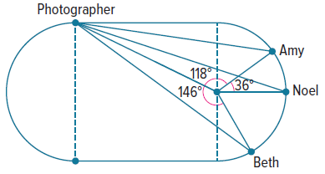
20. PHOTOGRAPHY A photographer is taking pictures of three track stars, Amy, Noel, and Beth. The photographer stands on the track, which is shaped like a rectangle with semicircles on both ends.
a. Based on the information in the figure, list the runners in order from nearest to farthest from the photographer.

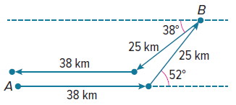
b. Explain how to locate the point along the semicircular curve that the runners are
on that is farthest away from the photographer.

21. SUBMARINES Submarine A is moving toward the most recent position it has for submarine B. It sails due east for 38 kilometers and then sails 52° north of east for 25 kilometers, arriving at submarine B’s starting position. Meanwhile, submarine B sails 38° south of west for 25 kilometers and then due west for 38 kilometers.
a. Does submarine B end up northeast, northwest, southeast, or southwest of submarine A’s starting point?

b. If the lengths of submarine B’s legs were switched, what conclusions could you make about submarine B’s final position?

22. CREATE Give a real-world example of an object that uses a hinge. Draw two sketches in which the hinge on your object is adjusted to two different positions. Use your sketches to explain why Theorem 6.12 is called the Hinge Theorem.

23. PERSEVERE Given $△$RST with median $\overline{RQ}$, if RT is greater than or equal to RS, what are the possible classifications of $△$RQT? Explain your reasoning.

24. WRITE Compare and contrast the Hinge Theorem to the SAS Postulate for
triangle congruence.
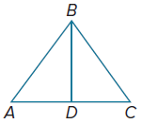

25. ANALYZE If $\overline{BD}$ is a median and AB < BC, then is ∠BDC sometimes, always, or never an acute angle? Justify your argument.

