Angles of Polygons ⸱ Practice

Example 1
Find the measure of each interior angle.
1. 2.
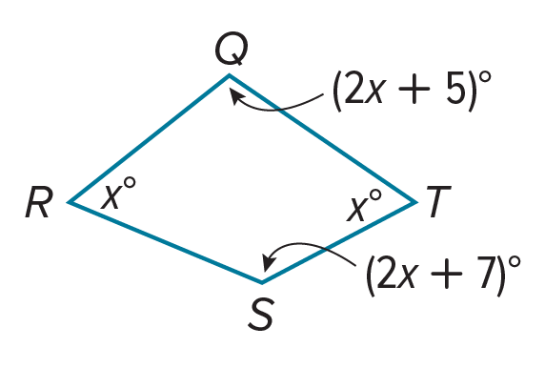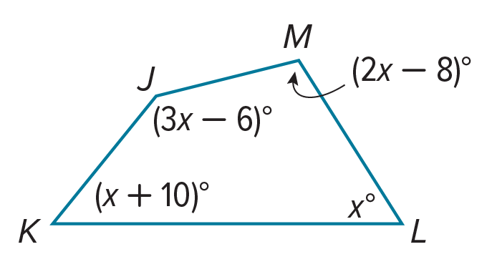

3. 4.
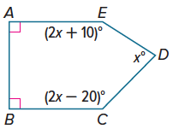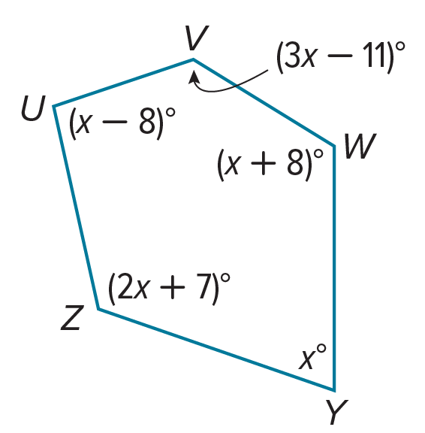

Example 2

5. ARCHITECTURE In the Uffizi gallery in Florence, Italy, there is a room built by Buontalenti called the Tribune (La Tribuna in Italian). This room is shaped like a regular octagon. What is the measure of the angle formed by two consecutive walls of the Tribune.

6. THEATER A theater floor plan is shown in the figure. The upper five sides are part of a regular dodecagon. Find m∠1.
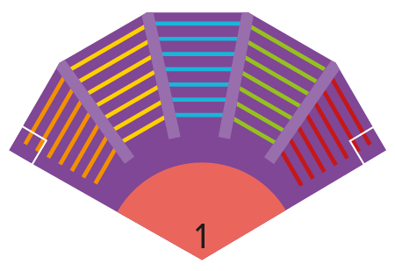

7. FARM An animal pen is in the shape of a regular heptagon. What is the measure of each interior angle of the animal pen? Round to the nearest tenth.

8. POLYGON PATH In Ms. Rickets’ math class, students made a “polygon path” that consists of regular polygons of 3, 4, 5, and 6 sides joined together as shown.

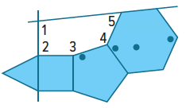

a. Find m∠2 and m∠5.
b. Find m∠3 and m∠4.
c. What is m∠1?

Example 3
The measure of an interior angle of a regular polygon is given. Find the number of sides in
the polygon.
9. 144$°$ 10. 156$°$ 11. 160$°$

12. 108$°$ 13. 120$°$ 14. 150$°$

Example 4
Find the value of x in each diagram.
15. 16.
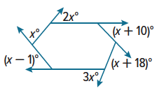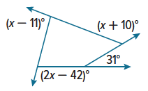

17. 18.
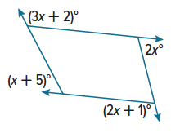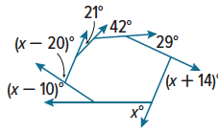

Example 5
Find the measure of each exterior angle of each regular polygon.

19. pentagon 20. 15-gon 21. hexagon

22. octagon 23. nonagon 24. 12-gon

Mixed Exercises
Find the measures of an exterior angle and an interior angle given the number of sides of each regular polygon. Round to the nearest tenth, if necessary.
25. 7 26. 13 27. 14

For Exercises 28 and 29, find the value of x.
28. A convex octagon has interior angles with measures (x + 55)°, (3x + 20)°, 4x°, (4x – 10)°,
(6x – 55)°, (3x + 52)°, 3x°, and (2x + 30)°.

29. A convex hexagon has interior angles with measures x°, (5x – 103)°, (2x + 60)°, (7x – 31)°,
(6x – 6)°, and (9x – 100)°.

For Exercises 30 and 31, find the measure of each interior angle in the given polygon.
30. A decagon in which the measures of the interior angles are (x + 5)°, (x + 10)°, (x + 20)°, (x + 30)°,
(x + 35)°, (x + 40)°, (x + 60)°, (x + 70)°, (x + 80)°, and (x + 90)°.

31. A polygon ABCDE, in which the measures of the interior angles are (6x)°, (4x + 13)°, (x + 9)°, (2x – 8)°, (4x – 1)°.

32. Find the measure of each exterior angle of a regular 2x-gon.

33. Find the sum of the measures of the exterior angles of a convex 65-gon.

34. PROOF Write a paragraph proof to prove the Polygon Interior Angles Sum Theorem.

35. PROOF Use algebra to prove the Polygon Exterior Angles Sum Theorem.

36. REASONING The measure of each interior angle of a regular polygon is 24 more than 38 times the measure of each exterior angle. Find the number of sides of the polygon.

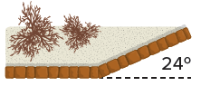
37. ARCHAEOLOGY Archeologists unearthed parts of two adjacent walls of an ancient castle. Before it was unearthed, they knew from ancient texts that the castle was shaped like a regular polygon, but nobody knew how many sides it had. Some said 6, others 8, and some even said 100. From the information in the figure, how many sides did the castle really have?

38. DESIGN Ronella is designing boxes she will use to ship her jewelry. She wants to shape the box like a regular polygon. For the boxes to pack tightly, she decides to use a regular polygon in which the measure of its interior angles is half the measure of its exterior angles. What regular polygon should she use?

39. CRYSTALLOGRAPHY Crystals are classified according to seven crystal systems. The basis of the classification is the shapes of the faces of the crystal. Turquoise belongs to the triclinic system. Each of the six faces of turquoise is in the shape of a quadrilateral. Find the sum of the measures of the interior angles of one such face.

40. STRUCTURE If three of the interior angles of a convex hexagon each measure 140°, a fourth angle measures 84°, and the measure of the fifth angle is 3 times the measure of the sixth angle, find the measure of the sixth angle.

41. FIND THE ERROR Marshawn says that the sum of the exterior angles of a decagon is greater than that of a heptagon because a decagon has more sides. Liang says that the sum of the exterior angles for both polygons is the same. Who is correct? Explain your reasoning.

42. WRITE Explain how triangles are related to the Polygon Interior Angles Sum Theorem.

43. CREATE Sketch a polygon and find the sum of its interior angles. How many sides does a polygon with twice this interior angles sum have? Justify your answer.

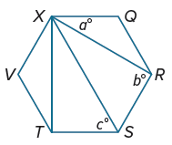
44. PERSEVERE Find the values of a, b, and c if QRSTVX is a regular hexagon. Justify your answer.

45. ANALYZE If two sides of a regular hexagon are extended to meet at a point in the exterior of the polygon, will the triangle formed sometimes, always, or never be equilateral? Justify your argument.

