Parallelograms ⸱ Practice
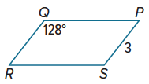
Example 1
Use ▭ PQRS to find each measure.
1. m∠R 2. QR

3. QP 4. m∠S

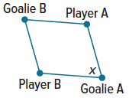
5. SOCCER Four soccer players are practicing a drill. Goalie A is facing Player B to receive the ball. Goalie A then turns x° to face Player A to pass her the ball. If Goalie B is facing Player A to receive the ball, then through what angle measure should Goalie B turn to pass the ball to Player B?

Example 2
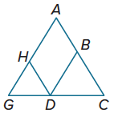
PROOF For 6-7, Write a two-column proof.
6. Given: ▭BDHA, $\overline{CA}$ ≅ $\overline{CG}$
Prove: ∠BDH ≅ ∠G

7. Given: WXYV and YZTV are parallelograms.
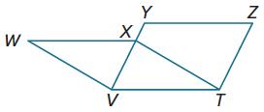
Prove: $\overline{WX}$ ≅ $\overline{YZ}$

8. Write a paragraph proof.
Given: ▭PRST and ▭PQVU
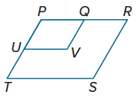
Prove: ∠V ≅ ∠S

Example 3
Find the value of each variable in each parallelogram.
9. 10.
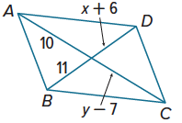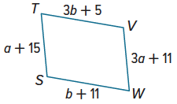

11. 12.
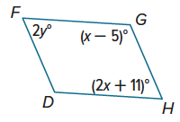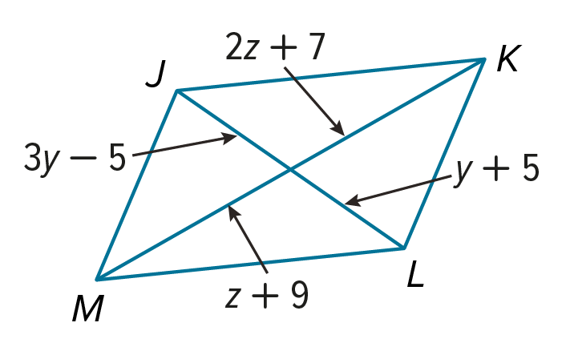

Example 4
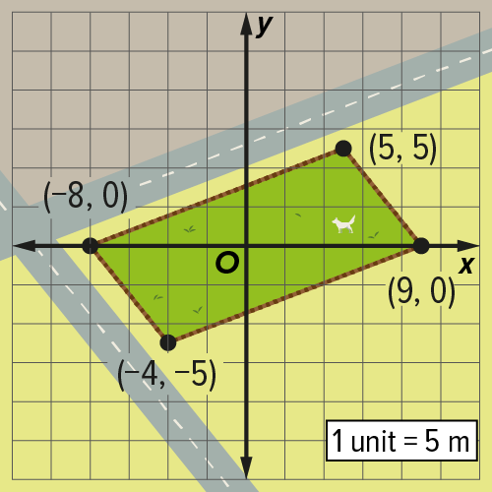
13. PARK A new dog park is being designed by a city planner. The park is enclosed by a fence and shaped like a parallelogram. What is the area and perimeter of the dog park? Round your answers to the nearest hundredth, if necessary.

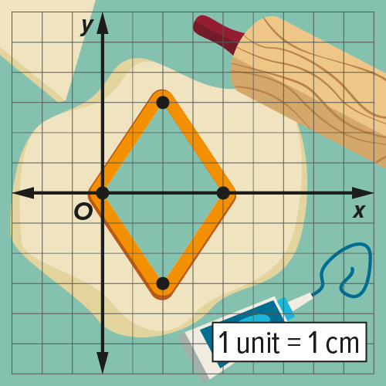
14. STATE YOUR ASSUMPTION Breelyn is making cookies using a cookie cutter in the shape of a parallelogram. What are the perimeter and area of each cookie? Explain any assumptions that you make. Round your answers to the nearest hundredth, if necessary.

Mixed Exercises
PROOF Write a two-column proof for each theorem.
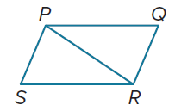
15. Theorem 7.3
Given: ▭PQRS
Prove: $\overline{PQ}$ ≅ $\overline{RS}$, $\overline{QR}$ ≅ $\overline{SP}$

16. Theorem 7.7
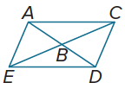
Given: ▭ACDE
Prove: $\overline{EC}$ bisects $\overline{AD}$.

17. Theorem 7.5
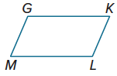
Given: ▭GKLM
Prove: ∠G and ∠K, ∠K and ∠L,
∠L and ∠M, and ∠M and ∠G
are supplementary.

18. Theorem 7.8
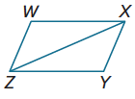
Given: ▭WXYZ
Prove: △WXZ ≅ △YZX

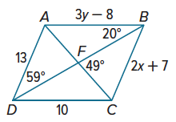
Use ▭ ABCD to find each measure or value.
19. x

20. y

21. m∠AFB

22. m∠DAC

23. m∠ACD

24. m∠DAB
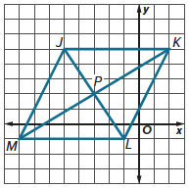
25. REGULARITY Use the graph shown.
a. Use the Distance Formula to determine if the diagonals of JKLM bisect each other. Explain.

b. Determine whether the diagonals are congruent. Explain.

c. Use slopes to determine if the consecutive sides are perpendicular. Explain.

26. USE TOOLS Make a Venn diagram showing the relationship between squares, rectangles, and parallelograms.

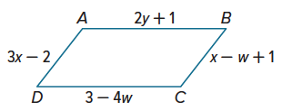

27. PERSEVERE ABCD is a parallelogram with side lengths as indicated in the figure at the right. The perimeter of ABCD is 22. Find AB.

28. ANALYZE Explain why parallelograms are always quadrilaterals, but quadrilaterals are sometimes parallelograms.

29. WRITE Summarize the properties of the sides, angles, and diagonals of a parallelogram.

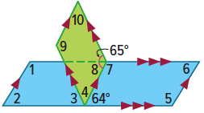
30. CREATE Provide an example to show that parallelograms are not always congruent if their corresponding sides are congruent.

31. PERSEVERE Find m∠1 and m∠10 in the figure. Explain your reasoning.

