Tests for Parallelograms ⸱ Practice

Example 1
Determine whether each quadrilateral is a parallelogram. Justify your answer.
1. 2.
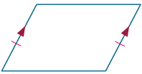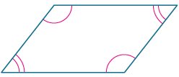

3. 4.
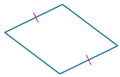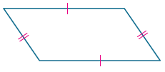

5. 6.
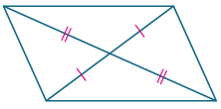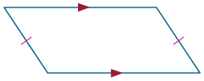

Example 2
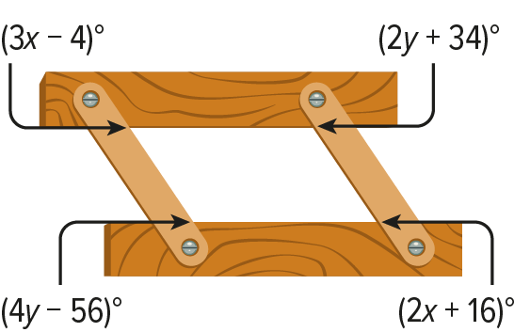
7. ORGANIZATION The space between the hinges and trays of a collapsible tray organizer appears to be a parallelogram. Find the values of x and y so that the trays and hinges of the organizer form a parallelogram.

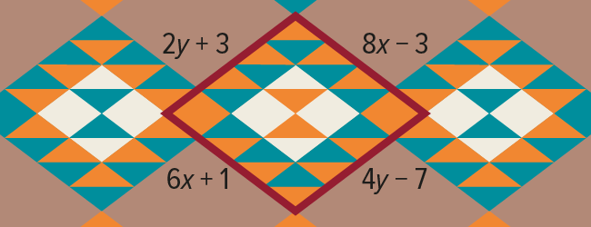
8. PATTERNS Many Native American rugs and blankets incorporate parallelograms into the designs. Find the values of x and y so that the quadrilateral shown is a parallelogram.

Find the values of x and y so that each quadrilateral is a parallelogram.

9. 10.
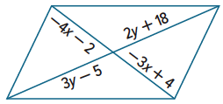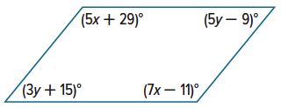

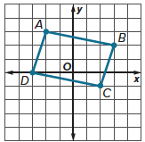
Example 3
11. Determine whether ABCD is a parallelogram. Justify your answer.

CONSTRUCT ARGUMENTS For exercises 12-15, graph each quadrilateral with the given vertices. Determine whether the figure is a parallelogram. Justify your answer with the method indicated.
12. P(0, 0), Q(3, 4), S(7, 4), Y(4, 0); Slope Formula

13. S(–2, 1), R(1, 3), T(2, 0), Z(–1, –2); Distance and Slope Formulas

14. W(2, 5), R(3, 3), Y(–2, –3), N(–3, 1); Midpoint Formula

15. W(1, –4), X(–4, 2), Y(1, –1), and Z(–2, –3); Slope Formula

Example 4
16. PROOF Write a coordinate proof for the statement: If both pairs of opposite sides of a quadrilateral are congruent, then the quadrilateral is a parallelogram.

17. PROOF Write a coordinate proof for the statement: If a parallelogram has one right angle, it has four right angles.

Mixed Exercises
PROOF Write the specified type of proof for each theorem.
18. paragraph proof of Theorem 7.10 19. two-column proof of Theorem 7.11
Given: $∠K≅∠M, ∠N≅∠L$ Given: $\overline{PR}$ bisects $\overline{TQ}$.
Prove: KLMN is a parallelogram. $\overline{TQ}$ bisects $\overline{PR}$.
Prove: PQRT is a parallelogram.
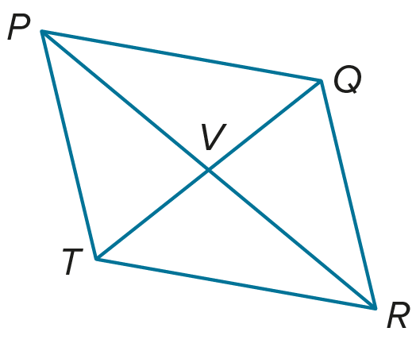
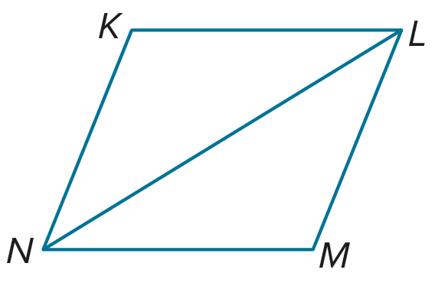

20. ABCD is a parallelogram with A(5, 4), B(‒1, ‒2), and C(8, –2). Find one possible set of coordinates for D.

21. STRUCTURE A parallelogram has vertices R(–2, –1), S(2, 1), and T(0, –3). Find all possible coordinates for the fourth vertex.

22. If the slope of $\overline{PQ}$ is $\frac{2}{3}$ and the slope of $\overline{QR}$ is $-\frac{1}{2}$, find the slope of $\overline{SR}$ so that PQRS is
a parallelogram.


23. If the slope of $\overline{AB}$ is $\frac{1}{2}$, the slope of $\overline{BC}$ is –4, and the slope of $\overline{CD}$ is $\frac{1}{2}$, find the slope of $\overline{DA}$ so that ABCD is a parallelogram.

24. REASONING The pattern shown in the figure is to consist of congruent parallelograms. How can the designer be certain that the shapes are parallelograms?

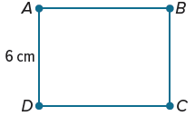
25. Refer to parallelogram ABCD. If AB = 8 cm, what is the perimeter of the parallelogram?

26. PICTURE FRAME Aston is making a wooden picture frame in the shape of a parallelogram. He has two pieces of wood that are 3 feet long and two that are 4 feet long.
a. If he connects the pieces of wood at their ends to each other, in what order must he connect them to make a parallelogram?

b. How many different parallelograms could he make with these four lengths of wood?

c. Explain something Aston might do to specify precisely the shape of the parallelogram.

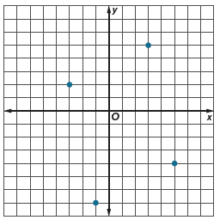
27. STATE YOUR ASSUMPTION When a coordinate plane is placed over the Harrisville town map, the four street lamps in the center are located as shown. Do the four lamps form the vertices of a parallelogram? Justify your reasoning. Explain any assumptions that you make regarding the coordinate plane and the map.

28. USE TOOLS Explain how you can use Theorem 7.11 to construct a parallelogram.
Then construct a parallelogram using your method.

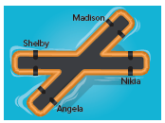
29. BALANCING Nikia, Madison, Angela, and Shelby are balancing on an X-shaped floating object. To balance, they want to stand so they are at the vertices of a parallelogram. In order to achieve this, do all four of them have to be the same distance from the center of the object? Explain.

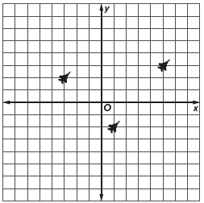
30. FORMATION Four jets are flying in formation. Three of the jets are shown in the graph. If the four jets are located at the vertices of a parallelogram, what are the three possible locations of the missing jet?


31. PROOF Write a coordinate proof to prove that the segments joining the midpoints of the sides of any quadrilateral form a parallelogram.

32. ANALYZE If two parallelograms have four congruent corresponding angles, are the parallelograms sometimes, always, or never congruent? Justify your argument.

33. WRITE Compare and contrast Theorem 7.9 and Theorem 7.3.

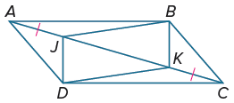
34. PERSEVERE If ABCD is a parallelogram and $\overline{AJ}≅\overline{KC}$, show that quadrilateral JBKD is a parallelogram.

35. ANALYZE The diagonals of a parallelogram meet at the point (0, 1). One vertex of the parallelogram is located at (2, 4), and a second vertex is located at (3, 1). Find the locations of the remaining vertices.

