Rectangles ⸱ Practice

Example 1
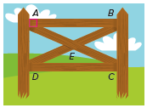
FENCING X-braces are also used to provide support in rectangular fencing. If AB = 6 feet, AD = 2 feet, and m∠DAE = 65$°$, find each measure. Round to the nearest tenth, if necessary.

1. BC 2. DB

3. m∠CEB 4. m∠EDC

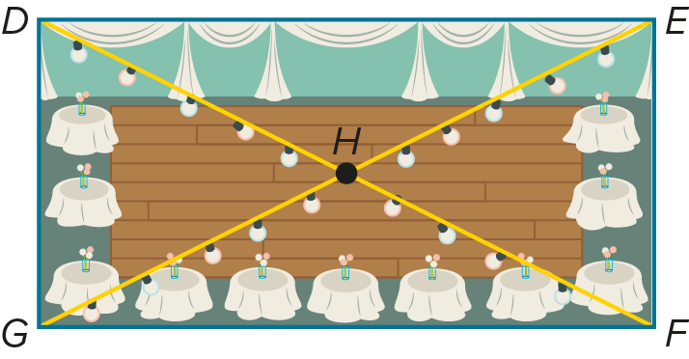
PROM The prom committee is decorating the venue for prom and wants to hang lights above the diagonals of the rectangular room. If DH = 44.5 feet, EF = 39 feet, and m∠GHF= 128°, find each measure.

5. DG 6. GE

7. m∠EHF 8. m∠HEF

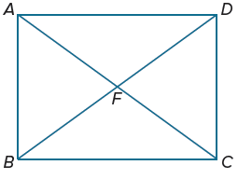
Example 2
9. Quadrilateral ABCD is a rectangle.
If m∠ADB = (4x + 8)° and m∠DBA = (6x + 12) °,
find the value of x.

Quadrilateral EFGH is a rectangle. Use the given information to find each measure.

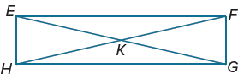
10. If m∠FEG = 57°, find m∠GEH.

11. If m∠HGE = 13°, find m∠FGE.

12. If FK = 32 feet, find EG.

13. Find m∠HEF + m∠EFG.

14. If EF = 4x ‒ 6 and HG = x + 3, find EF.

Example 3
PROOF Write a two-column proof.
15. Given: ABCD is a rectangle. 16. Given: QTVW is a rectangle, $\overline{QR}$ ≅ $\overline{ST}$
Prove: △ADC ≅ △BCD Prove: △SWQ ≅ △RVT

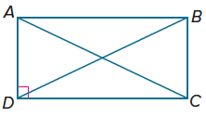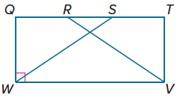

Example 4
PRECISION Graph each quadrilateral with the given vertices. Determine whether the figure is a rectangle. Justify your answer using the indicated formula.

17. B(–4, 3), G(–2, 4), H(1, –2), L(–1, –3); Slope Formula

18. N(–4, 5), O(6, 0), P(3, –6), Q(–7, –1); Distance Formula

19. C(0, 5), D(4, 7), E(5, 4), F(1, 2); Slope Formula

20. P(–3, –2), Q(–4, 2), R(2, 4), S(3, 0); Slope Formula

21. J(–6, 3), K(0, 6), L(2, 2), M(–4, –1); Distance Formula

22. T(4, 1), U(3, –1), X(–3, 2), Y(–2, 4); Distance Formula

Mixed Exercises
PROOF Write a two-column proof to prove each theorem.
23. Theorem 7.13
Given: ABCD is a rectangle with diagonals $\overline{AC}$ and $\overline{BD}$.
Prove: $\overline{AC}≅\overline{BD}$

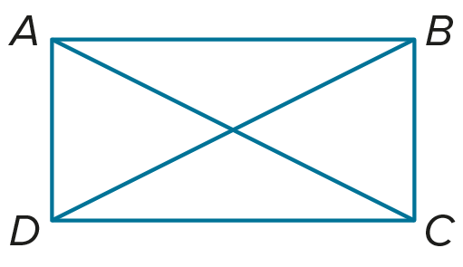

24. Theorem 7.14
Given: $\overline{PR}≅\overline{QT}$; PQRT is a parallelogram.
Prove: PQRT is a rectangle.
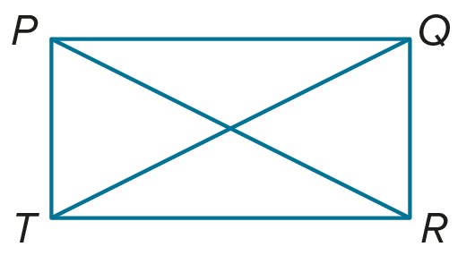

25. LANDSCAPING Huntington Park officials approved a rectangular plot of land for a Japanese Zen garden. Is it sufficient to know that opposite sides of the garden plot are congruent and parallel to determine that the garden plot is rectangular? Explain.

26. Name a property that is true for a rectangle and not always true for a parallelogram.

27. USE TOOLS Construct a rectangle using the construction for congruent segments and the construction for a line perpendicular to another line through a point on the line. Justify each step of the construction.

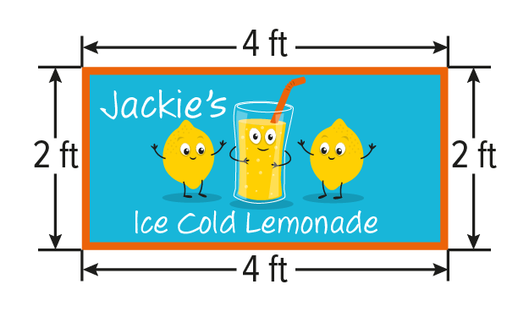
28. SIGNS The sign is attached to the front of Jackie’s lemonade stand. Based on the dimensions given, can Jackie be sure that the sign is a rectangle? Explain your reasoning.

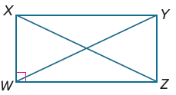
For Exercises 29-30, refer to rectangle WXYZ.
29. If XW = 3 and WZ = 4, find YW.

30. If ZY = 6 and XY = 8, find WY.

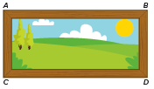
31. FRAMES Jalen makes the rectangular frame shown. Jalen measures the distances BD and AC. How should these two distances compare if the frame is a rectangle?

32. BOOKSHELVES A bookshelf consists of two vertical planks with five horizontal shelves. Are each of the four sections for books rectangles? Explain.

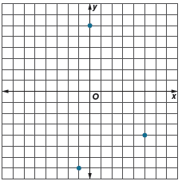

33. REASONING A landscaper is marking off the corners of a rectangular plot of land. Three of the corners are in the place as shown. What are the coordinates of the fourth corner?

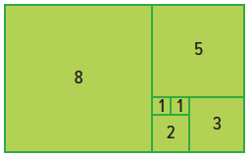
34. STRUCTURE Veronica made the pattern shown out of 7 rectangles with four equal sides. The side length of each rectangle is written inside the rectangle.

a. How many rectangles can be formed using the lines in this figure?

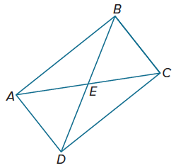
b. If Veronica wanted to extend her pattern by adding another rectangle with 4 equal sides to make a larger rectangle, what are the possible side lengths of rectangles that she can add?

35. PERSEVERE In rectangle ABCD, m∠EAB = (4x + 6)°, m∠DEC = (10 ‒ 11y)°, and m∠EBC = 60°. Find the values of x and y.

36. FIND THE ERROR Parker says that any two congruent acute triangles can be arranged to make a rectangle. Takeisha says that only two congruent right triangles can be arranged to make a rectangle. Who is correct? Explain your reasoning.

37. WRITE Why are all rectangles parallelograms, but all parallelograms are not rectangles? Explain.

38. CREATE Write the equations of four lines having intersections that form the vertices of a rectangle. Verify your answer using coordinate geometry.

39. ANALYZE Danny argues that to prove a quadrilateral is a rectangle, it is sufficient to prove that it has one right angle. Do you agree? If so, explain why. If not, explain and draw a counterexample.

