Rhombi and Squares ⸱ Practice

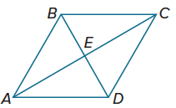
Examples 1 and 2
Quadrilateral ABCD is a rhombus. Find each value or measure.
1. If m∠ABD = 60°, find m∠BDC. 2. If AE = 8, find AC.

3. If AB = 26 and BD = 20, find AE. 4. Find m∠CEB.

5. If m∠CBD = 58°, find m∠ACB. 6. If AE = 3x – 1 and AC = 16, find x.

7. If m∠CDB = 6y° and m∠ACB = (2y + 10)°, find the value of y.
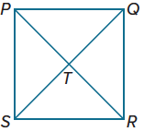
8. If AD = 2x + 4 and CD = 4x – 4, find the value of x.

Example 3
9. PQRS is a square. If PR = 42, find TR.

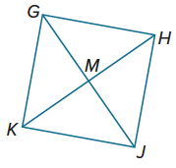
10. GHJK is a square. If KM = 26.5, find KH.

Example 4
PROOF Write a two-column proof.
11. Given: ACDH and BCDF are 12. Given: QRST is a parallelogram, $\overline{TR}$ ≅ $\overline{QS}$
parallelograms, $\overline{BF}$ ≅ $\overline{AB}$ m∠QPR = 90$°$.
Prove: ABFH is a rhombus. Prove: QRST is a square.

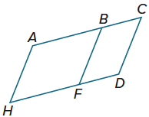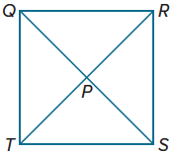

13. Given: $\overline{WZ}$ ∥ $\overline{XY}$, $\overline{WX}$ ∥ $\overline{ZY}$, $\overline{WX}$ ≅ $\overline{XY}$ 14. Given: JKQP is a square,
Prove: WXYZ is a rhombus. $\overline{ML}$ bisects $\overline{JP}$ and $\overline{KQ}$.
Prove: JKLM is a parallelogram.

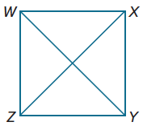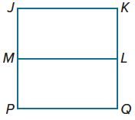

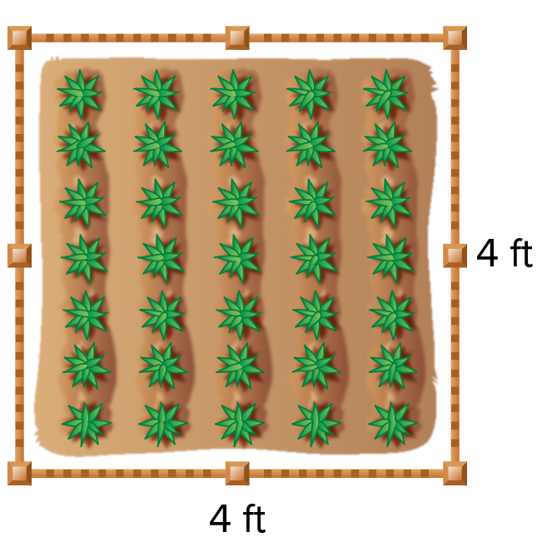
Example 5
15. PRECISION Jorge is using this box garden to plant his vegetables this year. What does Jorge need to know to ensure that the box garden is a square? Explain.


16. PRECISION Ingrid is designing a quilt with patches like the one shown. The patch is a parallelogram with all four angles having the same measure and the top and right sides having the same measure. Ingrid says that the patch is a square. Is she correct? Explain.

Example 6
Regularity Determine whether quadrilateral ABCD is a rhombus, a rectangle, a square, a parallelogram, or none. List all that apply. Explain.
17. A(0, 2), B(2, 4), C(4, 2), D(2, 0) 18. A(–2, –1), B(0, 2), C(2, –1), D(0, –4)

19. A(–6, –1), B(4, –6), C(2, 5), D(–8, 10) 20. A(2, –4), B(–6, –8), C(–10, 2), D(–2, 6)

21. A(1, 3), B(7, –3), C(1, –9), D(–5, –3) 22. A(–9, 1), B(2, 3), C(12, –2), D(1, –4)

Mixed Exercises
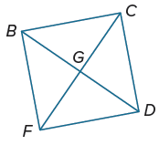
BCDF is a square with FD = 55. Find each measure.
23. BC 24. CD

25. GD 26. BD

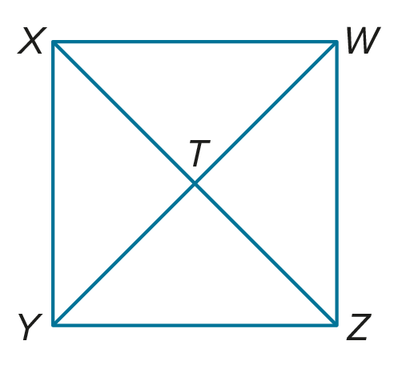
WXYZ is a square. If WT = 3, find each measure.
27. ZX 28. XY

29. m∠WTZ 30. m∠WYX

PROOF Write a two-column proof to prove each theorem.

31. Theorem 7.16 32. Theorem 7.17
Given: ABCD is a rhombus. Given: PQRS is a parallelogram; $\overline{PR}⊥\overline{QS}.$
Prove: $\overline{AC}$ bisects $∠DAB$ and $∠DCB$. Prove: PQRS is a rhombus.
$\overline{BD}$ bisects $∠ABC$ and $∠ADC$.

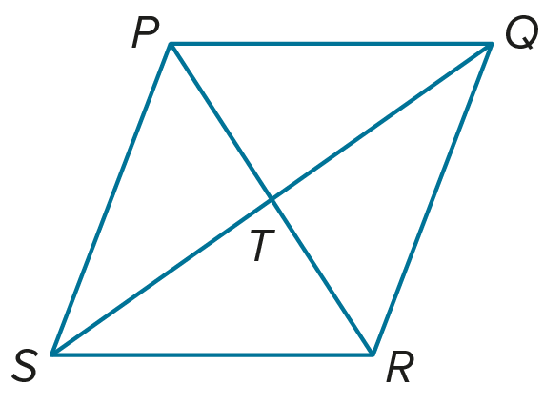
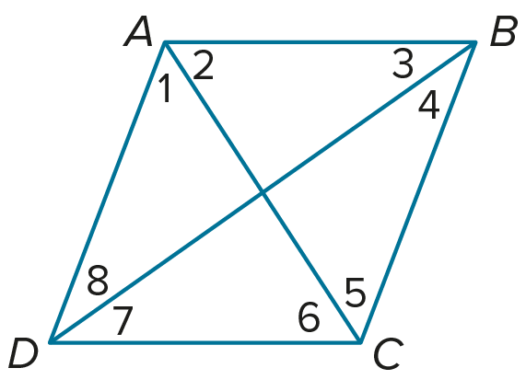

33. Theorem 7.19 34. Theorem 7.20
Given: RSTU is a parallelogram; $\overline{RS}≅\overline{ST}$. Given: WXYZ is a rectangle and a rhombus.
Prove: RSTU is a rhombus. Prove: WXYZ is a square.

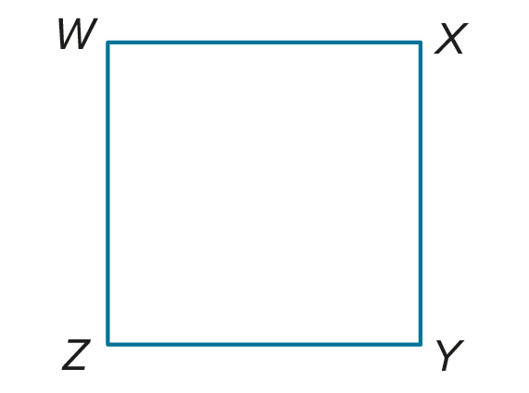
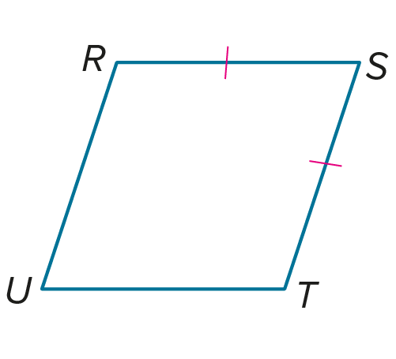


35. USE ESTIMATION The figure is an example of a quilt pattern. Estimate the type and number of shapes in the figure. Use a ruler or protractor to measure the shapes and then name the quadrilaterals used to form the figure. Compare this to your estimation.

Classify each quadrilateral.
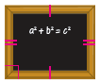
36. 37. 38.

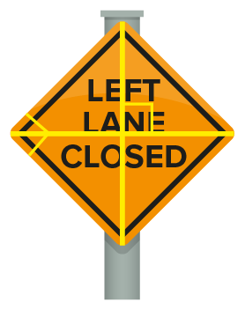

USE TOOLS Use diagonals to construct each figure. Justify each construction.
39. rhombus 40. square

41. CAKE Douglas cuts a rhombus-shaped piece of cake along both diagonals. He ends up with four congruent triangles. Classify these triangles as acute, obtuse, or right.

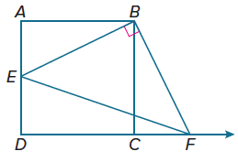
42. PERSEVERE The area of square ABCD is 36 square units and the area of ΔEBF is 20 square units. If $\overline{EB}$⊥ $\overline{BF}$ and AE = 2, find CF.

43. WRITE Compare all of the properties of the following quadrilaterals: parallelograms, rectangles, rhombi, and squares.

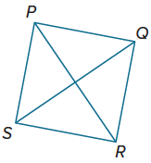
44. FIND THE ERROR In parallelogram PQRS, $\overline{PR}≅\overline{QS}$. Graciela thinks that the parallelogram is a square, and Xavier thinks that it is a rhombus. Is either of them correct? Explain your reasoning.

45. ANALYZE Determine whether the statement is true or false. Then write the converse, inverse, and contrapositive of the statement and determine the truth value of each. Justify your argument.
If a quadrilateral is a square, then it is a rectangle.

46. CREATE Find the vertices of a square with diagonals that are contained in the graphs of y = x and y = ‒x + 6. Justify your reasoning.

