Trapezoids and Kites ⸱ Practice

Example 1
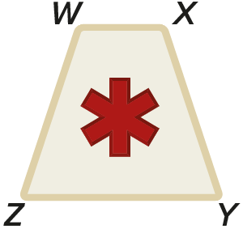
1. SIGNS The medical sign shown is a trapezoidal prism. The front face of the sign is an isosceles trapezoid. WX = 2x ‒ 2, YZ = 2x + 6, WZ = 4x + 5, XY = 5x ‒ 3.
a. Prove x = 8.

b. Find m∠Z if m∠W = 106°.

c. Find the perimeter of the front face of the sign in inches.

Find each measure.
2. m∠T 3. m∠Y
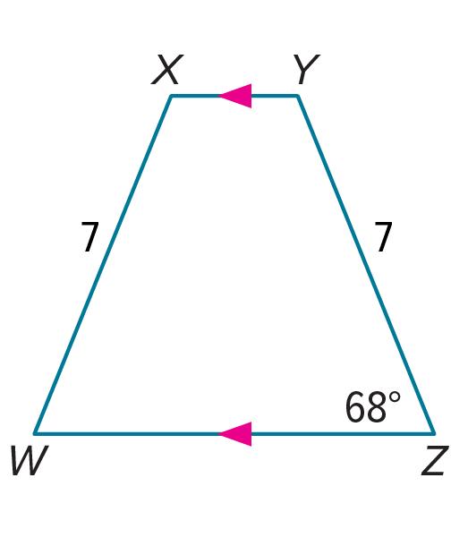
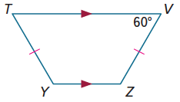

Example 2
4. RSTU is a quadrilateral with vertices R(–3, –3), S(5, 1), T(10, –2), and U(–4, –9).

a. Verify that RSTU is a trapezoid.

b. Is RSTU an isosceles trapezoid? Explain.

5. ABCD is a quadrilateral with vertices A(–1, 5), B(3, 2), C(–8, 2), and D(–4, 5).

a. Verify that ABCD is a trapezoid.

b. Is ABCD an isosceles trapezoid? Explain.
Examples 3 and 4
$\overline{TS}$ is the midsegment of trapezoid HJKL.

6. If HJ = 14 and LK = 42, find TS.

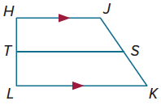
7. If LK = 19 and TS = 15, find HJ.

8. If HJ = 7 and TS = 10, find LK.

9. If KL = 17 and JH = 9, find ST.

10. If TS = 24 and LK = 27.4, find HJ.

Example 5
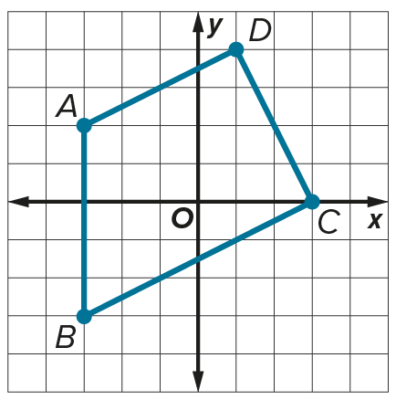
11. In trapezoid ABCD, $\overline{AD}$ $∥$ $\overline{BC}$. Find the endpoints of the midsegment.

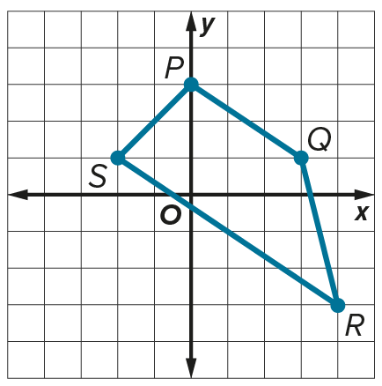
12. In trapezoid PQRS, $\overline{PQ}$ $∥$ $\overline{SR}$. Find the endpoints of the midsegment.

Example 6
Find each measure in the kites.
13. m∠Q 14. m∠D
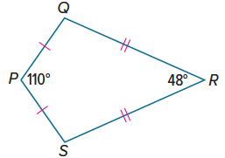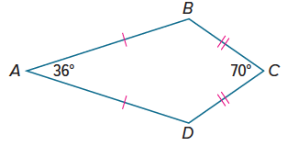

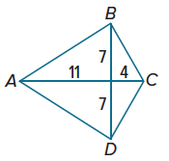
Example 7
15. REASONING Quadrilateral ABCD is a kite.
a. Find BC. Write your answer in simplest radical form.
b. Find the perimeter of kite ABCD. Round your answer to the nearest tenth, if necessary.
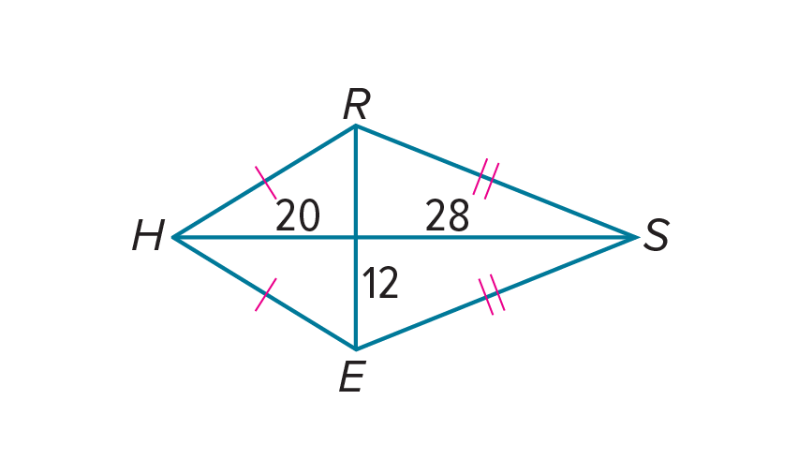
16. REASONING Quadrilateral HRSE is a kite.
a. Find RH. Write your answer in simplest radical form.
b. Find the perimeter of kite HRSE. Round your answer to the nearest tenth, if necessary.

Mixed Exercises
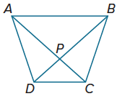
ABCD is a trapezoid.
17. If AC = 3x ‒ 7 and BD = 2x + 8, find the value of x so that ABCD is isosceles.

18. If m∠ABC = (4x + 11)° and m∠DAB = (2x + 33)°, find the value of x so that ABCD is isosceles.

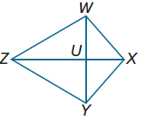
WXYZ is a kite.
19. If m∠WXY = 120°, m∠WZY = (4x)°, and m∠ZWX = (10x)°, find m∠ZYX.

20. If m∠WXY = (13x + 24)°, m∠WZY = 35°, and m∠ZYX = (13x + 14)°, find m∠ZWX.

21. USE A MODEL A set of stairs leading to the entrance of a building is designed in the shape of an isosceles trapezoid with the longer base at the bottom of the stairs and the shorter base at the top. If the bottom of the stairs is 21 feet wide and the top is 14 feet wide, find the width of the stairs halfway to the top.

22. DESK TOPS A carpenter needs to replace several trapezoid-shaped desktops in a classroom. The carpenter knows the lengths of both bases of the desktop. What other measurements, if any, does the carpenter need?

PROOF Write a two-column proof to prove each theorem.
23. Theorem 7.22
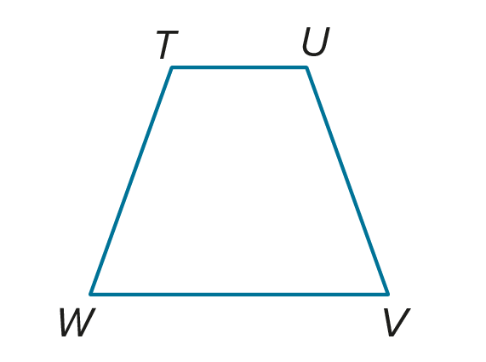
Given: TUVW is a trapezoid; $∠W≅∠V$.
Prove: Trapezoid TUVW is isosceles.

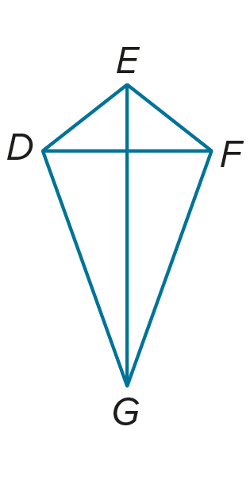
24. Theorem 7.25
Given: DEFG is a kite.
Prove: $\overline{DF}⊥\overline{EG}$

25. PROOF Write a paragraph proof to prove Theorem 7.26.
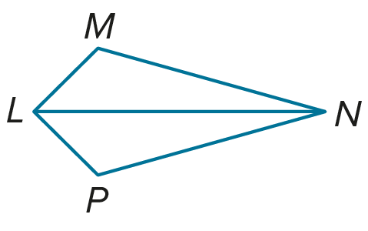
Given: LMNP is a kite.
Prove: $∠M≅∠P$; $∠MLP≇∠MNP$

26. USE A SOURCE Go online to research diamond kites.
a. Find the perimeter of a traditional diamond kite.

b. Find the area of the kite.

27. CREATE Write the equations of four lines that intersect to form the vertices of an isosceles trapezoid. Verify your answer using coordinate geometry.

28. WHICH ONE DOESN’T BELONG The following three characteristics describe all but which of the following quadrilaterals? Justify your conclusion.
- At least one pair of opposite sides are parallel.
- Diagonals are not perpendicular.
- At least one pair of opposite sides are congruent.

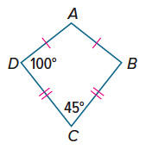
29. FIND THE ERROR Bedagi and Belinda are trying to determine m∠A in kite ABCD. Begadi says $m∠A=45°$, and Belinda says $m∠A=115°$. Who is correct? Explain your reasoning?

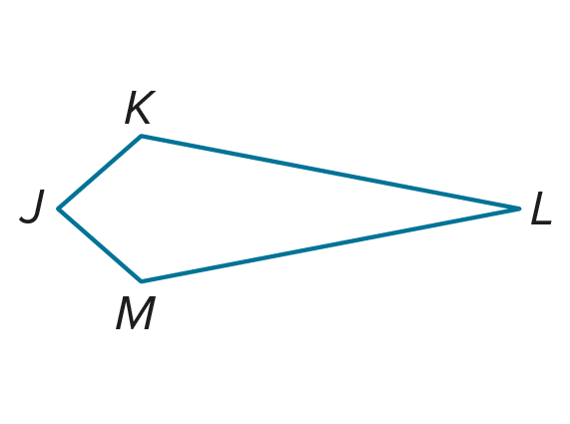
30. PERSEVERE JKLM is a kite. $JM=4y^{2}-4y+2, JK=3y^{2}-5y+8, ML=3x^{2}-6x-10,$and $KL=2x^{2}-2x-5$. If $KL>JK$, find the perimeter of JKLM.

31. WRITE Describe the properties that a quadrilateral must possess for the quadrilateral to be classified as a trapezoid, an isosceles trapezoid, or a kite. Compare the properties of all three quadrilaterals.

ANALYZE Determine whether each statement is sometimes, always, or never true. Justify your argument.

32. A square is also a kite.

33. One pair of opposite sides are congruent in a kite.

34. The opposite angles of a trapezoid are supplementary.

