Dilations ⸱ Practice

Example 1
Determine whether the dilation from the figure on the left to the figure on the right is an enlargement or a reduction. Then find the scale factor of the dilation.
1. 2.
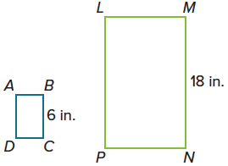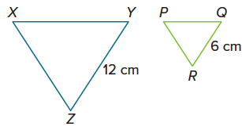

3. 4.
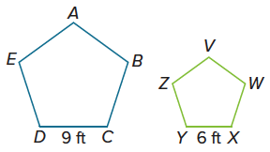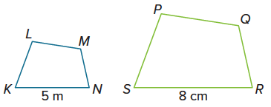

Example 2
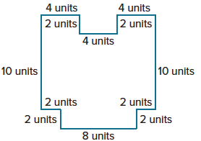
5. BLUEPRINTS Ezra is redrawing the blueprint shown of a stage he is planning to build for his band. By what percentage should he multiply the dimensions of the stage so that the dimensions of the image are $\frac{1}{2}$ the size of the original blueprint? What will be the perimeter of the updated blueprint?

Example 3
For each set of triangle vertices, find and graph the coordinates of the vertices of
the image after a dilation of the triangle by the given scale factor.
6. J(–8, 0), K(–4, 4), L(–2, 0), k = 0.5 7. S(0, 0), T(–4, 0), V(–8, –8), k = 1.25

8. A(9, 9), B(3, 3), C(6, 0), k = $\frac{1}{3}$ 9. D(4, 4), F(0, 0), G(8, 0), k = 0.75

Example 4
Find the scale factor of the dilation.
10. $△$J’K’P’ is the image of $△$JKP. 11. $△$D’F’G’ is the image of $△$DFG.
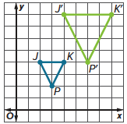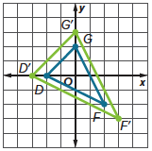

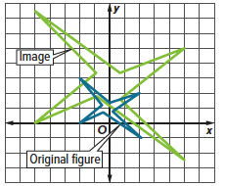
12. Tyrone drew a logo and a dilation of the same logo on the coordinate plane. What is the scale factor of the dilation?

Mixed Exercises
Graph the image of each polygon with the given vertices after a dilation centered at the origin with the given scale factor.
13. F(–10, 4), G(–4, 4), H(–4, –8), k = 0.25 14. X(2, –1), Y(–6, 4), Z(–2, –5), k = $\frac{5}{4}$

15. M(4, 6), N(–6, 2), P(0, –8), k = $\frac{3}{4}$ 16. R(–2, 6), S(0, –1), T(–5, 3), k = 1.5

Find the scale factor of the dilation.
17. A’B’C’D’ is the image of ABCD. 18. $△$P’Q’R’ is the image of $△$PQR.
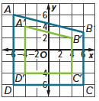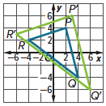

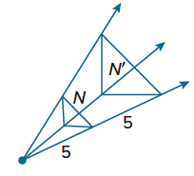
19. Determine whether the dilation from Figure N to N′ is an enlargement or a reduction. Find the scale factor of the dilation.

20. △ABC has vertices A(2, 2), B(3, 4), and C(5, 2). What are the coordinates of point C of the image of the triangle after a dilation centered at the origin with a scale factor of 2.5?

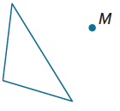
21. USE TOOLS Use a ruler to draw the image of the figure under a dilation with center M and the scale factor of $\frac{1}{5}$.

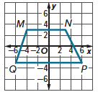
22. Davion is using a coordinate plane to experiment with quadrilaterals, as shown in the figure. Davion creates M'N'P'Q' by enlarging MNPQ with a dilation with a scale factor of 2. Then he creates M″N″P″Q″ by dilating M'N'P'Q' with a scale factor of $\frac{1}{3}$. The center of dilation for each dilation is the origin.

a. Draw and label the final image, M"N"P"Q".

b. Can Davion map MNPQ directly to M"N"P"Q" with a single transformation? If so, what transformation should he use?

c. In general, what can you say about a dilation with scale factor k₁ that is followed by a dilation with scale factor k₂?

23. The point P’ is the image of point P(a, b) under a dilation centered at the origin with scale factor k ≠ 1.

a. Assuming that point P does not lie on the y-axis, what is the slope of $\overset{⃡}{PP’}$? Explain how you know.

b. In part a, why is it important that P does not lie on the y-axis?

24. WXYZ has vertices W(6,2), X(3,7), Y(–1,4), and Z(4, –2).
a. Find the perimeter of WXYZ.

b. Find the perimeter of the image of WXYZ after a dilation of $\frac{1}{2}$ centered at the origin and compare it to the perimeter of WXYZ.

25. PERSEVERE Find the equation for the dilated image of the line y = 4x – 2 if the dilation is centered at the origin with a scale factor of 1.5.

26. WRITE Are parallel lines (parallelism) and collinear points (collinearity) preserved under all transformations? Explain.

27. ANALYZE An invariant point is a point that remains fixed under a transformation. For the transformations described below, determine whether there will sometimes, always, or never exist at least one invariant point. If so, describe the invariant point(s). If not, explain why invariant points are not possible.
a. dilation of ABCD with scale factor of 1

b. rotation of $\overline{AB}$ 74$°$ about B

c. reflection of $△$MNP in the x-axis

d. translation of PQRS along $〈7, 3〉$

e. dilation of $△$XYZ centered at the origin with scale factor 2

28. CREATE Graph a triangle. Dilate the triangle so that its area is four times the area of the original triangle. State the scale factor and center of your dilation.

29. WRITE Can you use transformations to create congruent figures? Explain.

30. ANALYZE Determine whether each statement is sometimes, always, or never true. Justify your argument.

a. If c is a real number, then a dilation centered at the origin maps the line y = cx to itself.

b. If k > 1, then a dilation with scale factor k maps $\overline{AB}$ to a segment that is congruent to $\overline{AB}$.

