Similar Polygons ⸱ Practice

Example 1
List all pairs of congruent angles, and write a proportion that relates the corresponding sides for each pair of similar polygons.
1. ABCD $\sim$ WXYZ 2. MNPQ $\sim$ RSTU
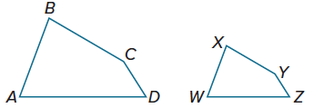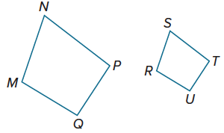

3. $△$FGH $\sim$ $△$JKL 4. $△$DEF $\sim$ $△$VWX
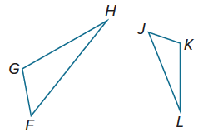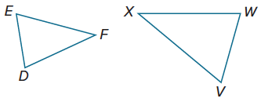

5. ABCD $\sim$ FGHJ 6. $△$MNP $\sim$ $△$QRP
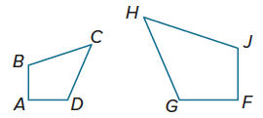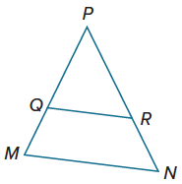

Example 2
Determine whether each pair of figures is similar. If so, find the scale factor. Explain your reasoning.
7. 8.
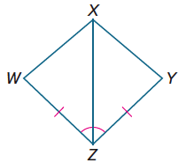
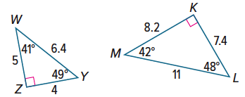

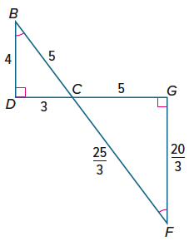
9. 10.
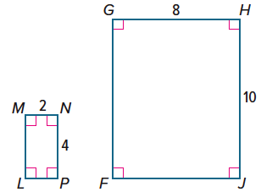

Example 3
Each pair of polygons is similar. Find the value of x.
11. 12.
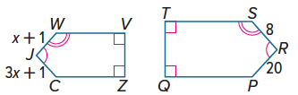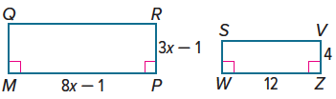

13. 14.
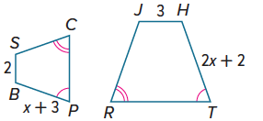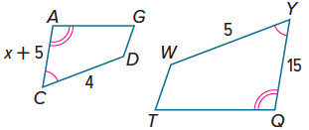

Example 4
15. GAMING In a role-playing video game, the user navigates his or her character across an unknown land using a map. On the map, the distance between the character’s home and the health food store is 2 centimeters, the distance between the health food store and the first dungeon is 8 centimeters, and the distance between the first dungeon and the character’s home is 7 centimeters. If the actual distance between the health food store and the first dungeon is 4 kilometers, how far will the character have to travel in the game to visit all three destinations?

16. LAWN CARE Nayeli’s rectangular lawn has a perimeter of 126 meters. The ratio of the length of the lawn to the width of the lawn is 5:2. What is the width of Nayeli’s lawn?

Mixed Exercises
Find the perimeter of each triangle.
17. △CBH, if △CBH ∼ △FEH, 18. △DEF, if △DEF ∼ △CBF,
ADEG is a parallelogram, CH = 7, perimeter of △CBF = 27,
FH = 10, FE = 11, and EH = 6 DF = 6, FC = 8
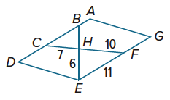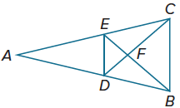

Find the value of x and y for each pair of polygons.
19. ABCD ∼ QSRP 20. △JKL ∼ △WYZ
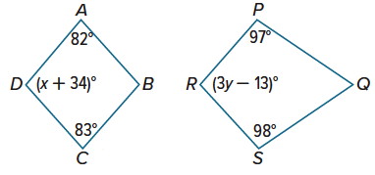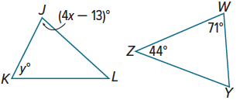

21. PROOF Write a paragraph proof of Theorem 8.3.
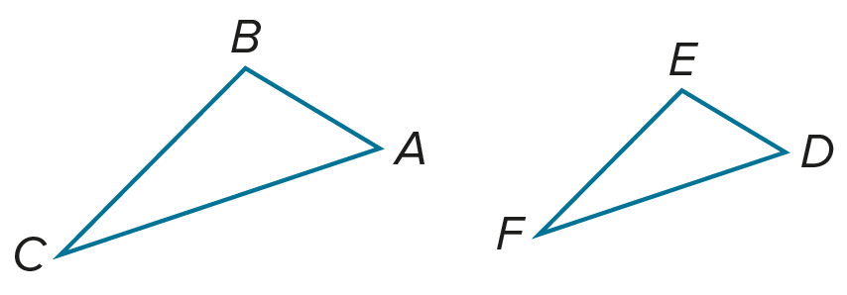
Given: $△ABC∼△DEF$ and $\frac{AB}{DE}=\frac{m}{n}$
Prove: $\frac{perimeter of △ABC}{perimeter of △DEF}=\frac{m}{n}$

22. If △ABC ∼ △DEC, find the value of x and the scale factor from △DEC to △ABC.
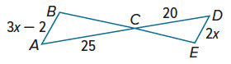
23. Rectangle ABCD ~ rectangle EFGH, the perimeter of ABCD is 54 centimeters, and the perimeter of EFGH is 36 centimeters. What is the scale factor from EFGH to ABCD?

24. △ABC is an isosceles triangle.
a. Write a possible ratio for the lengths of the sides of △ABC if its perimeter is 42 inches.

b. Name possible measures for the sides of △ABC using your answer to part a.

c. If △WXY is also isosceles and has a perimeter of 28 and △ABC has sides with the measures you gave in part b, what must be the measure of the sides of △WXY so that △WXY ∼ △ABC?

25. ICE HOCKEY An official Olympic-sized ice hockey rink measures 30 meters by 60 meters. The ice hockey rink at the local community college measures 25.5 meters by 51 meters. Are the ice hockey rinks similar? Explain your reasoning.

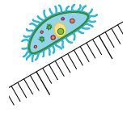
26. BIOLOGY A paramecium is a small single-cell organism. The magnified paramecium shown is actually one-tenth of a millimeter long.
a. If you want to make a photograph of the original paramecium so that its image is 1 centimeter long, by what scale factor should you magnify it?

b. If you want to make a photograph of the original paramecium so that its image is 15 centimeters long, by what scale factor should you magnify it?

c. By approximately what scale factor has the paramecium been enlarged to make the image shown?

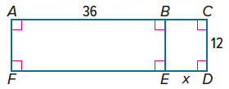
27. PERSEVERE For what value(s) of x is BEFA ∼ EDCB?

28. ANALYZE Recall that an equivalence relation is any relationship that satisfies the Reflective, Symmetric, and Transitive Properties. Is similarity an equivalence relation? Explain.

29. CREATE Find a counterexample of the following statement.
All rectangles are similar.

30. ANALYZE Draw two regular pentagons of different sizes. Are the pentagons similar? Will any two regular polygons with the same number of sides be similar? Explain.

31. WRITE How can you describe the relationship between two figures?

