Similar Triangles: AA Similarity ⸱ Practice

Example 1
Determine whether each pair of triangles is similar. Explain your reasoning.
1. 2.
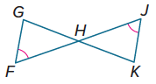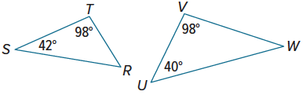

3. 4.
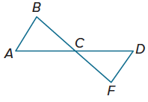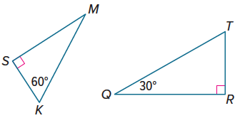

5. 6.
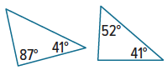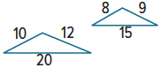

Example 2
7. CELL TOWERS A cell phone tower casts a shadow that is 100 feet long. At the same time, Lia stands near the tower and casts a shadow that is 3 feet 4 inches long. If Lia is 4 feet 6 inches tall, how tall is the cell phone tower?

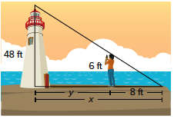
8. LIGHTHOUSE Maya wants to know how far she is standing from a lighthouse. The end of Maya’s shadow coincides with the end of the lighthouse’s shadow.
a. What is the distance from the lighthouse to the end of the lighthouse’s shadow, x?
b. What is the distance from Maya to the lighthouse, y?

Mixed Exercises
Identify the similar triangles. Then find each measure.
9. AC 10. JL
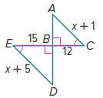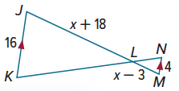

11. EH 12. VT
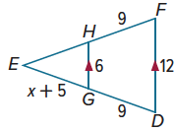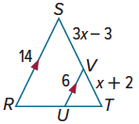

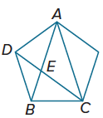
13. Olivia draws a regular pentagon and starts connecting its vertices to make a 5-pointed star. After drawing three of the lines in the star, she becomes curious about two triangles that appear in the figure, △ABC and △CEB. They look similar to her. Prove that this is the case.

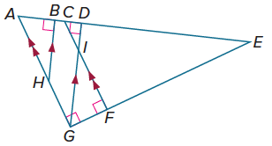
14. ANALZYE Write as many triangle similarity statements as possible for the figure shown. How do you know that these triangles are similar?

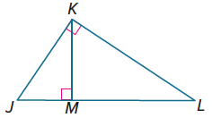
15. PERSEVERE In the figure, $\overline{KM}$⊥ $\overline{JL}$and $\overline{JK}$⊥ $\overline{KL}$. Is △JKL ∼ △JMK? Provide a proof to demonstrate their similarity or give an explanation of why they are not similar.

