Similar Triangles: SSS and SAS Similarity ⸱ Practice
Example 1
Determine whether each pair of triangles is similar. Explain your reasoning.
1. 2.
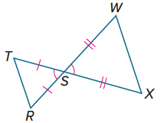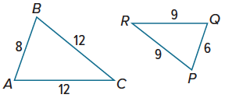

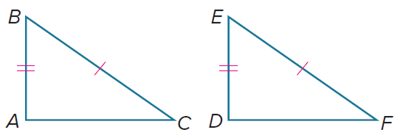
3. 4.
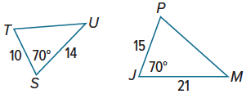

Example 2
Identify the similar triangles. Then find the value of x.
5. 6.
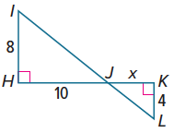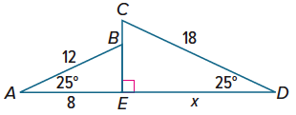

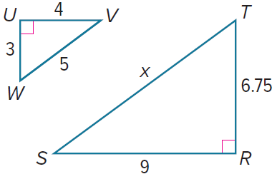
7. 8.
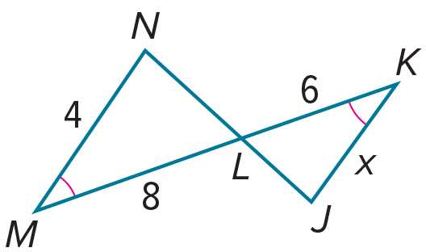

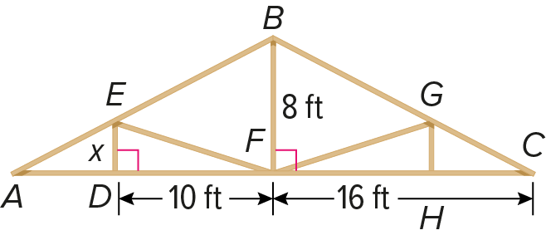
Example 3
9. ROOFING The skeleton of a roof is shown. Find the value of x such that triangles DEF and FBC in the outline of the roof are similar.

10. RADIO A radio tower casts an 8-foot-long shadow at the same time that a vertical yardstick casts a shadow one half inch long. If the triangles formed by the objects and their shadows are similar, how tall is the radio tower?
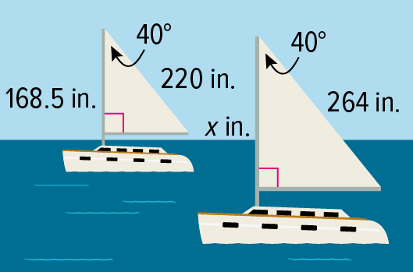
11. SAILING The two sailboats shown are participating in a regatta. If the sails are similar, what is the value of x?

12. MOUNTAIN PEAKS Marcus and Skye want to estimate how far a mountain peak is from their houses. After taking some measurements, they construct a diagram.
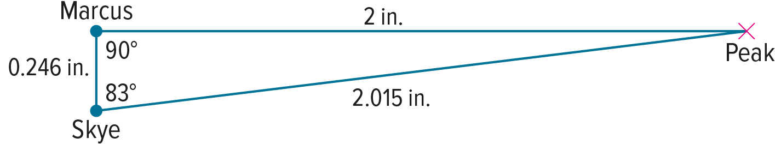
The actual distance between Marcus and Skye’s houses is 1$\frac{1}{2}$ miles.
a. What is the actual distance from Marcus’s house to the peak of the mountain? Round your answer to the nearest tenth of a mile.

b. What is the actual distance from Skye’s house to the peak of the mountain? Round your answer to the nearest tenth of a mile.
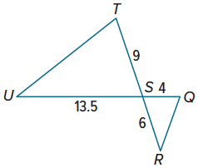

Mixed Exercises
13. Mia drew triangles STU and SQR. She claims that △STU and △SQR are similar. Is she correct? Justify your reasoning.

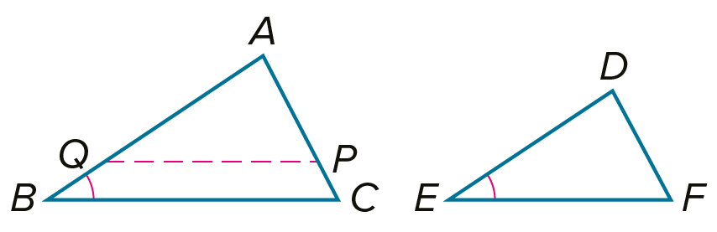
14. PROOF Write a two-column proof for the Side-Angle-Side (SAS) Similarity Proof. (Theorem 8.5)
Given: $∠B≅∠E$, $\overline{QP}∥\overline{BC}$, $\overline{QP}≅\overline{EF}$, $\frac{AB}{DE}=\frac{BC}{EF}$
Prove: △ABC ∼ △DEF

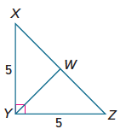
15. WRITE Compare and contrast the AA Similarity Postulate, the SSS Similarity Theorem, and the SAS Similarity Theorem.

16. PERSEVERE $\overline{YW}$ is an altitude of $△$XYZ. Find YW.

17. ANALYZE A pair of similar triangles has angles that measure 50°, 85°, and 45°. The sides of one triangle measure 3, 3.25, and 4.23 units, and the sides of the second triangle measure x – 0.46, x, and x + 1.81 units. Find the value of x to the nearest integer.

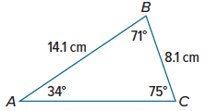

18. CREATE Draw a triangle that is similar to $△$ABC shown. Explain how you know that it is similar.

