Triangle Proportionality ⸱ Practice
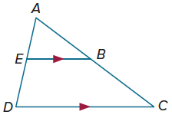
Example 1
Use the figure at the right.
1. If AB = 6, BC = 4, and AE = 9, find ED.

2. If AB = 12, AC = 16, and ED = 5, find AE.

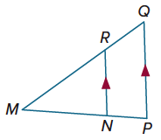
Example 2
Determine whether $\overline{NR}$ $∥$ $\overline{PQ}$. Justify your answer.
3. PM = 18, PN = 6, QM = 24, and RM = 16

4. QM = 31, RM = 21, and PM = 4PN

Example 3
$\overline{VR}$, $\overline{VZ}$, and $\overline{ZR}$ are midsegments of $△$UWY. Find the value of x.
5. 6.
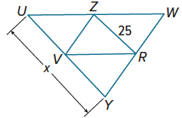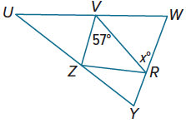

7. 8.

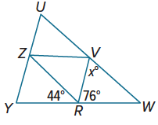
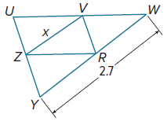

Example 4
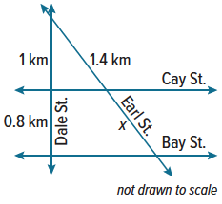
9. MAPS In Mika’s town, Cay Street and Bay Street are parallel. Find the value of x, the distance from Cay Street to Bay Street along Earl Street.

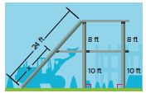
10. PLAYSCAPES Prassad is building a two-story playscape using the plans shown. Find the value of x.

Example 5
Find the values of x and y.
11. 12.
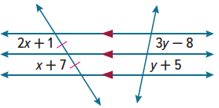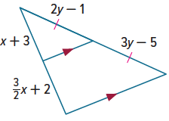

Mixed Exercises
$\overline{JH}$ is a midsegment of △KLM. Find the value of x.
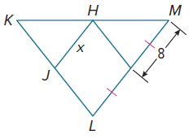
13. 14. 15.
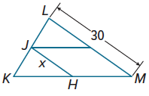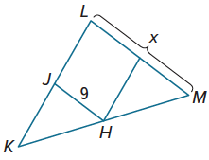

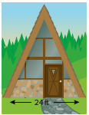
16. In △ABC, $\overline{DE}$ is parallel to $\overline{AC}$ and DE = 10. Find the length of $\overline{AC}$ if $\overline{DE}$ is a midsegment of △ABC.

17. CARPENTRY Jake is fixing an A-frame. He wants to add a horizontal support beam halfway up and parallel to the ground. How long should this beam be?

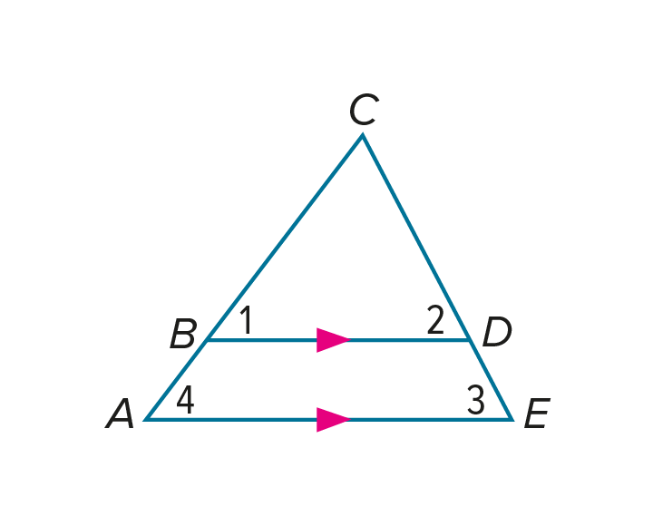
18. PROOF Write a paragraph proof of the Triangle Proportionality Theorem. (Theorem 8.8)
Given: $\overline{BD}∥\overline{AE}$
Prove: $\frac{BA}{CB}=\frac{DE}{CD}$

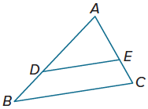
19. PROOF Write a paragraph proof of the Converse of the Triangle Proportionality Theorem. (Theorem 8.9).
Given: $\frac{AD}{DB}$ = $\frac{AE}{EC}$
Prove: $\overline{DE}$ $∥$ $\overline{BC}$
(Hint: Explain how you can use the given proportion to show that $\frac{AB}{AD}$ = $\frac{AC}{EC}$. Then, use this proportion to complete the proof.)

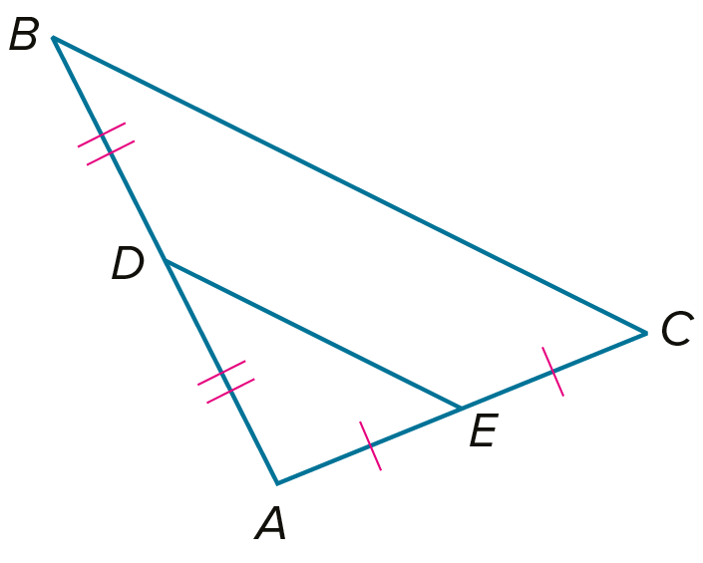
20. PROOF Write a two-column proof of the Triangle Midsegment Theorem. (Theorem 8.10)
Given: $△ABC$; D is the midpoint of $\overline{AB}$; E is the midpoint of $\overline{AC}$.
Prove: $\overline{DE}$ $∥$ $\overline{BC}$, $DE=\frac{1}{2}BC$

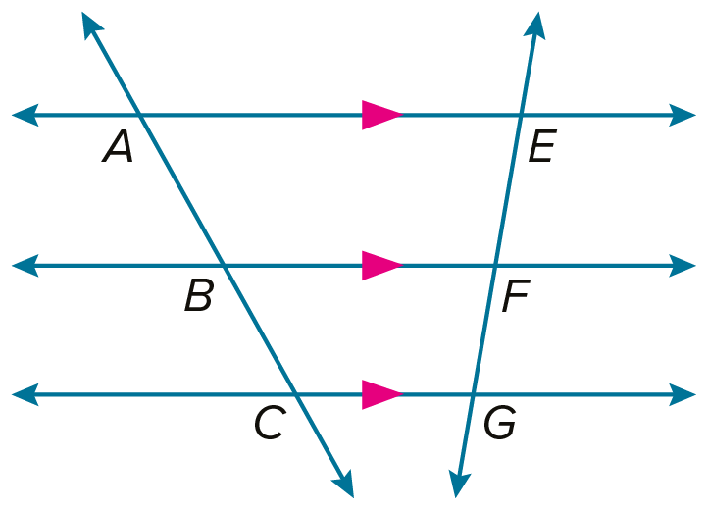
21. PROOF Write a paragraph proof of Corollary 8.1.
Given: $\overset{⃡}{AE}∥\overset{⃡}{BF}∥\overset{⃡}{CG}$
Prove: $\frac{AB}{BC}=\frac{EF}{FG}$

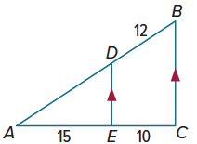

22. REGULARITY In the figure, $\overline{DE}$ $∥$ $\overline{BC}$, BD = 12, EC = 10, and AE = 15. Explain how to find the length of $\overline{AD}$.

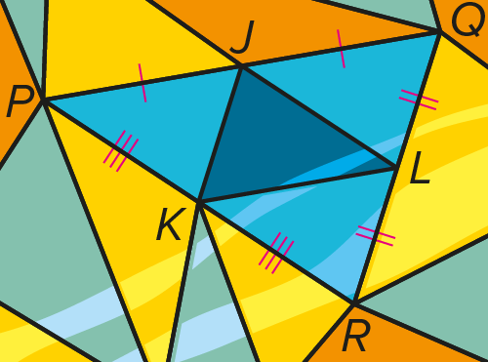
23. ART The divider bars between the pieces of colored glass in a stained glass window are called cames. In the stained window at the right, the total length of the cames for △PQR is 78 centimeters. What is the total length of the cames for △JKL? Give an argument to support your answer.

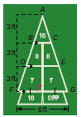
24. SHUFFLEBOARD A crew is laying out a shuffleboard court using the plan shown at the right. Explain how they can find the lengths of $\overline{AB}$, $\overline{BD}$, and $\overline{DF}$ to the nearest tenth of a foot.

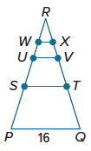
25. In △PQR, the length of $\overline{PQ}$ is 16 units. A series of midsegments are drawn such that $\overline{ST}$ is the midsegment of △PQR, $\overline{UV}$ is the midsegment of △STR, and $\overline{WX}$ is the midsegment of △UVR.
a. What is the length of each midsegment?

ST = UV = WX =

b. What would be the measure of midsegment $\overline{YZ}$ of △WXR?

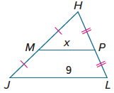
26. FIND THE ERROR Jacinda and Elaine are finding the value of x in $△$JHL. Jacinda says that MP is one half of JL, so x is 4.5. Elaine says that JL is one half of MP, so x is 18. Is either of them correct? Explain your reasoning.

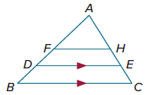
27. ANALYZE In $△$ABC, AF = FB and AH = HC. If D is $\frac{3}{4}$ of the way from A to B and E is $\frac{3}{4}$ of the way from A to C, is DE sometimes, always, or never $\frac{3}{4}$ of BC? Justify your argument.

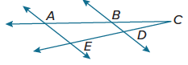
28. PROOF Write a two-column proof.
Given: AB = 4, BC = 4, and CD = DE
Prove: $\overline{BD}$ $∥$ $\overline{AE}$

29. CREATE Draw three segments a, b, c, and d of all different lengths such that $\frac{a}{b}$ = $\frac{c}{d}$.

30. WRITE Compare the Triangle Proportionality Theorem and the Triangle Midsegment Theorem.

