Parts of Similar Triangles ⸱ Practice

Example 1
Each pair of triangles is similar. Find the value of x.
1. 2. 3. 4.
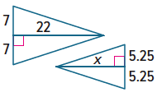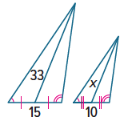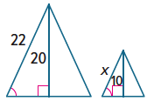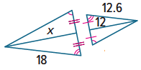

Example 2
5. If △RST ∼ △EFG, $\overline{SH}$ is an altitude of △RST, 6. If △ABC ∼ △MNP, $\overline{AD}$ is an altitude of △ABC,
$\overline{FJ }$is an altitude of △EFG, ST = 6, SH = 5, $\overline{MQ}$ is an altitude of △MNP, AB = 24, AD = 14,
and FJ = 7, find FG. and MQ = 10.5, find MN.
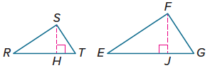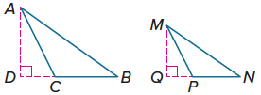

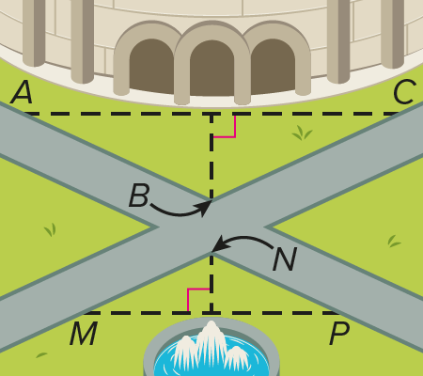
7. SCENERY The intersection of the two paths shown forms two similar triangles. If AC is 50 yards, MP is 35 yards, and the fountain is 5 yards from the intersection, about how far from the intersection is the stadium entrance? Round to the nearest yard.

Example 3
Find the value of each variable to the nearest tenth.
8. 9.
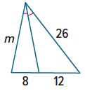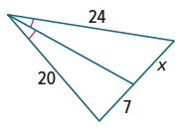

Mixed Exercises
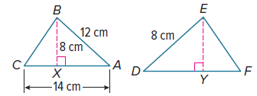
For Exercises 10 and 11, △ABC ∼ △DEF.
10. Find the length of $\overline{XC}$ to the nearest tenth.

11. Find the length of $\overline{EY}$ to the nearest tenth.

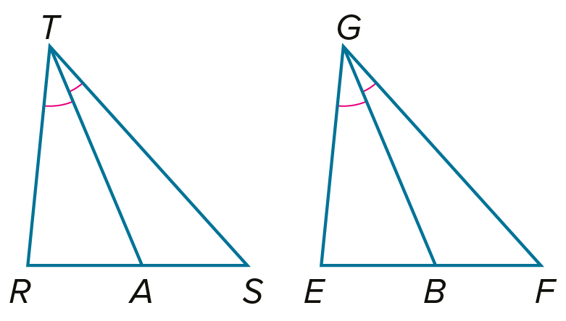
12. PROOF Write a paragraph proof of Theorem 8.12.
Given: $△RTS∼△EGF$; $\overline{TA}$ and $\overline{GB}$ are angle bisectors.
Prove: $\frac{TA}{GB}=\frac{RT}{EG}$

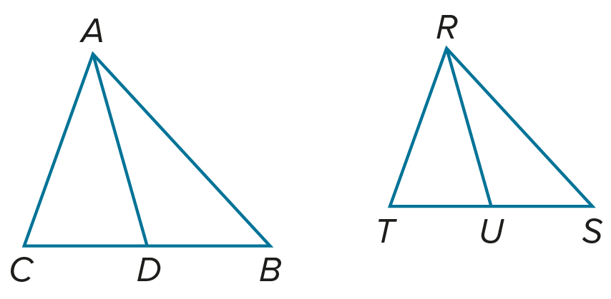
13. PROOF Write a two-column proof of Theorem 8.13.
Given: $△ABC∼△RST$; $\overline{AD}$ is a median of $△ABC$ and $\overline{RU}$ is a median of $△RST$.
Prove: $\frac{AD}{RU}=\frac{AB}{RS}$

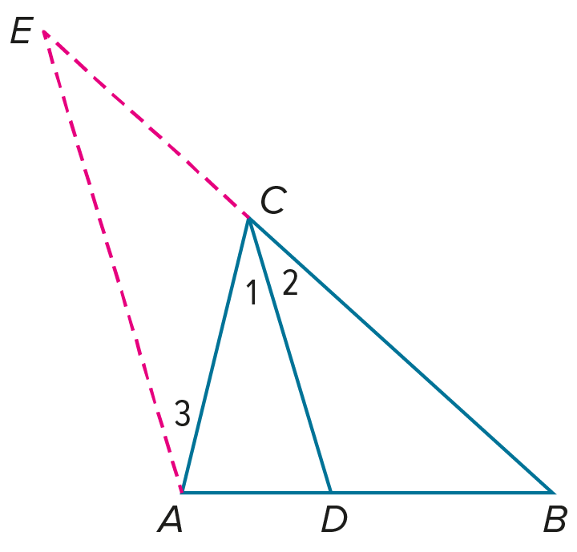
14. PROOF Write a two-column proof of the Triangle Angle Bisector Theorem. (Theorem 8.14)
Given: $\overline{CD}$ bisects $∠ACB$. By construction, $\overline{AE}∥\overline{CD}$.
Prove: $\frac{AD}{DB}=\frac{AC}{BC}$

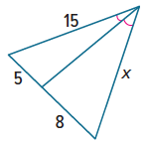
15. FIND THE ERROR Chun and Traci are determining the value of x in the figure. Chun says to find the value of x, solve the proportion $\frac{5}{8}$ = $\frac{15}{x}$, but Traci says to find the value of x, the proportion $\frac{5}{x}$ = $\frac{8}{15}$ should be solved. Is either of them correct? Explain your reasoning.

16. CREATE Draw two triangles so that the measures of an altitude and side of one triangle are proportional to the measures of an altitude and side of another triangle, but the triangles are not similar.
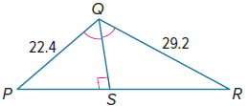

17. PERSEVERE The perimeter of $△$PQR is 94 units. $\overline{QS}$ bisects $∠$PQR. Find PS and RS. Round to the nearest tenth, if necessary.

