Geometric Mean ⸱ Practice

Example 1
Find the geometric mean between each pair of numbers.
1. 4 and 6 2. $\frac{1}{2}$ and 2 3. 4 and 25

4. 12 and 20 5. 17 and 3 6. 3 and 24

Example 2
REGULARITY Write a similarity statement identifying the three similar right triangles in each figure.
7. 8.
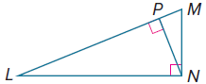
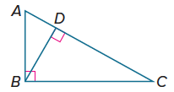

9. 10.
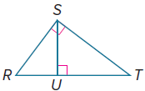
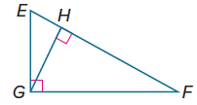

Example 3
Find the values of x, y, and z.
11. 12.
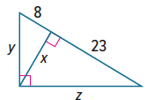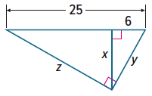

13. 14.
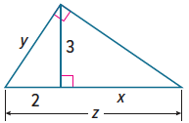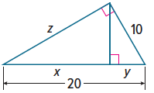

Example 4
15. USE A MODEL A museum has a famous statue on display. The curator places the statue in the corner of a rectangular room and builds a 15-foot-long railing in front of the statue. The railing forms a right triangle with the corner of the room. The legs of the triangle are 12 feet and 9 feet long. Approximate how close visitors will be able to get to the statue. Draw a diagram to model the situation.

16. USE A MODEL Noah wants to take a picture of a beach front. He wants to make sure two palm trees located at points A and B are just inside the edges of the photograph. He walks out on a walkway that goes over the ocean to get the shot. Point A is 90 feet from the entrance of the walkway, and point B is 40 feet from the entrance. If the walkway is perpendicular to AB, and Noah’s camera has a viewing angle of 90$°$, at what distance down the walkway should Noah stop to take his photograph? Draw a diagram to model the situation.

17. CIVIL ENGINEERING An airport, a factory, and a shopping center are at the vertices of a right triangle formed by three highways. The airport and factory are 6.0 miles apart. Their distances from the shopping center are 3.6 miles and 4.8 miles, respectively. A service road will be constructed from the shopping center to the highway that connects the airport and factory. What is the shortest possible length for the service road? Round to the nearest hundredth.

Mixed Exercises
18. REASONING The geometric mean of a number and four times the number is 22.
What is the number?

PROOF Write the specified type of proof to prove each theorem.
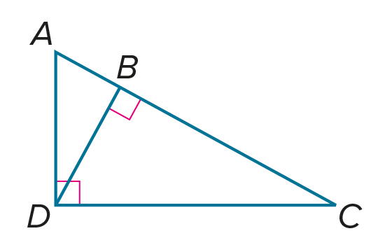
19. paragraph proof Theorem 9.2 20. two-column proof Theorem 9.3
Given: $△ADC$ is a right triangle. Given: $∠ADC$ is a right angle.
$\overline{DB}$ is an altitude of $△ADC$. $\overline{DB}$ is an altitude of $△ADC$.
Prove: $\frac{AB}{DB}=\frac{DB}{CB}$ Prove: $\frac{AB}{AD}=\frac{AD}{AC},\frac{BC}{DC}=\frac{DC}{AC}$

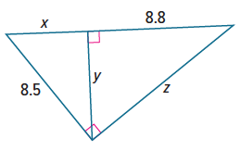
21. PERSEVERE Refer to the figure at the right. Find the values of x, y, and z.

22. WRITE Compare and contrast the arithmetic and geometric means of two numbers. When will the two means be equal? Justify your reasoning.

23. CREATE Find two pairs of whole numbers with a geometric mean that is also a whole number. What condition must be met in order for a pair of numbers to produce a whole-number geometric mean?

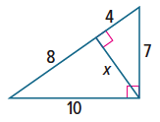
24. FIND THE ERROR Aiden and Tia are finding the value of x in the triangle shown. Is either of them correct? Explain your reasoning.
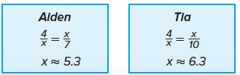

25. ANALYZE Determine whether each statement is sometimes, always, or never true. Justify your argument.
a. The geometric mean for consecutive positive integers is the mean of the two numbers.

b. The geometric mean for two perfect squares is a positive integer.

c. The geometric mean for two positive integers is another integer.

